A Level Computer Science

H446/03 Course Work

2021

Pain the Game

Name: Petru-Mihai Craciun

Student Number:205178

Contents

Analysis 3

Problem Identification 3

Stake Holders 4

Programming techniques 4

Research 5

Similar games 10

Problem Justification 14

Essential features 15

Design 15

Design Objectives 16

1.Aesthetics 16

2.Game Functions 17

3. Data handling 18

Game Design 19

Camera Change: 19

FIRING/WEAPONS 22

Firing 22

Reloading: 25

Aiming: 28

Proposed gun models: 29

Animation 31

Props: 32

User Interface: 35

Explanation and justification of my method 37

Validation methods 38

Testing methods 39

Production and testing 40

Stage 1: Decomposed production 41

Jetpack and movement 41

SUMMARY: 49

Bullet 50

SUMMARY: 51

Health system 52

SUMMARY: 53

Missile 54

SUMMARY: 57

Dash 57

SUMMARY: 59

DEAD 59

SUMMARY: 60

Platforms 60

FIXING THE PLATFORM ALGORYTHM 75

SUMMARY: 77

Kill Volume 77

SUMMARY: 78

Speedometer 78

SUMMARY: 80

Ramming Ai 81

SUMMARY: 84

Shooting Ai: 84

SUMMARY: 88

Fire Mechanism 88

SUMMARY: 90

SUMMARY: 91

ANIMATION 91

Crouching 91

SUMMARY: 97

SUMMARY: 100

SUMMARY: 102

Final tick testing: 102

FINAL TEST STAKE HOLDER TEST: 104

QUANTATIVE 107

Critique of game and critique of questionnaire 108

EVALUATION 109

Success criteria: 109

Usability 110

Usability issues 110

Limitations and their potential solution 111

Future development 112

Future development problems 113

Maintenance 113

The obey of design defined standards 113

# 

# Analysis

Problem Identification

The type of game I am choosing to code is a platformer which may appear easy at first but is harder than it seems you will have platforms which disappear the second the player steps off them and spawn a new platform the second you step on them. It will have random chances to spawn obstacles and random AI which will decide to push you off, it will be very random in nature making the game somewhat unpredictable everything from the size of the platform to the size and speed of the enemies will be random not only this but things such as landmines and spinning obstacles will be random so the player will be incentivised to avoid them as much as possible as it can be game ending or nothing to be scared at all. The player will have certain things to his disposal such as a Jet Pack which can have its fuel amount increased by finding certain items spawned on the small platforms, the player will also be able to defend themselves with thins such as mini turrets attached to their back or helpful drones flying around.

Stake Holders

This game is aimed at an average gamer who is looking for a challenge this is definitively not meant for people who are starting off playing video games however a lot of things will be adjustable in the menu widget allowing the player to set a lot of the things such as the chance of certain objects and ai generating, there will also be auto buttons such as easy mode which sets it to nicely set values.

Things such as Coyote time (delay before the player begins to fall essentially walking on air )will not be there to make the game just a tiny bit more frustrating.

It will include advanced movement closer to call of duty than halo where you will have many ways to transverse an area.

Programming techniques

Programming Decomposition:

The program can be made into a set of smaller problems eg.

Rather than making an ai it would be something like:

1.Ai get’s location of the player

2. Make the ai move to the player ( this could not work well via things such as nav mesh due to the platform spawning in and not being there at the start of the level so flying ai would be most suitable in this, there will be no sneaking aspect to this game so pawn sensing would be redundant anyway)

3. Set limits to how close it get’s

4.attack the player by either smashing into him or shooting him with balls

5. When its lifetime runs out it destroys itself

Abstraction:

Even though the player is using many abilities at once every animation must be done before something else must be done abstracting their abilities to one thing at the same time limiting the player to be more attentive with their time.

Object-Oriented programming

You can break down the problem into simpler steps this can be done via making actor files which have their own variables rather than keeping it all on one file such as the platform rather than having one game file you can make more files such as ai 1 file ai 2 file etc, (you can’t make a UE4 game without doing this).

Inheritance:

E.g. All Ai inherit a certain variable set in the menu like their maximum speed that they can move at etc.

Artificial Intelligence:

It will not include pawn sensing or travel via nav mesh due to the type of the game but they will be swirling around the player trying to attack him so there will be AI.

Research

Some questions I asked a couple of friends about thing’s I should include in this game, there are some references to some games I’ve made before this project that I’ve shown to them.

#### Main points of the questionnaire

1. To better understand what my stake holders liked and hated about my previous games, if they were too challenging and if they would benefit from a dynamic system where they can change the difficulty dynamically.
2. To better understand what kind of game graphics they would like
3. The variety of enemies they would enjoy
4. If they would have liked ways to defend themselves from the ai in the game or leave them there so that the game is more challenging

1. Did you find my previous game challenging(the platformer I previously showed you) if no please tell me how I could have made challenging?

Responses:

Friend 1: Previous game was challenging enough frustrating at the start however would have liked it to be a tiny bit easier

Friend 2: Ok so the game didn't feel challenging in a rewarding way, it felt unfair.

2. If you could change any of the variables in the previous game on an interface what would you change?

Friend 1: At max 10 variables

Friend 2: Not too many so that it becomes hectic

3. Would you like more of a variety of enemies?

Friend 1: at least 6 enemies rather than only 3 enemies ai

4. What was the thing you enjoyed the most about my last game?

Friend 1: Post-processing, lighting and graphics ( the platforms also changing colours)

Friend 2: would like less flashy graphics however the mini map was useful

5. What kind of graphics theme would you like to be implemented?

Friend 1: bright white

Friend 2: just more epileptic friendly

6. If I added in ways to defend yourself what would you like me to implement?

Friend 1 and 2: yes something like a gun but nothing too powerful

The responses from my friends where somewhat negative from a previous game I made in 8h they said it was way too hard and frustrating my solution to this can be by adding different difficulties which they can also alter, I also need to add more dopamine inducing objectives to get people hooked on playing the game.

Some pictures from my previous game and what I should improve on:

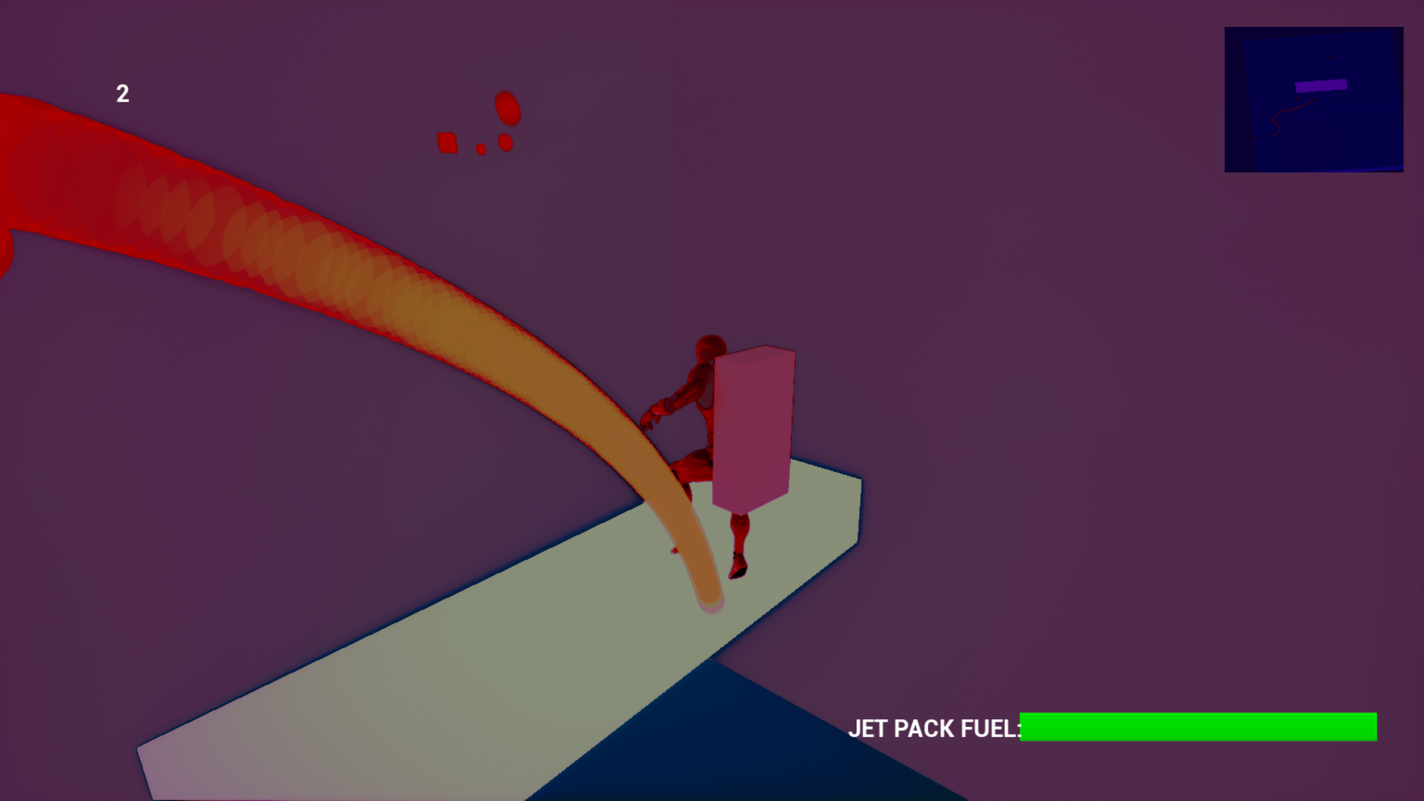

The things that I would also put in the next game would obviously be the mini map which was very useful when trying to jump around although a border around it or making it prettier would help a lot, the trail going after the player was also good as it offered a player a way of visualising their speed and acceleration and it made it easier to see where they were on the mini map, this might not work as good with my next set of graphics which will be different to this as the model’s were not too good looking for the moment due to it only being a 8h game.

Some features I implemented into the game that made it a little easier were double jump and the ability to push yourself to the left or the right however these might have not been enough, the idea of a glider would be interesting however it would be too quick for the small jumps so I should settle for something like balloons.

I should also change the way the platform looks for the moment they look extremely plain the only 3 ai I had were 1 which shot a stream of balls trying to knock you off but these balls were just physical objects ( you can kind of see it in the picture) another was a ai which just smashed into you however you could kind of use it to your advantage by riding it, and another one which shot balls which had radial damage which pushed you off if you got a tiny bit near them.

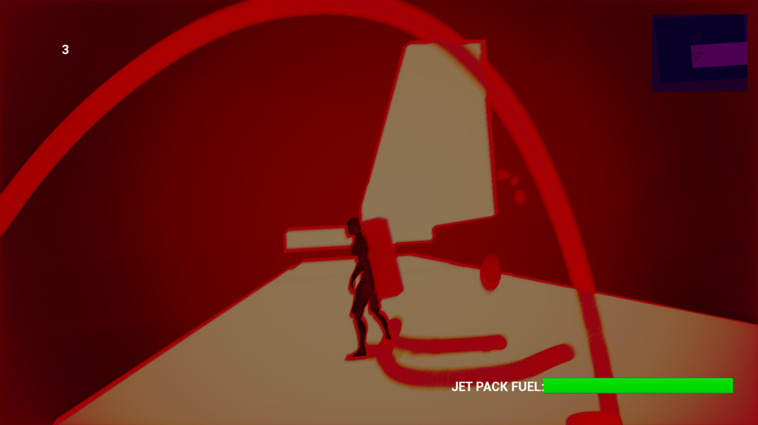

Other obstacles were spinning platforms, and landmines, from this picture you can see another feature which was to shake the camera from time to time, this would go well if there was some background music and it shook on the drop.

From these pictures you can see there is no way to defend yourself from the onslaught of the flying bullets coming from the floating blocks, I was thinking something such as a turret on the back of the player or a drone which follows him, to shoot them after he picks them up as a limited time ability.

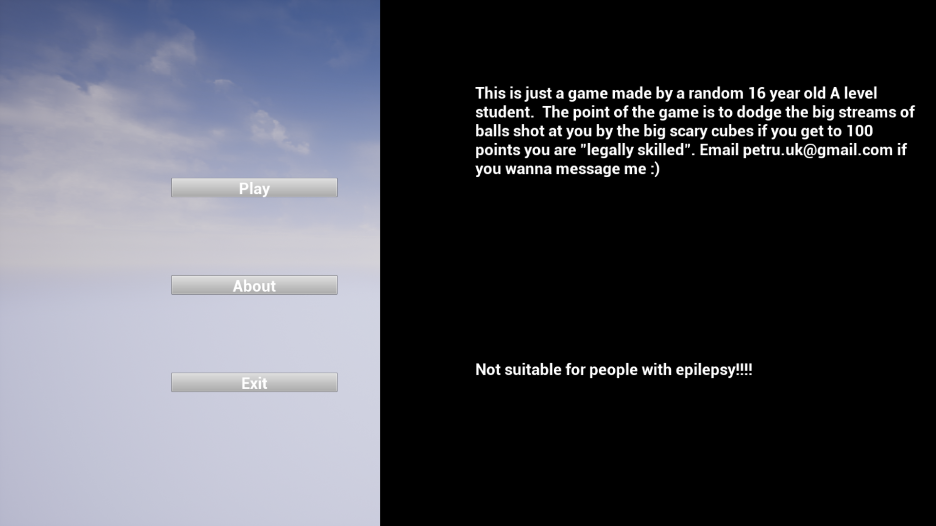

The menu was extremely simple including what the game was about etc, I would like to include the ability of setting the difficulty of the game into the game as well, not only this but the ability to save the high score would also be useful.

Places where I can find things such as assets can be CGTrader or the UE4 Marketplace

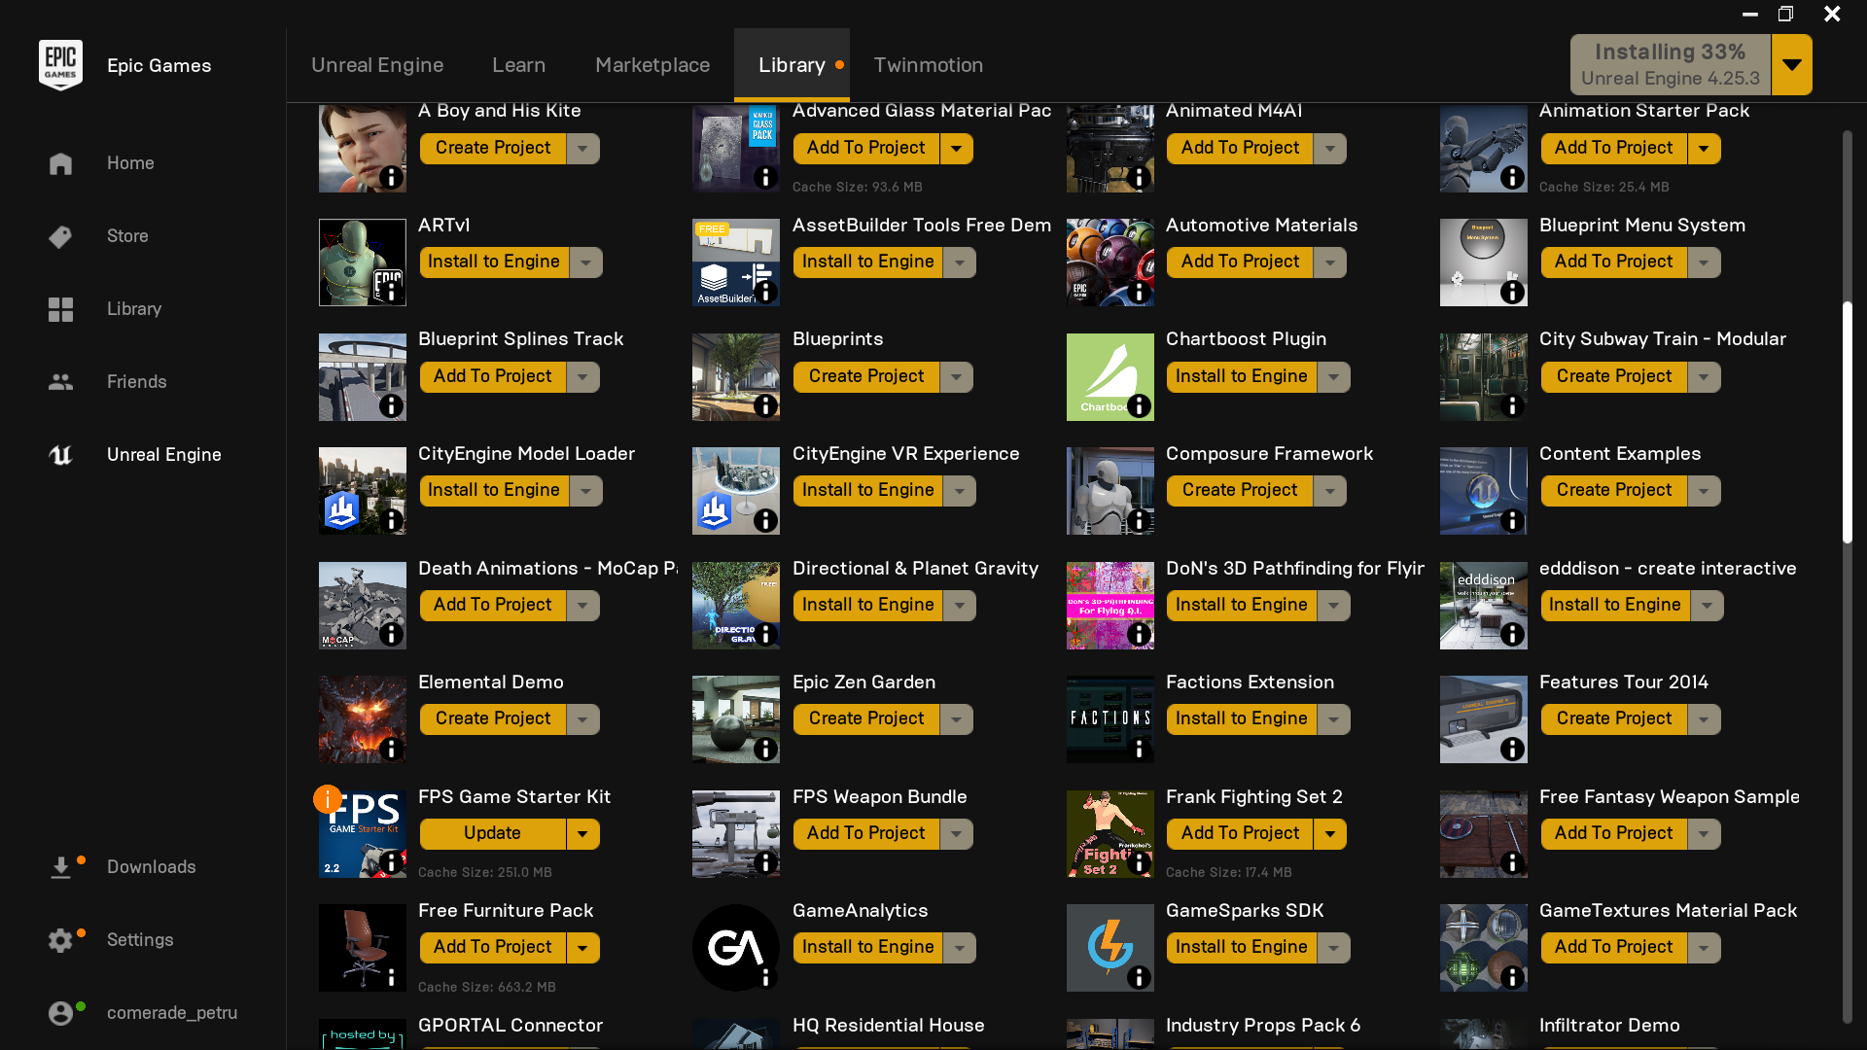

I already had a large amount of assets already installed this could save me a large amount of time from having to draw them (which I am not too good at).

Another useful thing that unreal engine has is the ability to code in both C++ and Blueprint, by also coding in blueprint it will make thing’s such as the Animation blueprint which turns on different animations at different times depending on the blueprint it was assigned to, I’ve already had plenty of practice with this from making games previously not only this but I can also nativize this code if I don’t find that it suits my needs therefore converting it from blueprint to C++

Another place where I made randomly generating structures was when I made a random race track generator:

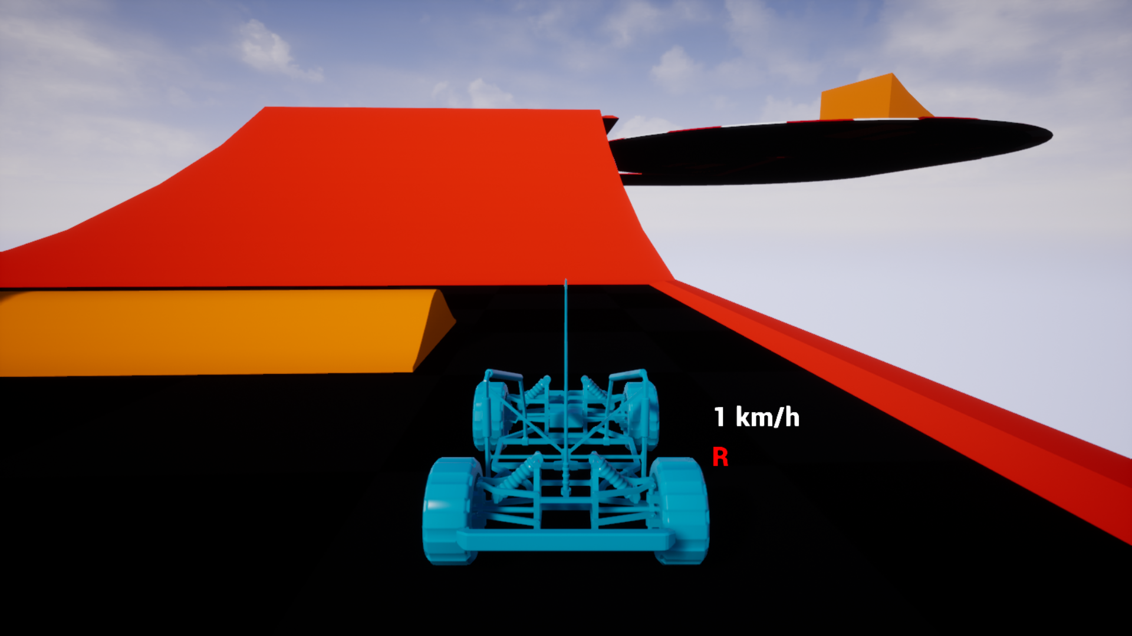

This was another of my 8h projects (however I believe I only spent 4h on this) it had it’s issues particularly the tracks overlapping with one another (sadly I no longer have my backtracking maze however the recursive division method would have also been good)

I could also add vehicles into the platformer where suitable if they would fit in with the game generally, the player might not even have to move something such that everything in front and behind is blurry and there is no need to load more space into the game, such that the player is animated as moving forward but the only places they move is upwards, downwards and sideways, the game only exits within a small area where things are loaded in.(like the player is running on a treadmill and they have obstacles put in front of them.

Another interesting idea might be to also add mini mazes into the game, the algorithms don’t have to be overly complicated something as the recursive maze generation algorithm may suffice.

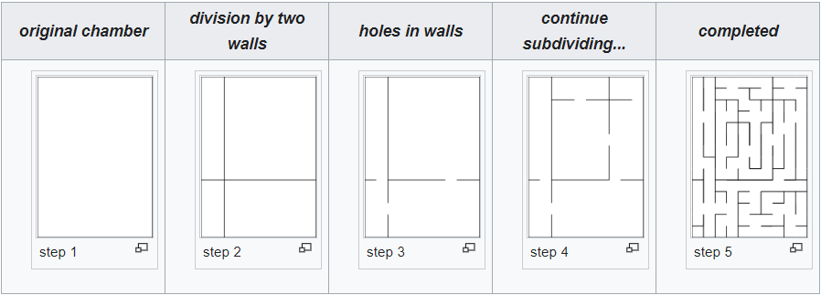

Requirements software and hardware:

I am planning on making the game have more pleasing graphics one way I can do this would be by turning on the built in Raytracing offered by unreal engine therefore preferably a computer with a RTX graphics card will be used by the stake holders however some GTX computers can run ray tracing however a lot more slowly this was done since the expansion in 2019.

Hardware:

1.A RTX or a good GTX graphics card, essentially a graphics card which is able to run ray tracing.

2.A mouse and a Keyboard.

Software

1.It will be able to be ran on Windows/Linux/Mac Os however for the sake of saving time I will only ‘’cook’’ it in windows however Unreal Engine allows it to be compiled on any operating system

2. Unreal engine 4.25 for development however the user will have all the needed code installed in the game file

Features of the proposed solution:

The game will include:

1.Platforms which will delete themselves after the player has stepped off them to allow for better computation.

2.Ai which follows the player and hinders their progress from reaching 100 platforms to be stepped on.

3.3D graphics with in built ray tracing

4.A GUI telling the player how many platforms they have stepped on and their current stats

5.A leader board which saves the scores of the players

6.Due to it being a fast paced platformer I will add aim assist to the player and the player character will lock on to enemy AI once they aim close to them

7.It will be a high polly game with some low polly characteristics to allow for dramatic effects.

## 

## Similar games

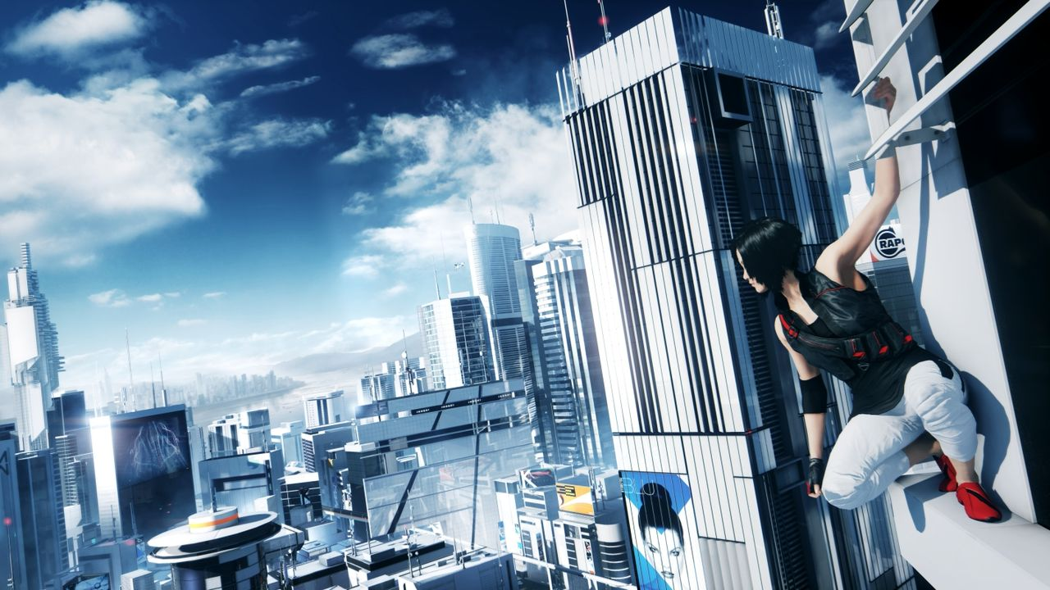

The reason it will be very similar to this game would have to be because it will have the same kind of feel the main thing that made Mirrors edge successful would have to be that it mixed the FPS and platformer concepts very well it allowed the player to use weapons to attack dystopian police officers and at the same time the player could wall run do back flips and just soar across sky scrapers

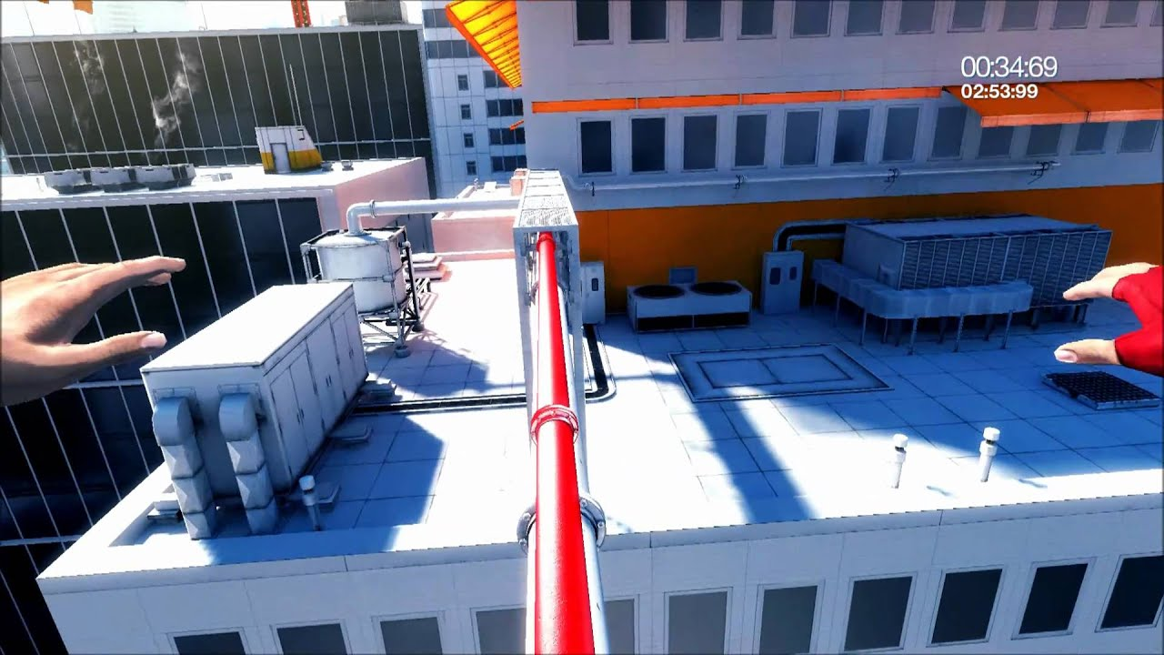

This picture from the gameplay of the game you can clearly see what makes the game stand out the timer makes you tense as you try to go over very unstable obstacles, the scenery of grandiosity is what makes the game great just knowing that you as a player are so tiny and that one little slip up can kill you is what I wish to definitively implement in my game just making the player feel small and overwhelmed is enough to make the player feel as they need to be essentially stuck to the screen so that they can traverse dangerous obstacles.

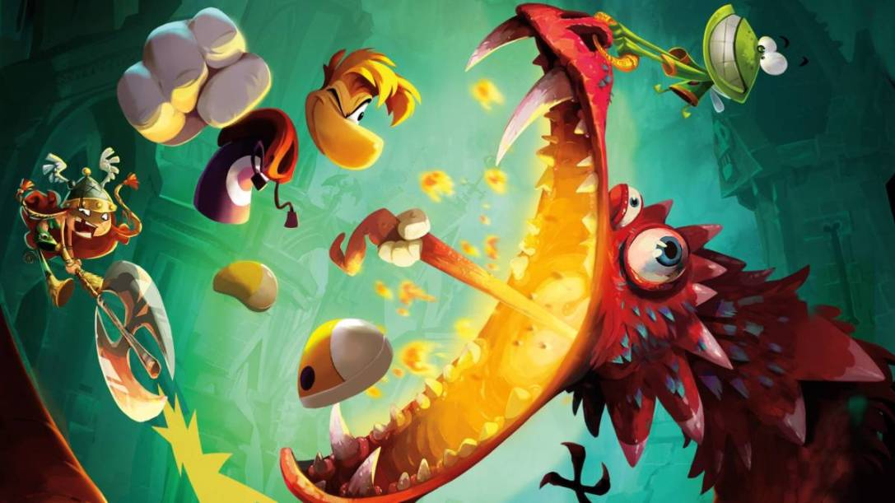

Another Great game would be Ryman’s origins as described by a gaming article:

After taking a weird hiatus to play around with those pesky Rabbids, Rayman returned to his roots in a platformer that captured the essence of the original without feeling outdated. Rayman Origins delighted fans and newcomers to the series, but it was Legends that really found its footing as a vibrant and enjoyable experience.

What starts out as your typical platformer progresses into a much deeper game involving stealth, massive bosses, and complex challenges that will really leave you thinking. Even if there’s one minuscule aspect of Legends you don’t like, chances are a dozen other things will make up for those small missteps.

Another thing that seems to be successful within the platformer industry appears to be cartoon graphics which is one thing I must keep in mind to at least make the platformers a tiny bit light hearted.

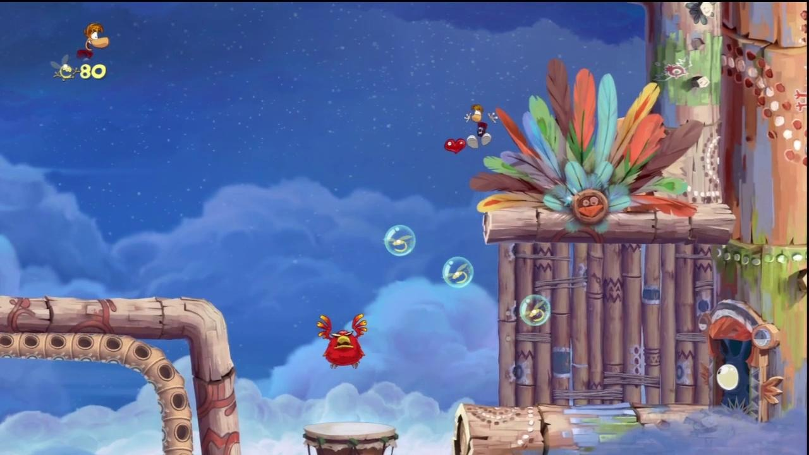

We can see that even in Ryman’s origins we can see the exact same effect as mirrors edge the player character is very very small in comparison to the surroundings, you can barely notice the character when it’s trying to dodge all of the nearby obstacles.

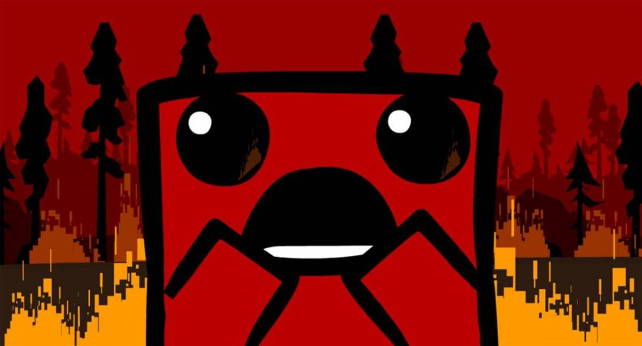

Super Meat Boy is just one of the dozens of punishingly difficult platformers, and while its concept is simple, it stands out among those that tried to do too many things.

In Super Meat Boy, the successor to the popular Flash game, you navigate hazard-filled levels as the titular anthropomorphic slab of meat who’s trying to save his girlfriend, Bandage Girl. It’s a platformer through-and-through that has you dodging obstacles using two mechanics: running and jumping.

The simplicity of it is enhanced by clever and diverse level designs, the inclusion of bosses, fun (and bloody) visuals, and a variety of characters with unique abilities that play off the effective core gameplay mechanics.

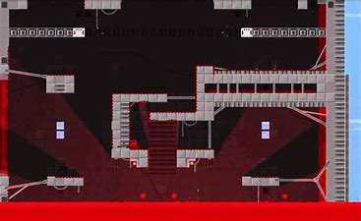

Although both Ryman’s origins and super meat boy have been 2D games they show that it’s sometimes better to offer slapstick entertainment to a video game, their art styles it’s what makes people enjoy them, the idea of a big block of meat slapping along the walls leaving a big fat trail of blood behind seems to be the kind of humour people seem to thoroughly enjoy, for my analysis it is good to include a variance of art styles which would be very good for current and future development.

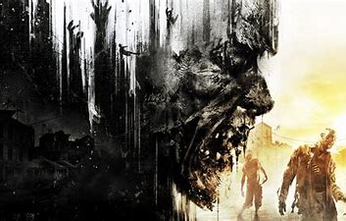

Another Game is Dying light this game offers a different perspective ,rather than it being a simplistic platformer you have to fight through hordes of zombies and use the environment around you to get around and evade as many of them as possible.

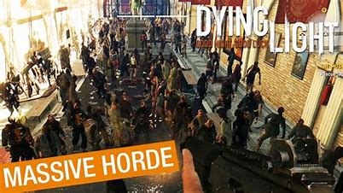

One thing that I will certainly take away from dying light is it’s usage of large onslaughts of zombies, obviously not using zombies however it would be interesting to see if I can implement a game where large hordes of ai’s shoot at you and chase you as you try to jump from platform to platform for dear life, just the idea of having to deal with 10 ai is scary however it would make the game very tense if I added a massive spawn of enemies coming to hunt down the player either by flying ramming or shooting the player, even though dying light gives the player weapons and multiple options to deal with the hordes of zombies it is still very hard to even attempt to avoid or kill all of them and I believe that these are some upmost important features which should be implemented in the later game .



Another Game would be limbo what makes special in that while it does not wholly depict that mysterious dimension as my mind did, it captures its essence. You are a boy who wakes up in a lonely world made up only of black, white, and shades of gray. Video game logic demands you walk from left to right, jumping over obstacles as they appear, a simple task that needs little attention in the initial moments. This is your chance to absorb your surroundings. The background provides an illusion of depth, but its branches and bridges are out of focus, as if you are dreaming them into existence. The pint-sized hero, his bright blinking eyes shining from his blackened silhouette, trots ahead with the charming gangliness of a six-year-old.

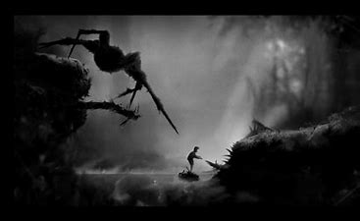

One thing I must say about limbo is that it is very good at implementing the feeling of eeriness into the player, not knowing what will happen next or what will happen next is scary, for me to actually implement this would be a very hard task however it would be fun to implement this in future development of the game.

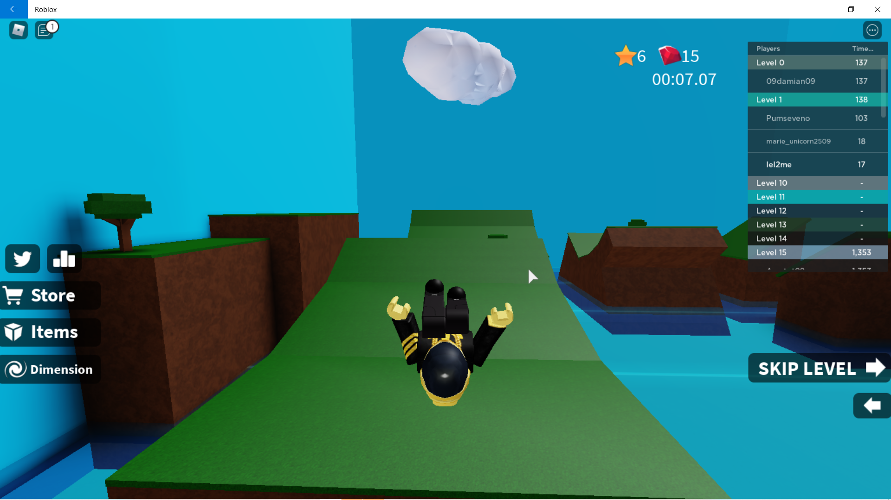

I personally play Roblox very often and I am very used to the movement system of the game the picture from above is of me playing their speed runner game it is a thoroughly enjoyable game and at times challenging, I am 100% planning to implement the exact same movement system inside my game this will be where the player camera can move around freely and the character is not only viewed in 3rd person but also controlled in 3rd person this means that even though the camera looks in a opposite direction the character moves forward in the direction that it was facing, I believe that this is also a very easy system to generally master and learn from as Roblox itself was designed to be very simplistic.

### Features to be implemented from other games:

As I said I would like to implement the motion system similar to a lot of motion systems on the Roblox gaming network as I explained it will all be from a 3rd person motion system and a 3rd person point of view, however when it comes to the graphics system due to the nature of the program I do not suspect this to be a very viable thing to achieve as asset creation is lengthier than actually coding the solution, this solution will be the bear bones which can be used to create multiple fun universes, more or less creating a very simple to use template which when aided by a artist or when there is more time a good graphics system can be implemented, I certainly want to implement two more features, one is to make the game simply feel grandiose making the player feel genuinely small and another one is to add hordes of ai to chase the player down, this will be perfect at making the game a genuinely fun and intense game the idea of being overwhelmed by massive hordes of ai has always interested me and it certainly captures the hearts of consumers.

Success criteria

|  |
| --- |
| **The ability for the player to actually play the game e.g. it can be cooked and exported as a actual game** |
| **A player character which has the ability to move around in numerous ways: eg: dashing jetpack running etc.** |
| **Enemy ai which have a big variance in what they do from aiming and shotting down the player with projectiles to actually ramming the player** |
| **A platform which spawns in other platforms which may or may not spawn in with pick up items** |
| **A weapon which the player can use to deal with enemy ai.** |
| **A save algorithm** |
| **A reloading mechanism with animation** |
| **Informative information for the player to get some understanding of the game out of** |
| **A purpose to play the game** |
| **The ability to change Key bindings** |
| **The ability to change the difficulty** |
| **Appropriate animation** |
| **The beginning of implementing models into the game** |
| **The ability to play iteratively( doesn’t close goes back to main menu so player can play again)** |
| **Death screen** |
| **The game has the ability to be developed e.g. new features would make sense to be added to the game it isn’t just a dead end** |

# Problem Justification

The point of this game will be to offer something the market has not had too much off, we have seen different video games like Dying light and Mirrors Edge but we haven’t yet to seen a more light hearted type of video game that is at the same time challenging, both of those games have a harsh sad setting, currently the games out there are either light hearted easy platformers or hard and sad tone games.

The implementation of a game which also has the light hearted fun components of things such as Mario but also has the hardness of Dying light is what I believe that this market needs. My stake holders have gotten bored of these two repetitive genres and I believe that this game will be able to fill this gap in the market.

This game would also allow the difficulty of the game to be set more dynamically, this will be done by allowing the players to set the amount of enemies spawning and their strengths etc to be set on a side settings menu, this will allow the game to feel more dynamic and it will make sure the player doesn’t get too frustrating, however at the same time it will also give the option to chose from given templates which will have their own values which I would have set by calibrating each part of the game in developmental testing and beta testing when I hand my game to some stake holders.

The game will also have the option to save the high score for each type of game and every time of setting, this will allow the player to not have to take pictures of their score etc which is a much needed function which is within every modern game.

### Essential features

1. The game must contain advanced movement, this means the player must have at least more than 3 types of movement, e.g. Jetpack, double jump, roll etc
2. The game must have a light hearted light design to it
3. At least 3 preferably 6 enemy ai’s

The game must be somewhat relatively the same as a lot of modern games, it has been shown time and time again that the games that succeed the best have familiar weapon systems, most players skip tutorials so it is of upmost importance to at least make the game somewhat familiar to other games in the market.

However the most essential features are to make the game actually enjoyable so I will fill the game up with multiple types of movement systems and weapons systems, a saving option should be added, this could be something like auto saving which the game is saved after the player plays, other things that are essential to this games success is a working platform system, it would be silly to make a platformer game without a proper platform generation algorithm.

Limitations of the game:

1. The game isn’t the type of game you would play if you wanted to play multiplayer as it is mostly centred on dodging ai rather than the fighting style between people
2. It will not have the same level of challenge as games as halo, if it did I would have to cancel the creation of the Jetpack
3. Even the easiest mode might actually end up being too hard for some people

-------------------------------------------------------------

# Design

The following list contains things I will include in the video game, this is only a rough Idea of the things that will be in, throughout development I will be taking out parts of the project. The game will all be made in Unreal Engine this will include a mixture of C++ code and some Blueprint code which is a Visual Scripting language it will allow me to code a lot more code on the sad loss of some performance however the use of this will be limited, it will only be majorly used for programming things such as animations ect.

To make everything work I will include built in object orientated programming into my design, within unreal engine you can use things such as Actors which are essentially separate files which work exactly like objects.

Design Objectives.

### 1.Aesthetics

General features:

1.3D graphics

2.Cartoony aesthetics with a little bit of realism( low polygon textures)

3. Possibly turning on raytracing for higher quality shadows

4.Ambient colours, very reflective colours everywhere maybe even Vapourwave

Main menu:

1.Exit game button

2.Choose level button

3. Settings button

Settings menu:

1. Ability to set key bindings
2. Ability to change the colour of Post Processing tint
3. Ability to reset game data like personal high scores
4. Ability to set master volume
5. Ability to change font size( for visually impaired people)
6. Ability to set sensitivity

Level select

1. Ability to set difficulty
2. Ability to select level
3. Tells you your high score per level

In Game screen:

1. Shows health points
2. Icon for currently equipped weapon
3. Ammunition within mag and max ammunition
4. Stamina points shown
5. Jetpack fuel tab
6. Current score
7. High score
8. Objective tab
9. Mini-map

Pause screen:

1. Leave game button
2. Restart level
3. Continue game

Death screen:

1. Main menu
2. Restart Level
3. Leave Game

Help section:

1. Option to go through tutorial
2. How to Tabs

### 2.Game Functions

Ai:

1. It will all be floating no need of nav mesh
2. Make Different types

Berserker:

HP: 300

Attacks: Rams into the player trying to push him off resemblance will be of a boxing glove with a rocket at the bottom.

Weaknesses:

It will be rather slow allowing the player to dodge it with ease

Archer:

HP:50

Attacks: shoots different kinds of projectiles which are high damaging, the

Archer also has high movement speed

Weaknesses:

Low health

Boomer:

HP:200

Attacks: Is highly quick and runs into the player exploding itself to kill the player

Weaknesses: It has spots which can be shot to prematurely explode the boomer

However radial damage is still given to everyone around it

Dropper:

HP: 400

Attacks: drops obstacles in the way of the player like explosive barrels

dropping out the sky

Weaknesses: shotting the drone when it’s hole where it drops the obstacles -----------------------------------out of will do critical damage to it (3x the damage)

2.Player movement

1. Jet pack with limited usage which replenishes

2. Double Jump

3. Running ability which has a stamina limitation

4. Repulsion from being exploded

3. Weapons

1. Assault rifle with the ability of Auto and Semi-Auto Fire

2.Hand guns with both Auto and Semi-Auto Fire

3. RPG’s which cause area damage

4. Ability to aim weapon using a scope or iron sights

4.Camera

1. Ability to change from first to third person

2.Hit markers and sound when a actor has been shot

3. Score changes on the main game widget

### 3. Data handling

High score:

1. The ability to save the persons high score according to each level
2. The ability for the player to see the amount of times they have died
3. The ability for the player to see how many enemies they have killed

Key bindings variables:

1. Every key binding such as attacking, jumping to be saved under a global array which will allow the player to set their own buttons for movement however pre set values will already be there

Variables:

1. Usage of global variables must be high limited and only to be used in the events where certain values must be accessed around the entire code, e.g. key bindings etc
2. Variables must have clear and legible names and the usage of Camel Case notation must be used
3. Values that don’t change must be saved as constants, this can be things such as the chance of a Ai spawning, this would be useful for post development testing where we want to make the game fairer
4. Arrays to be used where needed rather than hardcoding many variables
5. Variable usage must be kept low and every new variable made must be justified

Functions:

1. Functions should be made global where possible however with this kind of project it may be a bit harder as everything serves a different function

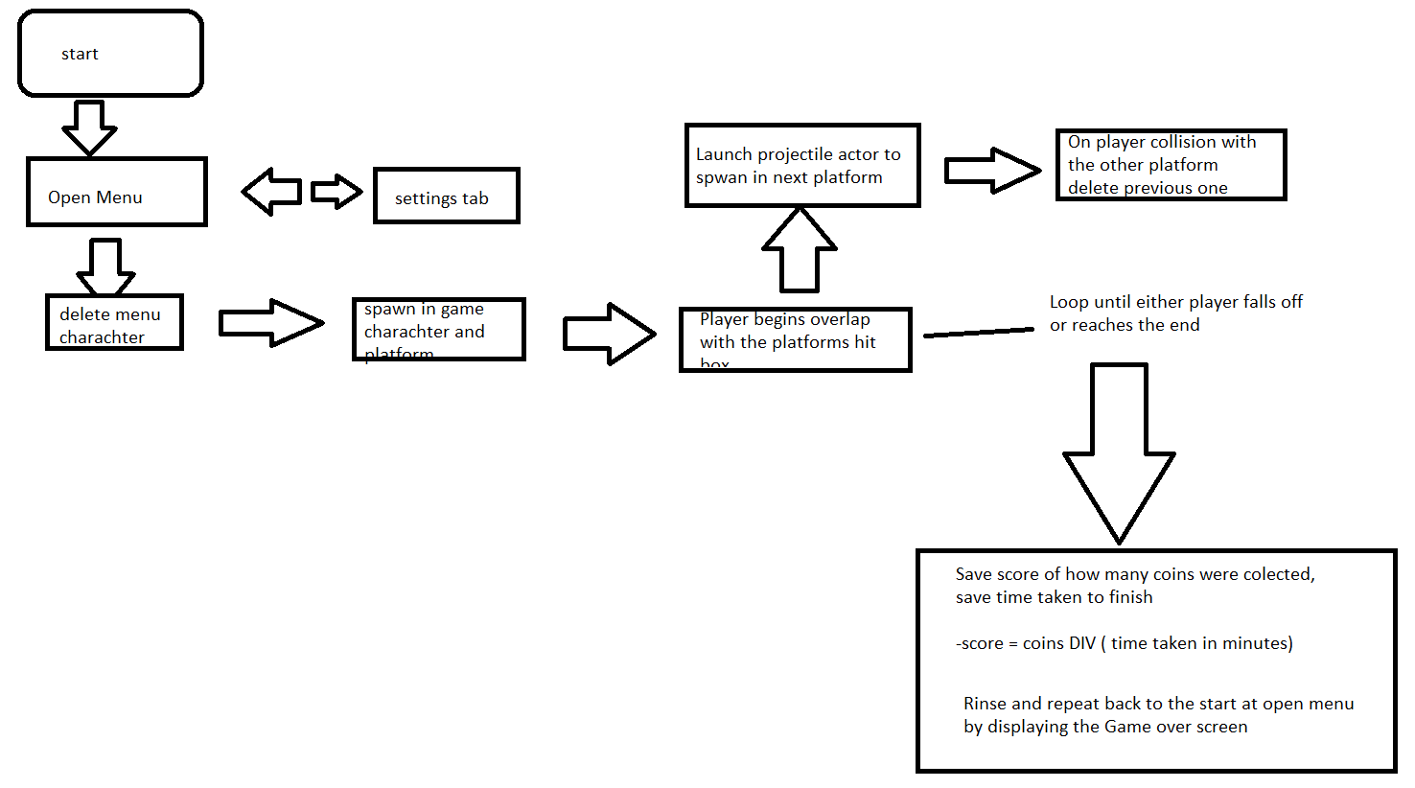

# Game Design

## Camera Change:

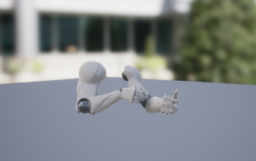

A very common thing in video games to allow for the First person and third person transition to be smooth is that the player can see their entire body in third person however once in first person the character disappears and only the arms are visible.

Blueprint is a very good prototyping language, the below blueprint code is representing the method of switching cameras

--------------------------------------------------------------------------------------------------------------------------

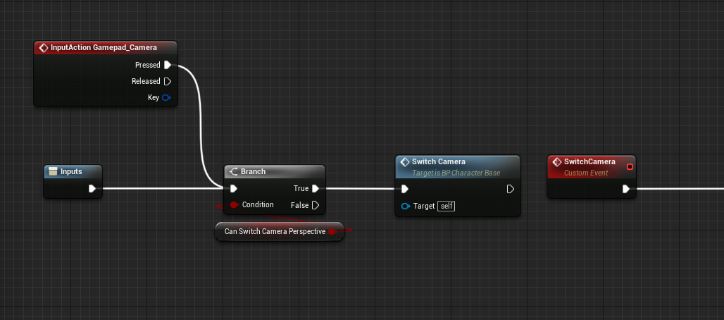

This piece of code acts as a verifier , the entire piece of code is within a function so it must be sure that it has been called correctly and it doesn’t just randomly changes the perspective of the player this is done by a branch operation which is like a if statement in normal code, if it passes the check than it calls the custom event switch camera

--------------------------------------------------------------------------------------------------------------------------

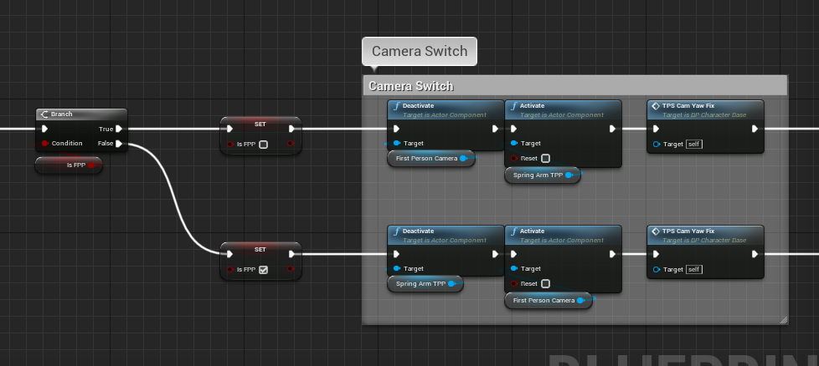

This is the Camera switch it checks with the branch statement if the Camera is in FPP which is a term used to say first person in Unreal Engine it then goes through a flip flop which essentially set’s that the camera is now in First Person in the case that the variable was false essentially being a Boolean flip flop after that it Activates and deactivates each Camera respectively

--------------------------------------------------------------------------------------------------------------------------

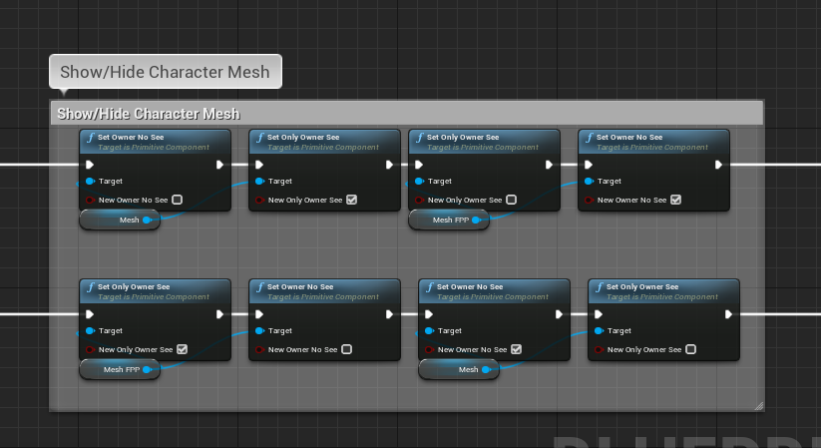

This simply sets each player mesh to visible or invisible this is so that both models aren’t loaded in which would cause a overall in the animation

--------------------------------------------------------------------------------------------------------------------------

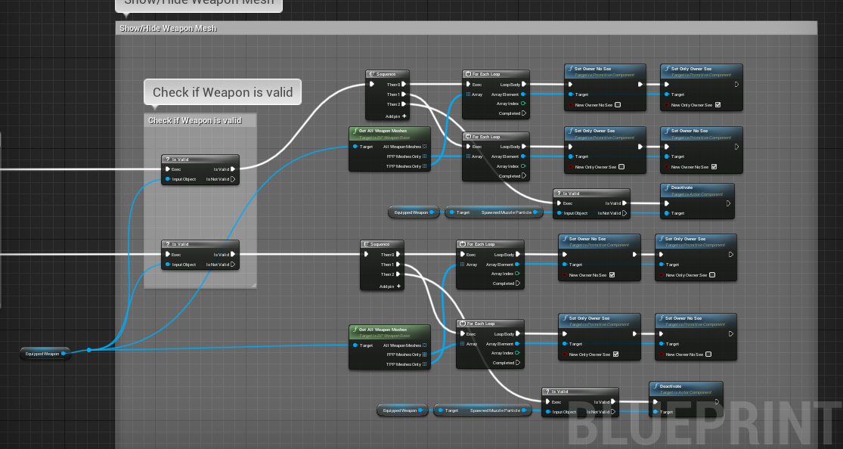

The amount of code here is non entirely necessary for our solution however essentially what is happening is that it first checks if the chosen weapon actually has a weapon type essentially do we have a object with the class type Ak shotgun etc then it goes through a for loop checking for if the weapon is a model for the FPP(first person) or the TPP(third person) model types and then set’s that meshes visibility in game

## FIRING/WEAPONS

# Firing

Seeing as we were talking all weapons should follow this model

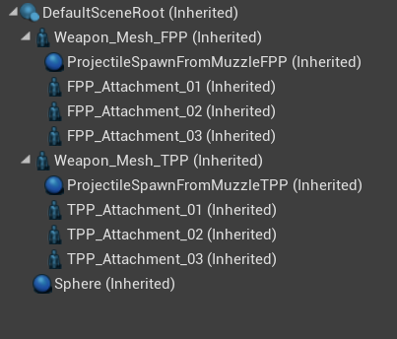

It is essential the make up of the physical areas of the weapon the muzzle where the sparks and the bullets come from, this was encompassed by a sphere and they will all spawn from the positive X axis direction of the sphere, the other attachments are where the hands attach to or from where gun cartridges are expelled from.

--------------------------------------------------------------------------------------------------------------------------

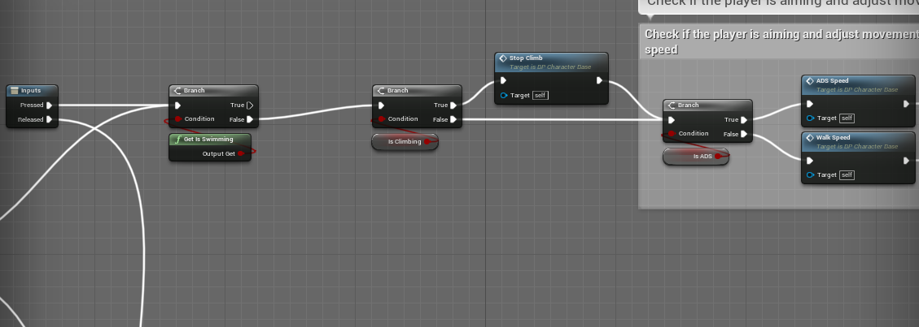

The first area is a simple area which adjusts things such as aim down sight speed and walk speed due to the beginning to fire the weapon this if further broken down

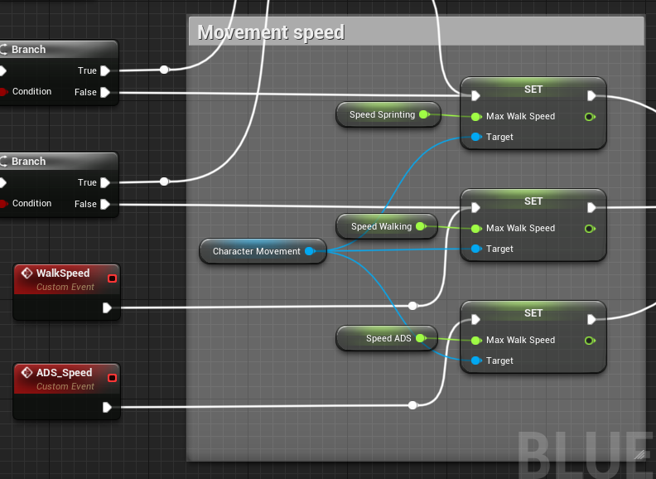

Both walk speed and ads speed are functions which can be called to set the walk speed accordingly.

--------------------------------------------------------------------------------------------------------------------------

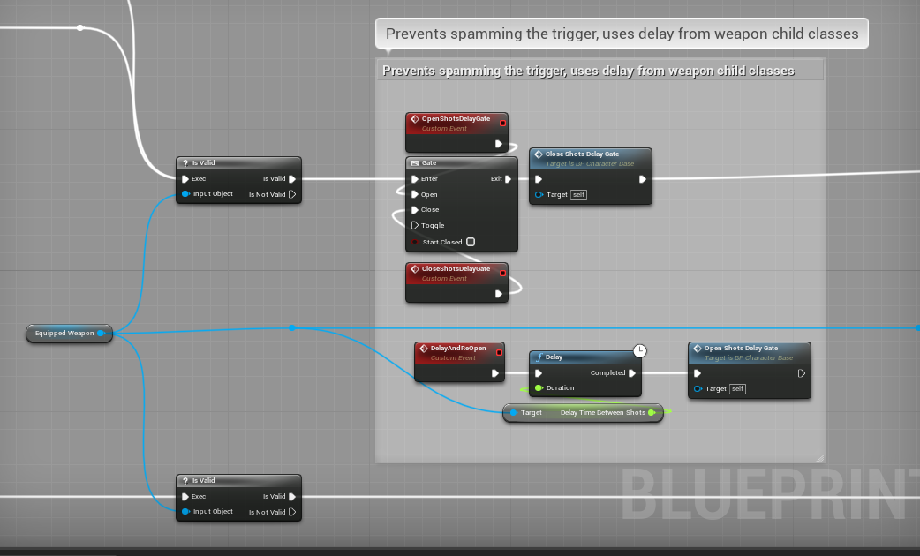

What you can see above is a gate which is a kind of If like statement it essentially stops the flow of the flow chart, this is so things such as auto clickers are used to cheat and make the shooting faster

--------------------------------------------------------------------------------------------------------------------------

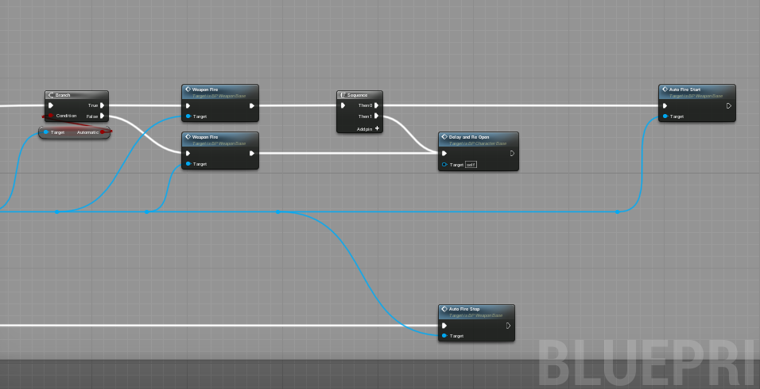

Here we have the piece of the chart where the weapon is being fired we also have a check to see if the weapon is automatic or semi automatic, then if the weapon is automatic after the weapon has been fired it will re open the gate, one nice thing about unreal engine is that you can make function events which stay on as long as a button is held down so as the left mouse button is held down the flow of the code will constantly go through the same steps, this also makes the piece of code extremely dynamic as it works as different things change, we can also see at the bottom that the piece of code has a stopping piece of code this is once the original left mouse button function is released

## Reloading:

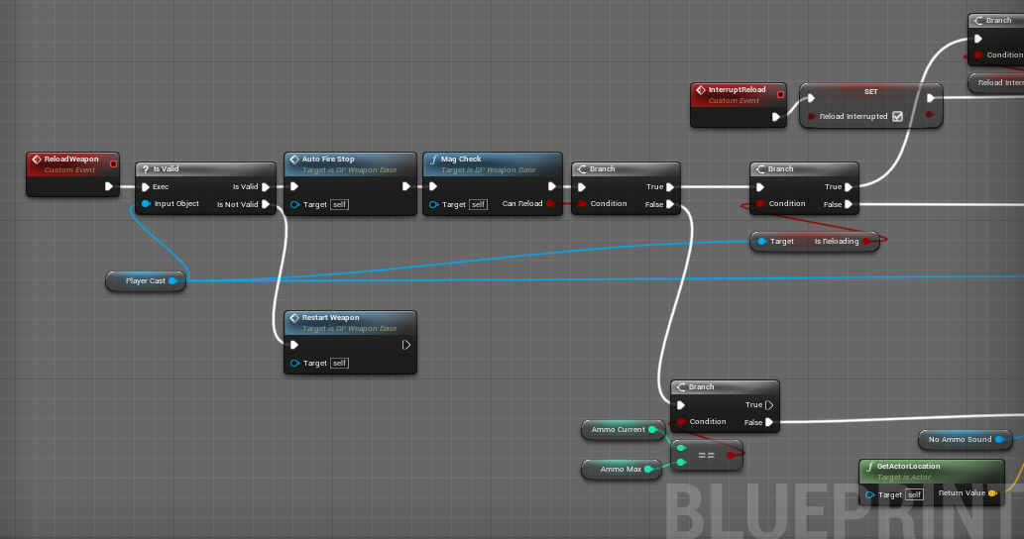

For the first bits it checks the amount of animation inside the magazine and it also stops guns from firing good that we used a function earlier to stop the gun from firing because we can now use it again 😊

--------------------------------------------------------------------------------------------------------------------------

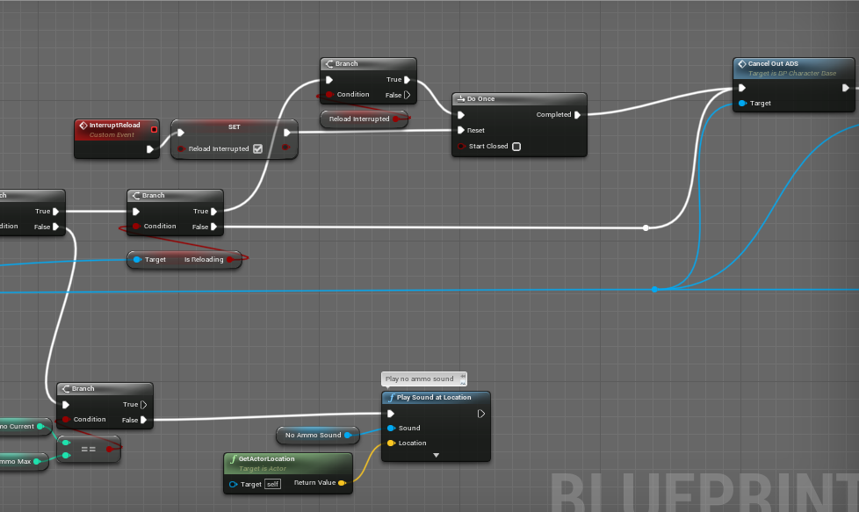

This area just plays a sound if the player doesn’t have anymore extra ammunition and it also turns on the variable is reloading which stops overlapping events from occurring.

--------------------------------------------------------------------------------------------------------------------------

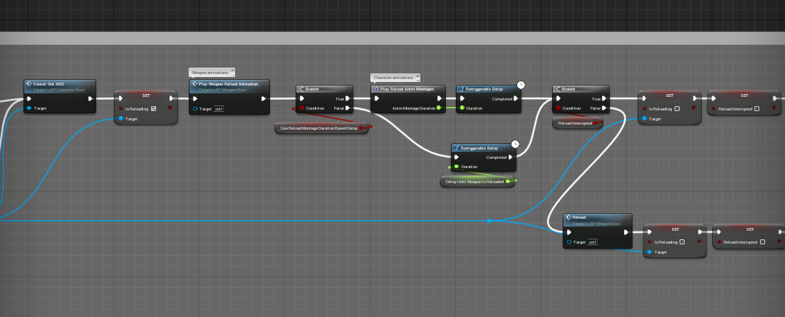

This area contains the steps of actually reloading and playing the reloading animations

--------------------------------------------------------------------------------------------------------------------------

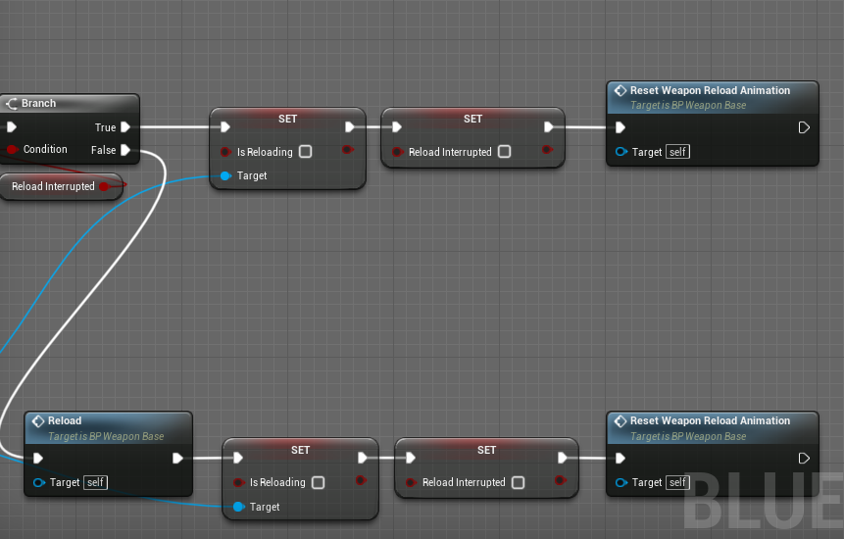

This area turns on the previous variables used to stop other events happening and it resets the mesh back to it’s non reloaded step

## Aiming:

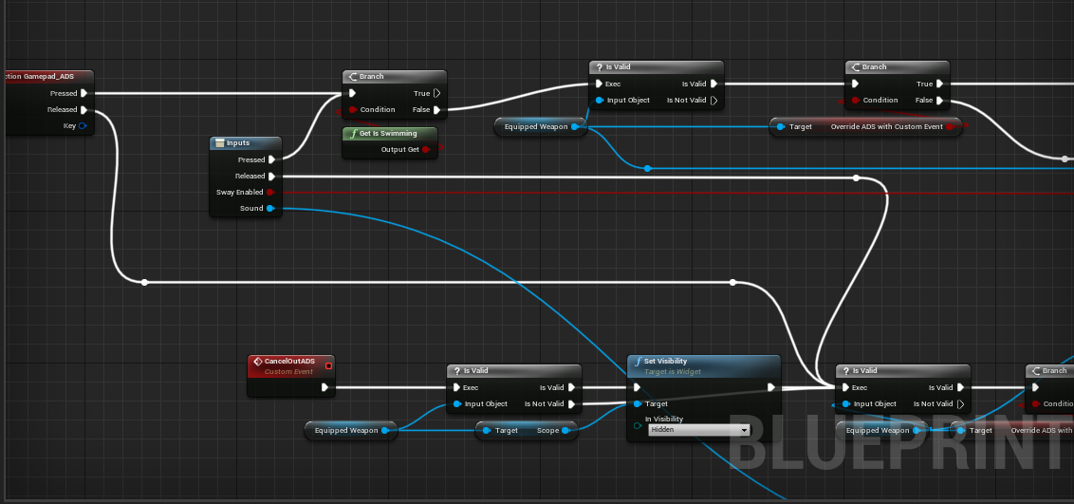

This area checks for events that might cause the aiming down sight to be impaired due to other events

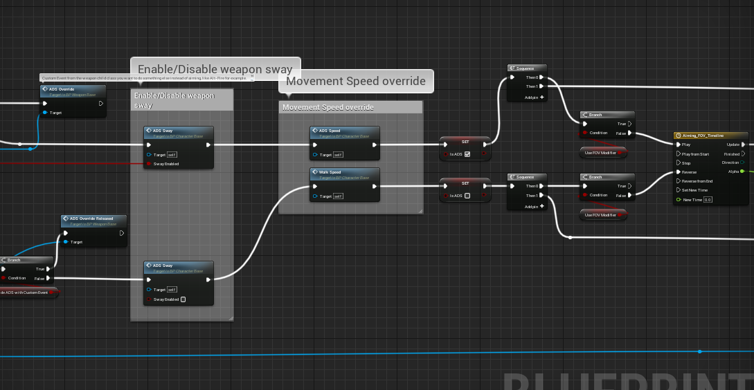

These are the given variable events that must happen such as setting the speed and the actual sway animations to happen etc adding a more realistic feel.

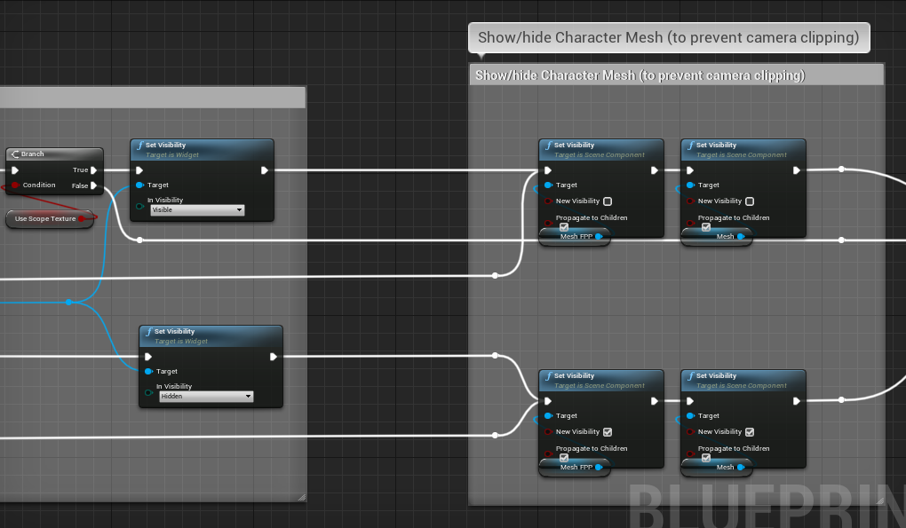 this is the area where the visibility of the character is somewhat adjusted to prevent camera clipping

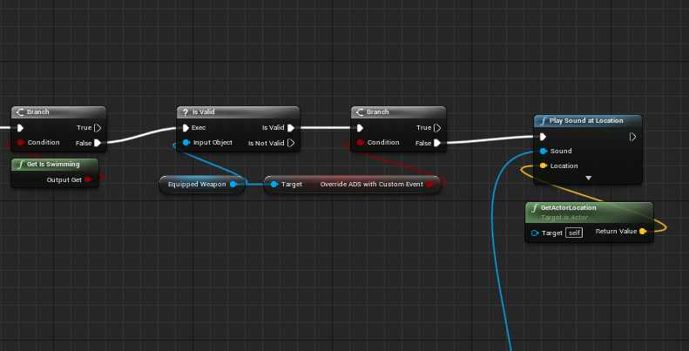

This is the final bits of the aiming down sights area things like scraping noises are played to make the game just appear a lot more realistic

### Proposed gun models:

Shotgun:

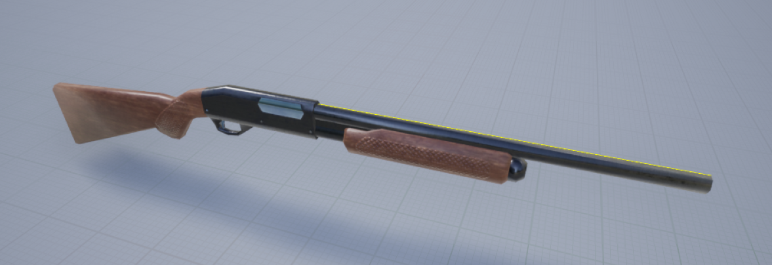

Assault Rifle(Ar-15):

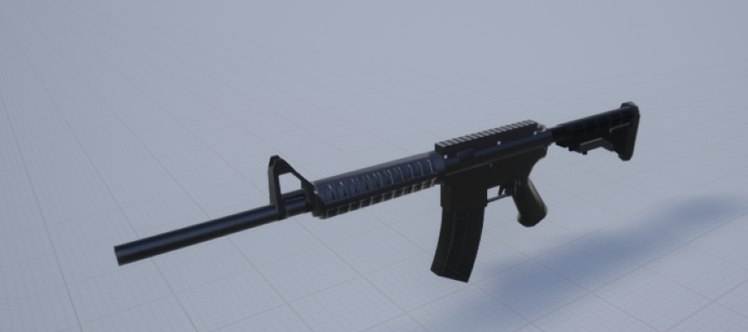

RPG:

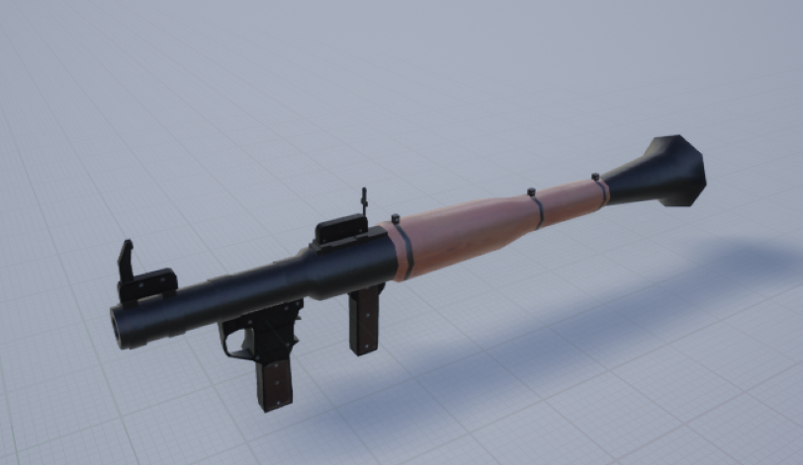

Desert Eagle:

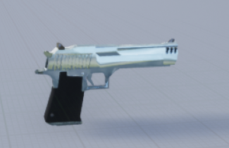

Some iterations that were rejected by my stake holders were:

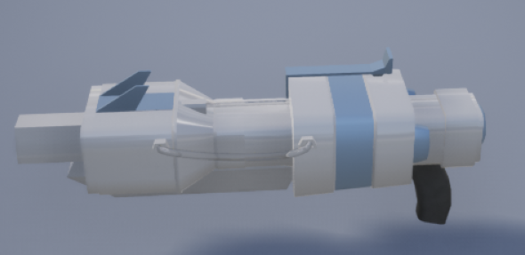

They wanted the game to have more modern weapons they weren’t big fans of the more futuristic designs, they thought it would be weird having a mix of both futuristic and modern

It was either one or the other

Animation:

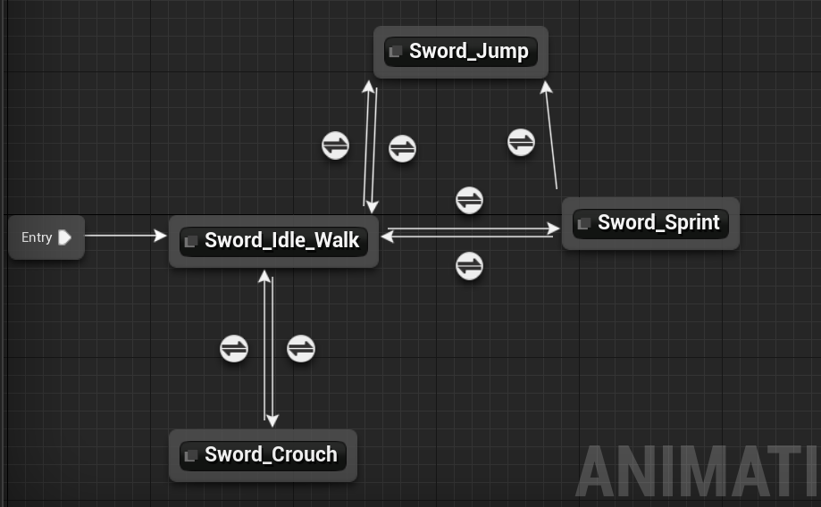

All of my animations will be done within animation blueprint containing state machines these state machines essentially have if statements per say which allows the mesh to change from one animation to another animation these variables and if statements are taken from the main blueprint area which “casts” to other flies, this is in order to take variables from them

## Props:

Explosive barrel:

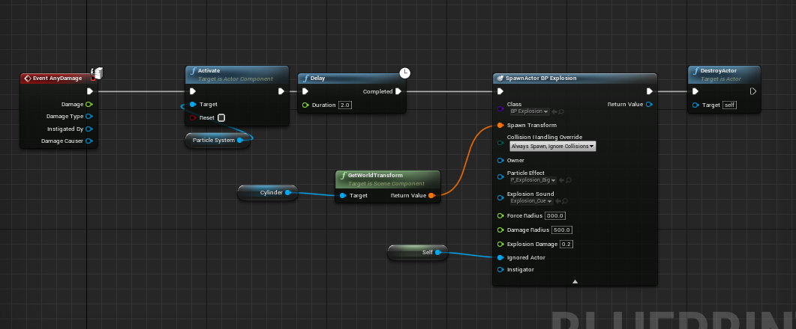

This is a explosive barrel it first plays a explosion particle system it then spawns in a explosion actor which does radial damage to it’s surroundings this is good because I can use the actors radial damage for more thing’s like a RPG or a grenade etc which saves on the amount of code used.

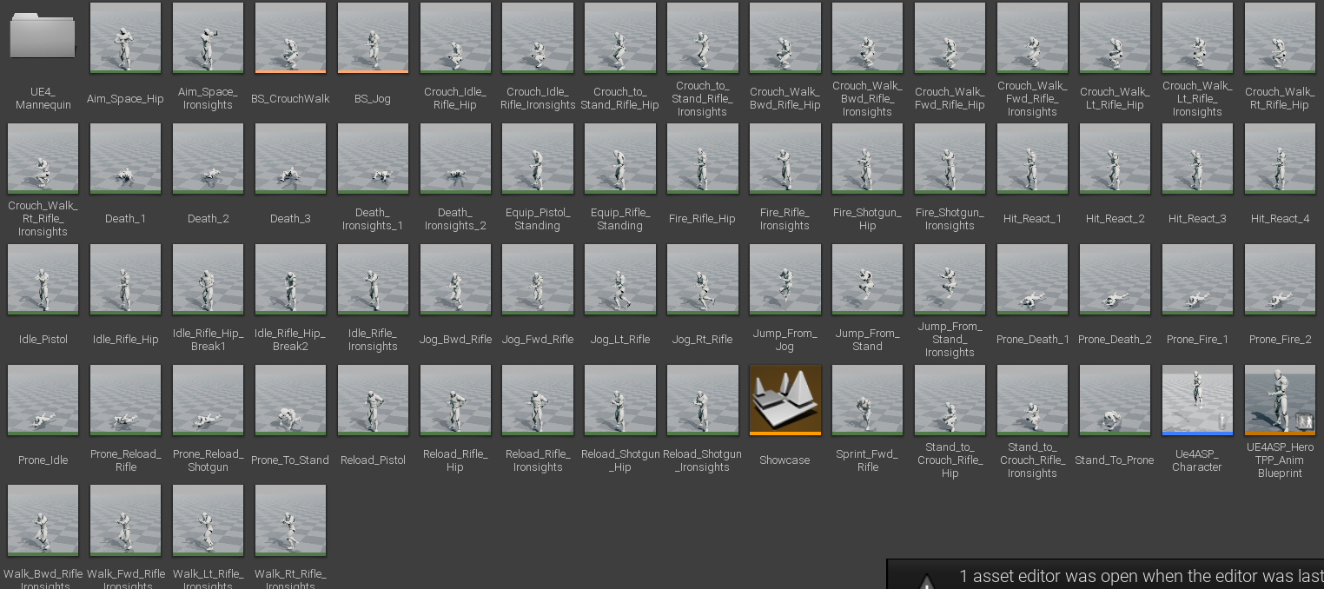

These are all the animations I got from the Epic Games store I will retarget them to the main character skeleton allowing the animations to be played on a different model.

Item box:

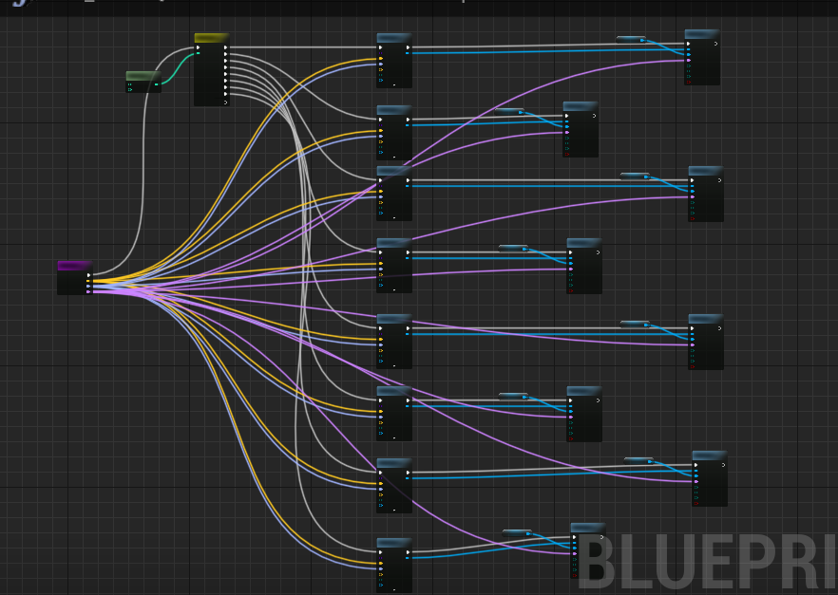

This is a item box which uses a random number faction to decide which item it will spawn in

Based on the number randomly generated the first function at the start simply takes in the different kinds of coordinates needed to spawn it in.

Door:

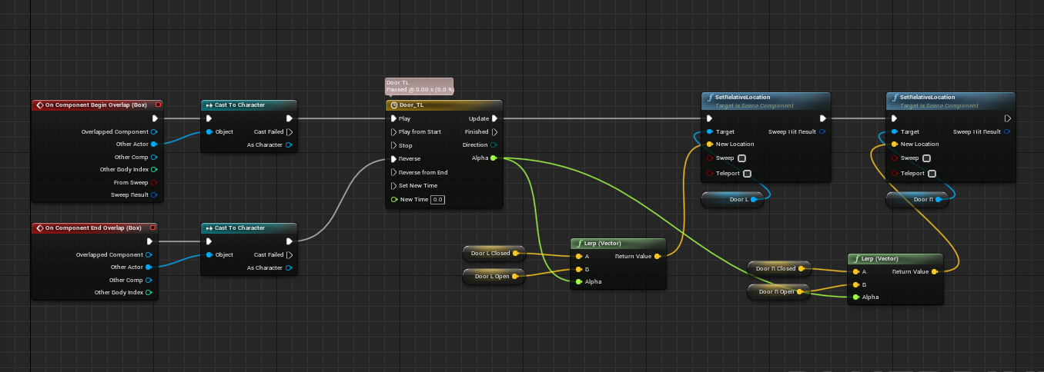

Simple sliding door algorithm which on overlap with box collision component it displaces the door.

Launch Pad algorithm:

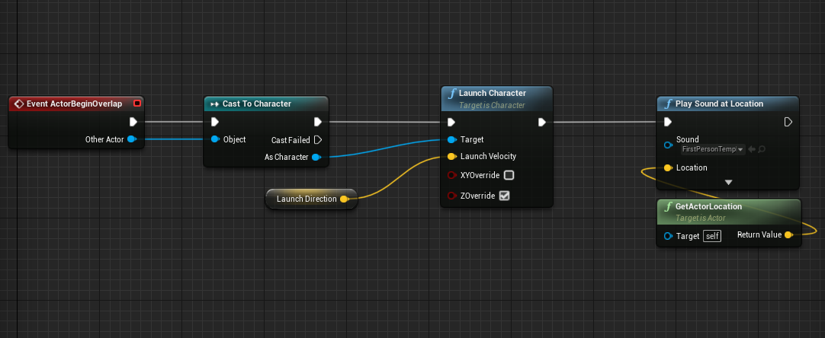

simple launch pad algorithm which launches the player character towards a given location which can be a landing pad.

Teleporter Algorithm:

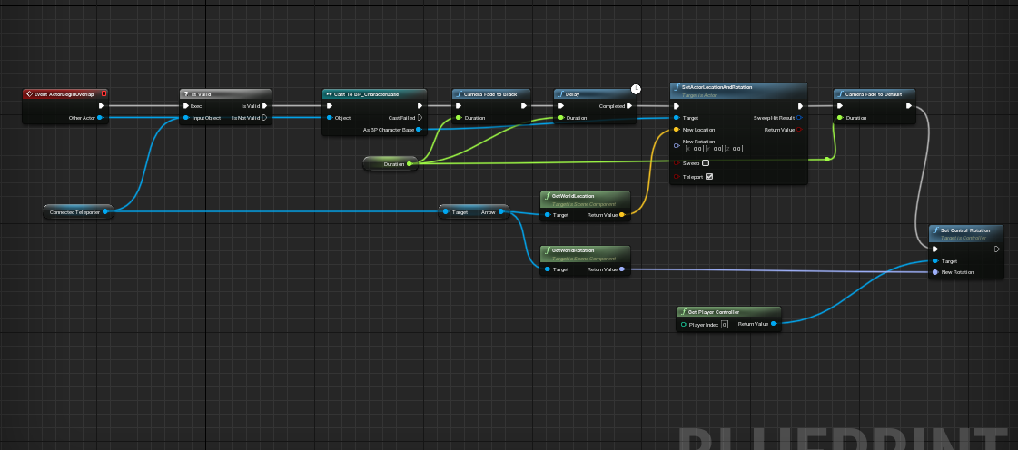

This is a simple teleporting algorithm which takes the player character through a teleporter and sets the characters rotation to what it should be on the other side of the teleporter.

## User Interface:

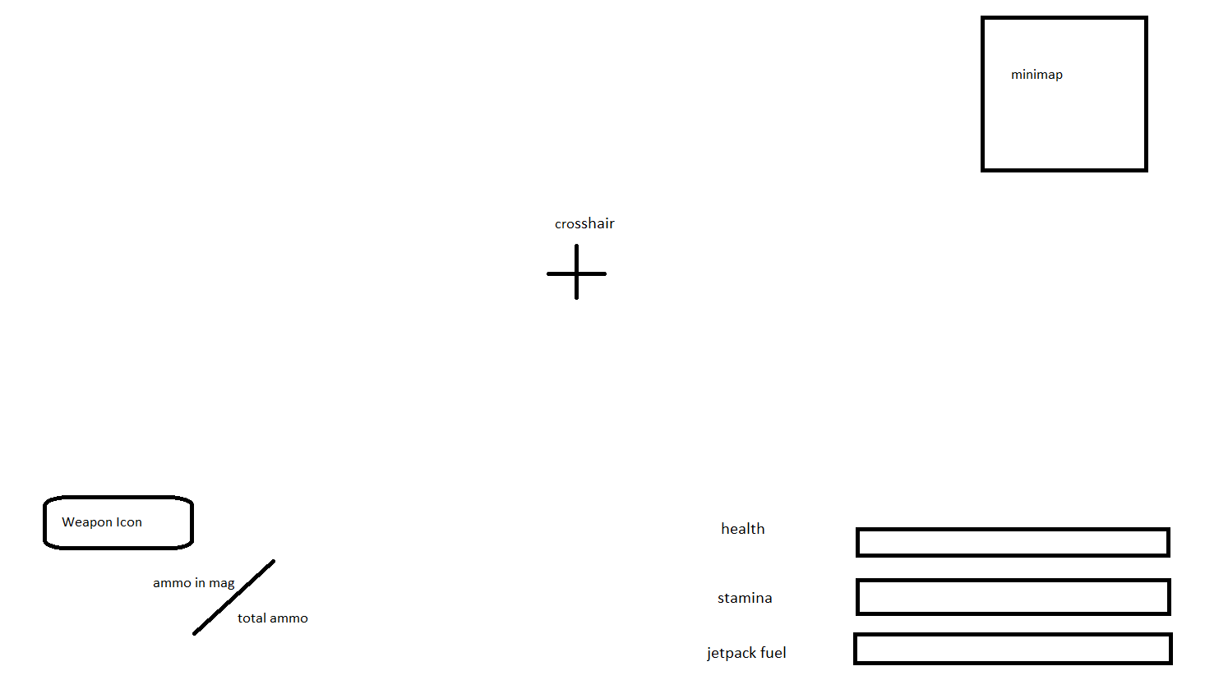

This is the general way that the UI is going to look in game

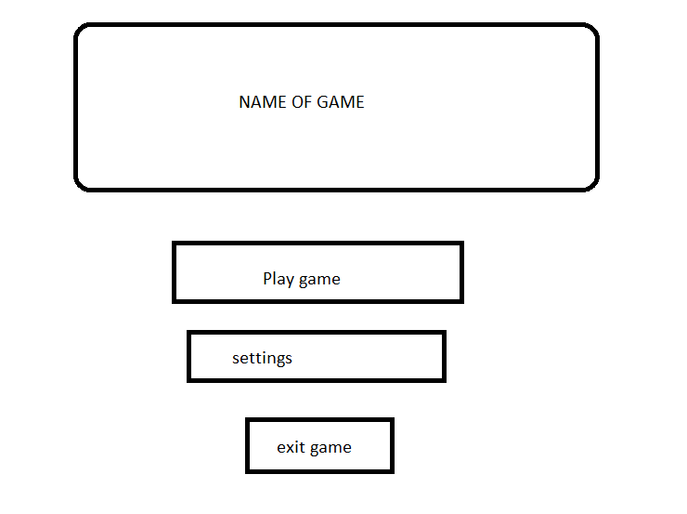

This is the main menu UI

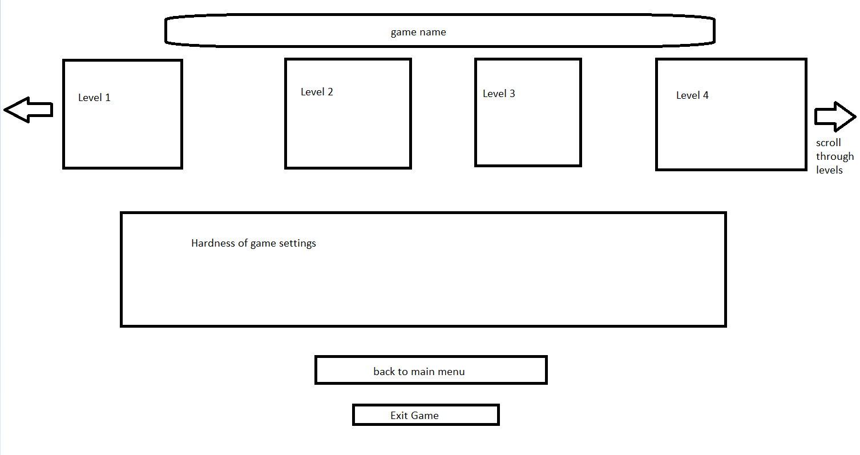

This is the level select screens

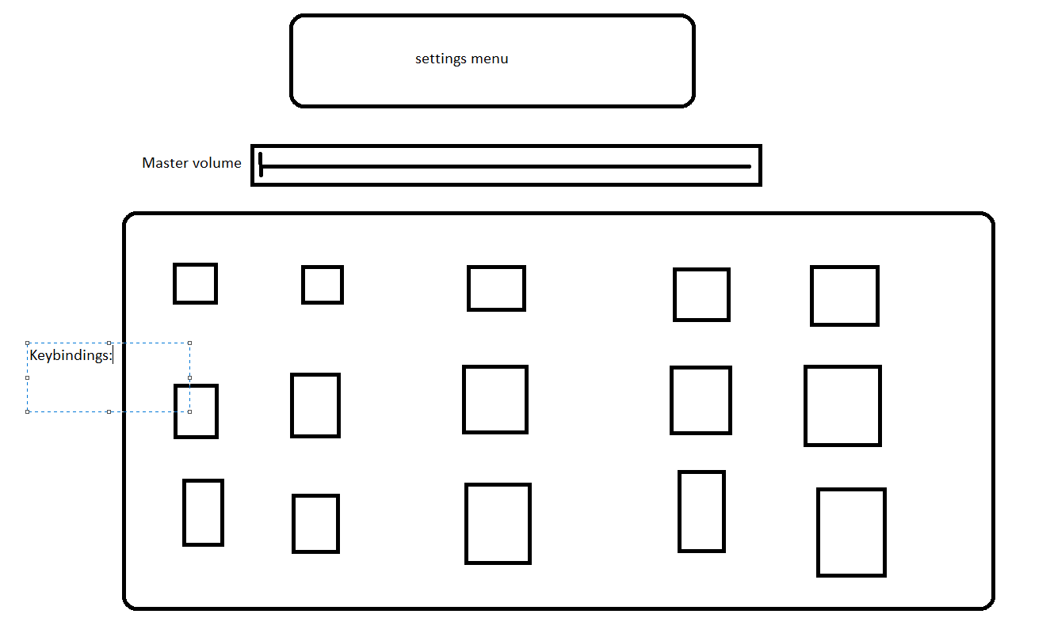

This is the settings menu UI

## Explanation and justification of my method

The project will be broken down into separate parts I will use decomposition by creating multiple functions to serve my method, this will allow for code reusability and it will allow me to create a game with less lines of code, not only this but as you have seen from previous examples that I can cancel functions which allows my code to be more dynamic and adapt to the situations.

Why functions are useful:

* Organization -- As programs grow in complexity, having all the code live inside the main() function becomes increasingly complicated. A function is almost like a mini-program that we can write separately from the main program, without having to think about the rest of the program while we write it. This allows us to reduce a complicated program into smaller, more manageable chunks, which reduces the overall complexity of our program.
* Reusability -- Once a function is written, it can be called multiple times from within the program. This avoids duplicated code (“Don’t Repeat Yourself”) and minimizes the probability of copy/paste errors. Functions can also be shared with other programs, reducing the amount of code that has to be written from scratch (and retested) each time.
* Testing -- Because functions reduce code redundancy, there’s less code to test in the first place. Also because functions are self-contained, once we’ve tested a function to ensure it works, we don’t need to test it again unless we change it. This reduces the amount of code we have to test at one time, making it much easier to find bugs (or avoid them in the first place).
* Extensibility -- When we need to extend our program to handle a case it didn’t handle before, functions allow us to make the change in one place and have that change take effect every time the function is called.
* Abstraction -- In order to use a function, you only need to know its name, inputs, outputs, and where it lives. You don’t need to know how it works, or what other code it’s dependent upon to use it. This lowers the amount of knowledge required to use other people’s code (including everything in the standard library).
* Statements that appear more than once in a program should generally be made into a function. For example, if we’re reading input from the user multiple times in the same way, that’s a great candidate for a function. If we output something in the same way multiple times, that’s also a great candidate for a function.
* Code that has a well-defined set of inputs and outputs is a good candidate for a function, particularly if it is complicated. For example, if we have a list of items that we want to sort, the code to do the sorting would make a great function, even if it’s only done once. The input is the unsorted list, and the output is the sorted list.
* A function should generally perform one (and only one) task.
* When a function becomes too long, too complicated, or hard to understand, it can be split into multiple sub-functions. This is called **refactoring**.

## Validation methods

|  |  |
| --- | --- |
| Validation Method | Description |
| Range Check | Checks the data falls between an acceptable upper and lower value, within a set range |
| Type Check | Checks the data falls between an acceptable upper and lower value, within a set range |
| Length check | Checks the number of characters meets expectations, e.g. an 8 character password |
| Presence check | Checks that the user has at least inputted something, stopping them from accidentally entering nothing |
| Check digit | An extra digit added to a number which is calculated from the other digits, this ensures the rest of the number has been entered properly |

I will make sure that every function is validated so that all the parameters given to the piece of code are not only relevant but also allow the code to continue.

## Testing methods

Every function will be tested separately to be checked if it works, the entire project will be decomposed separately into different parts, this will be useful for us later as it will allow to cancel these functions later in the code if we need to stop them happening during certain events.

My testing methods will first start by doing developmental testing, this is when I isolate one function, we will then move on to Beta testing where I hand my game to some stakeholders and they have a try at the game, this will give in great insight to what is good and what needs to be thrown out of the game.

These are some examples of test types

* **Unit testing:**Developers test the most basic parts of code like classes, interfaces, and functions/procedures. They know how their code should respond and can make adjustments depending on output.
* **Component testing:**This step is also known as "module" or "program" testing. It’s similar to unit testing but contains a higher level of integration. Modules of the software are tested for defects to verify their individual function.
* **Integration testing:**This identifies errors when the modules are integrated. Different methods for integration tests include "bottom-up", "top down", and "functional incremental".
* **System testing:**Components of a project are tested as a whole in different environments. System testing falls under the black box method and is one of the final tests in the process. It will determine if the system is prepared to meet business and user needs.
* **Alpha testing:**Internal staff test the software at the developer’s site in a simulated or actual environment. After that, developers rectify bugs and other issues.
* **Beta testing:**Also known as field testing, clients test the product on their own sites in real conditions. Clients may offer a group of end-users the opportunity to test the software via prerelease or beta versions. Feedback on possible improvements is then sent to the developer.
* **Acceptance testing:**Also under the scope of black box testing, clients test software to find out if the developer has fully developed the program to fit desired specifications.

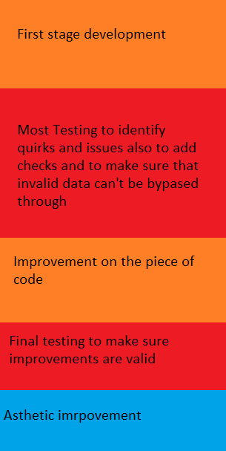

-------------------------------------------------------------

# 

# Production and testing

# Stage 1: Decomposed production

## Jetpack and movement

I first started off by making a float called maxRiseSpeed this is essentially going to set the speed at which my character will rise into the air this was made into a float so that I can use more accurate values.



I gave it the ability to be also read written by a blueprint class as well if I need to do this later at any time( like a interface)

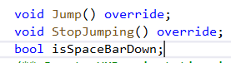

I then made two procedures and made sure they can override the parent class which also has two procedures with the same name after that I made a isSpaceBarDown variable to check for this just to prevent glitches ahead of time( especially in animaton)

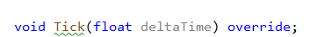

I then did a override of the method known as Tick which updates with DeltaTime

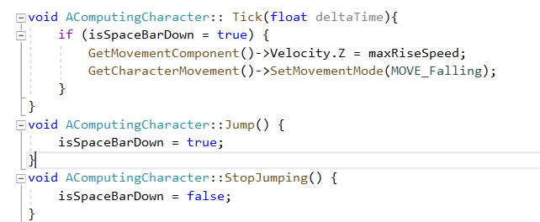

I then wrote the definition for these functions in the Cpp file.

Test 1:

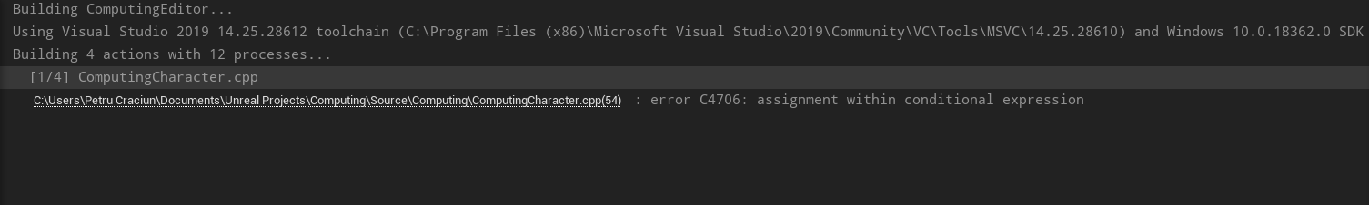

It gave a error initially but thankfully I noticed what was causing the error:



I previously had this as if(isSpaceBarDown = true) which was causing the error

Test 2:

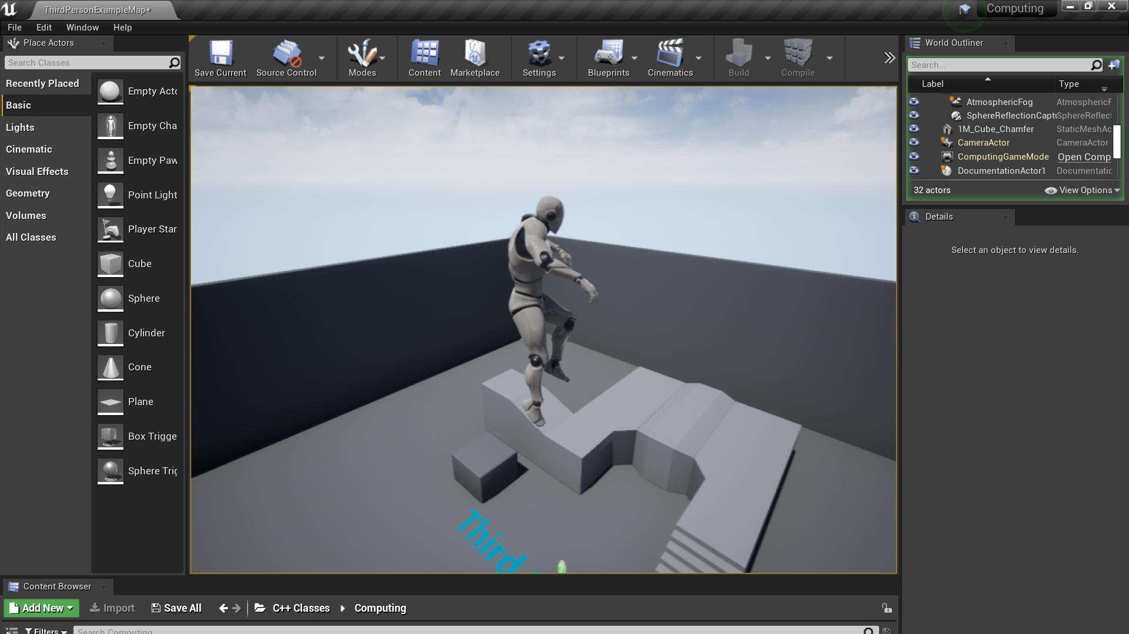

The purpose of the test was to check if the character would fly upwards which turned out to be a success now it’s time to set 2 values which act as fuel

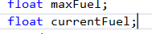

I made two variables I put them as public this is in case that I need to access them from things such as a widget or maybe even for animation in the future.

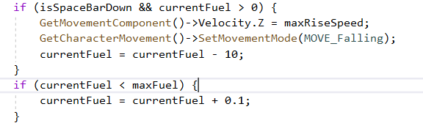

Within the same Tick method I added this algorithm which replenishes the amount of fuel within the storage over time and it also removes how much fuel there is slowly

Test 1:

I used a absurdly large value at the start of 10 to minus from the fuel per second and this was about as high as I could get barely higher than the normal jump this was enough proof for me that it worked and I changed the values to more appropriate values.

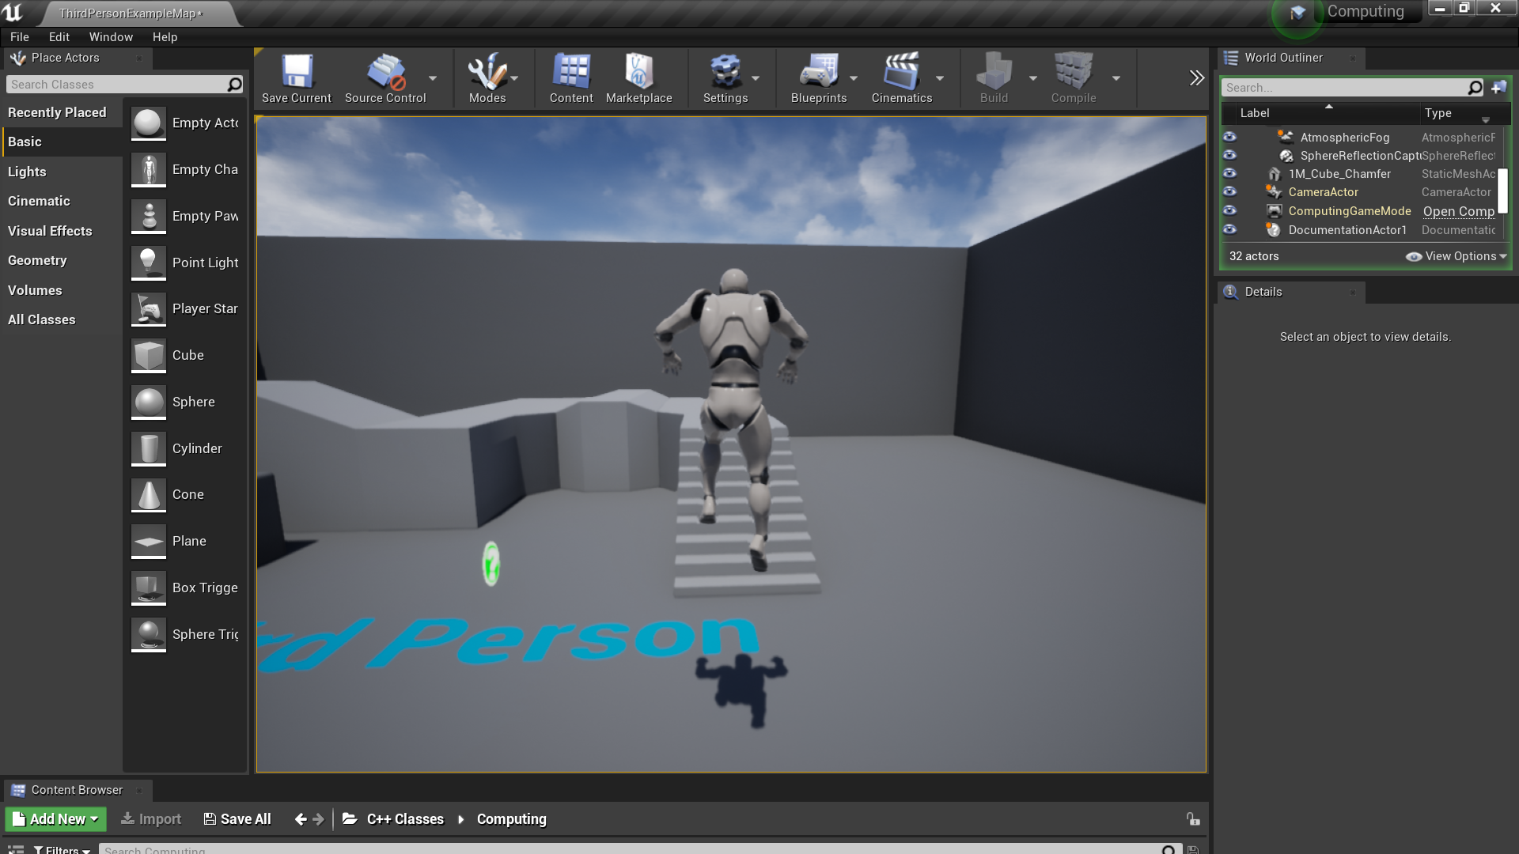

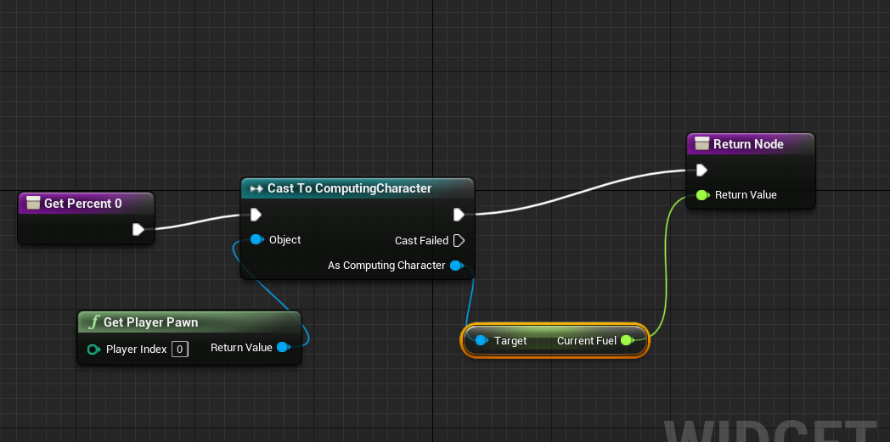

I then quickly patched together a widget interface in blueprint, sadly widgets don’t work too well and are a lot harder to make using C++ so I brute forced it using this method, I casted the current fuel value from my character and then I checked if it changes

Test 1:

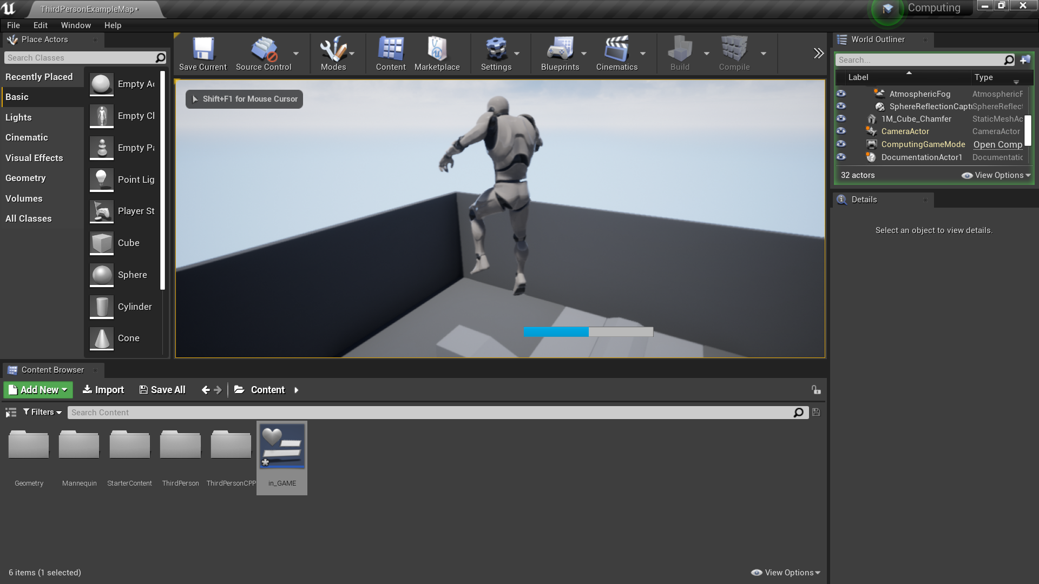

Sadly you can’t see it in this print screen but a problem that I had was that widget percentage bar don’t take values above 1 so I simply divided my current fuel by 100

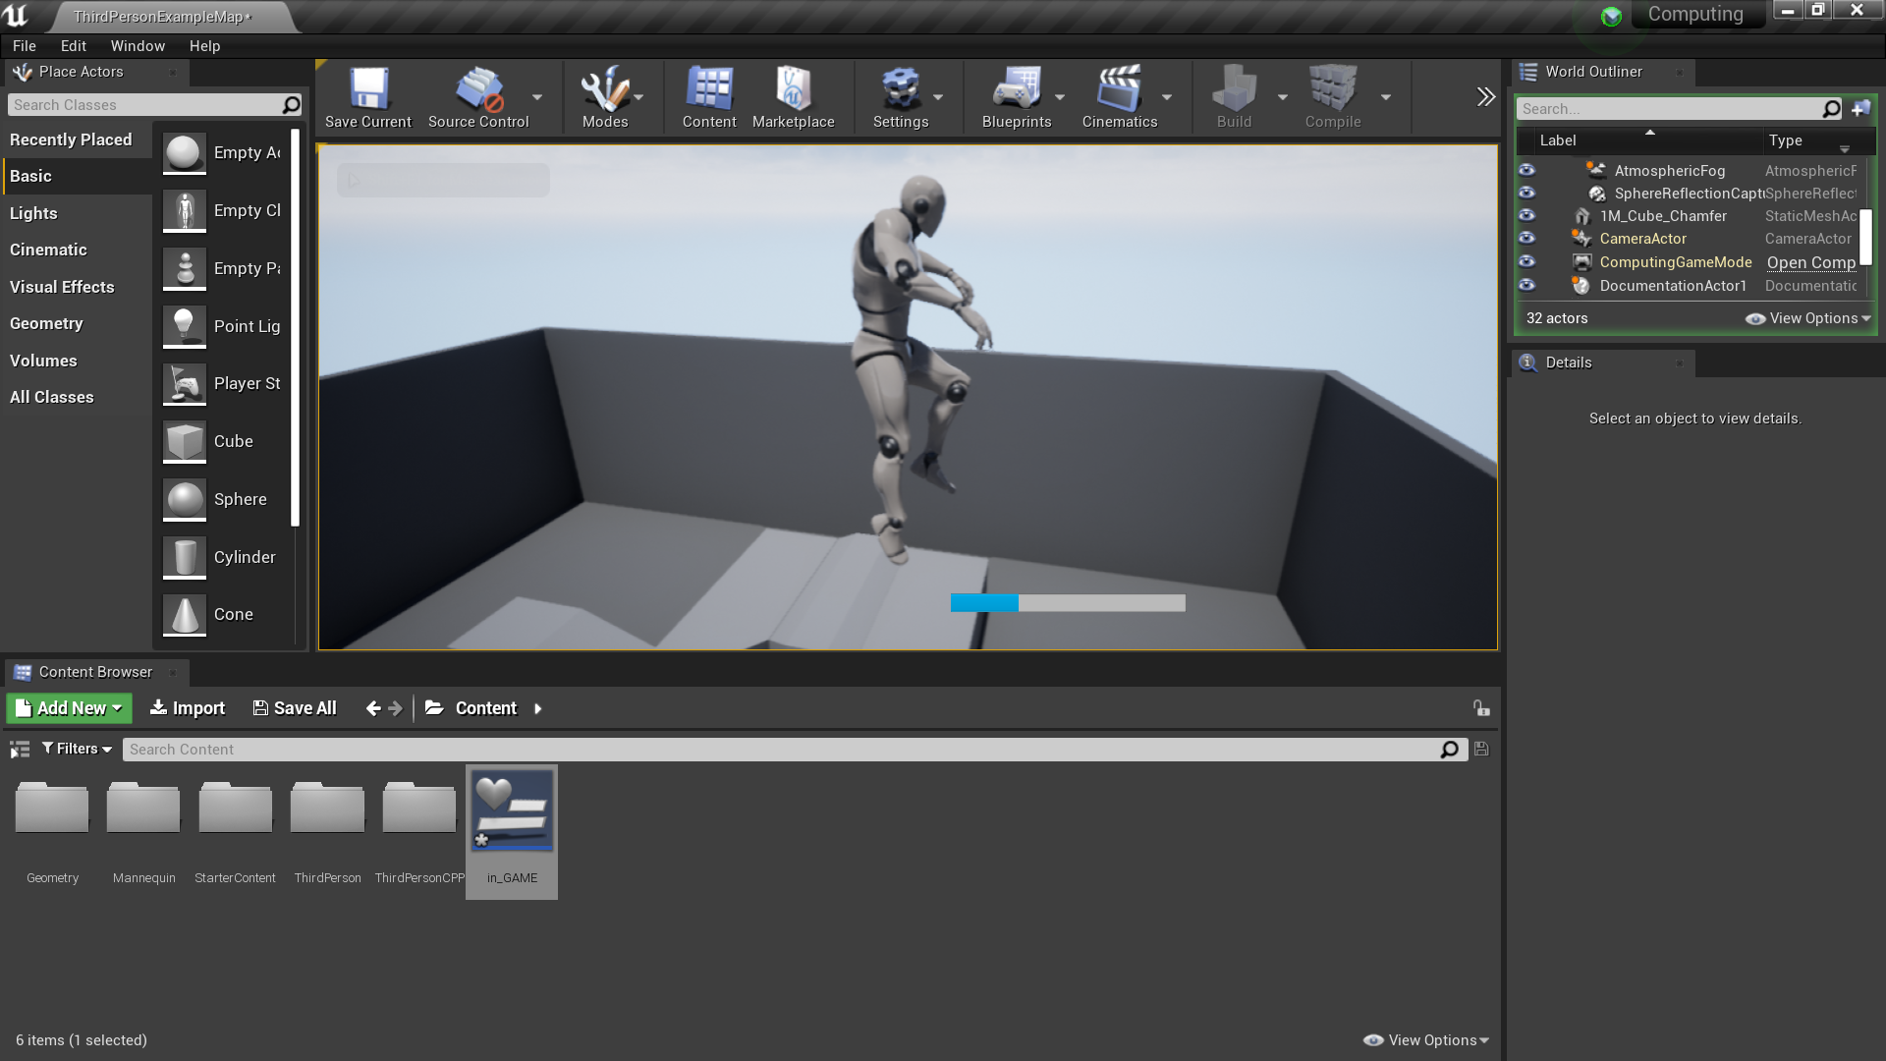

I fixed this and you can clearly see that now it lowers nicely one thing I must change is the replenishing rate it is very very quick and I should make it so that it is turned off when the jetpack is moving upwards.

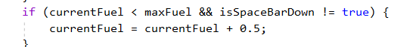

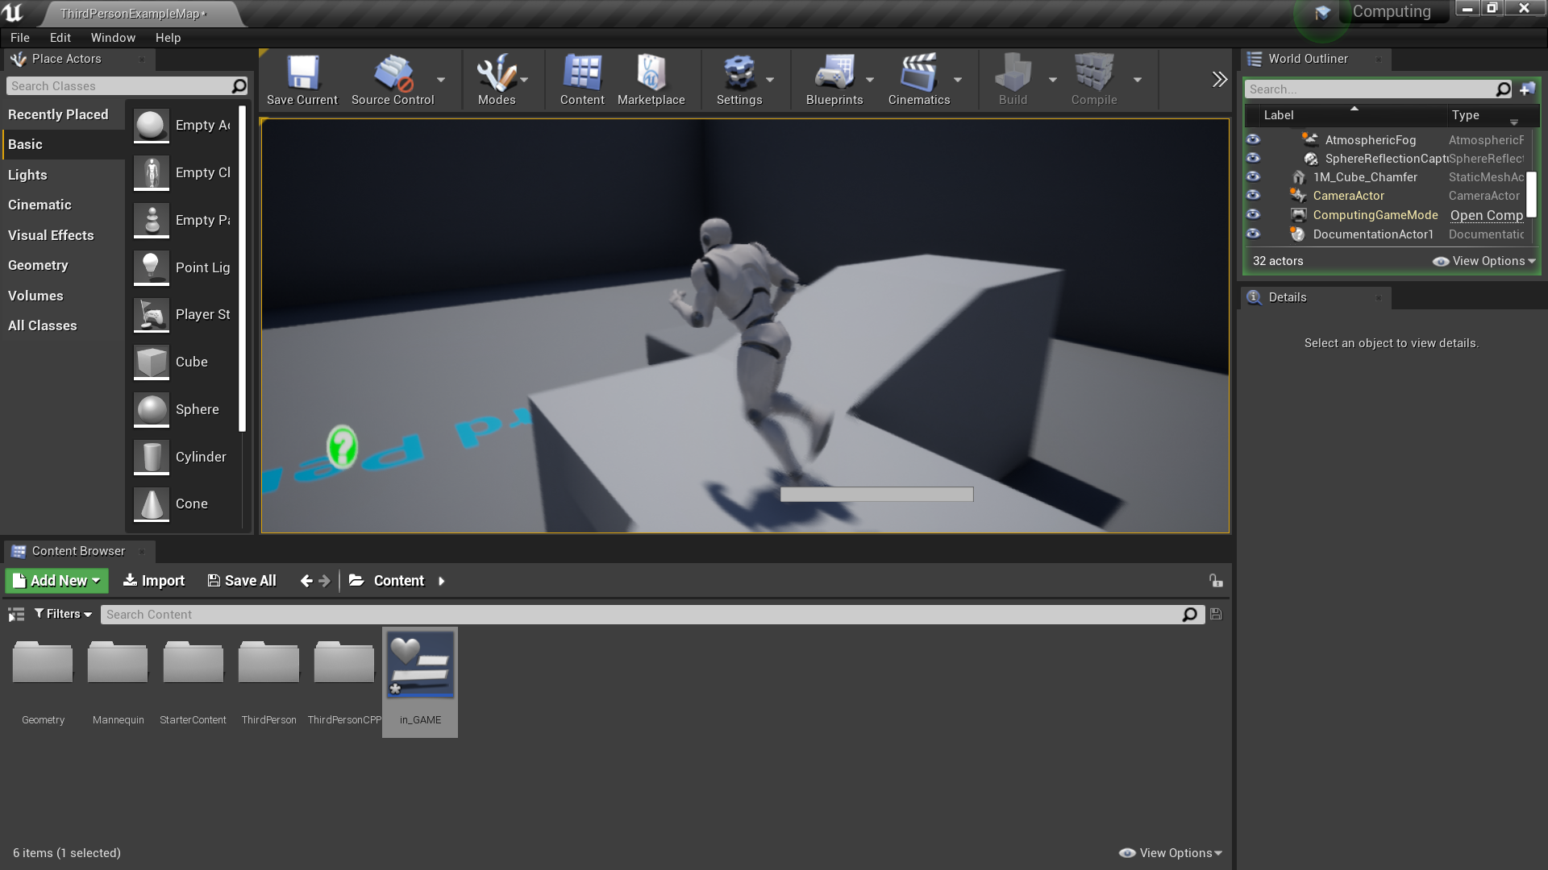

I changed this but I had one major problem with this, it is that if I kept holding it down it didn’t replenish at all when it reached 0, the reason I’d like this is to add more of a visual effect when the character can’t move upwards.

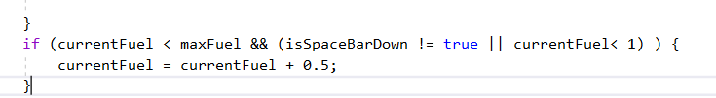

So I changed this and add a or operand so that it turns on if current Fuel is below 0

Test 1:

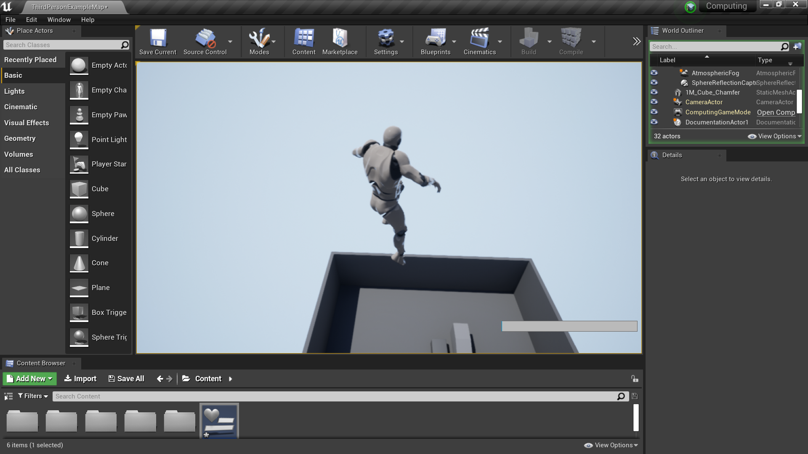

This added a very unwanted effect essentially the character kept moving upwards due to the reason it technically always had fuel in it’s current Fuel

I found a solution to this this was by adding a else f to the previous if statement which boosted the character up I am going to test this to see the effect

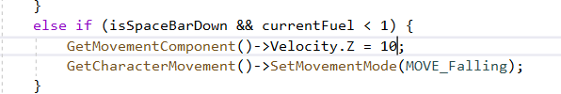

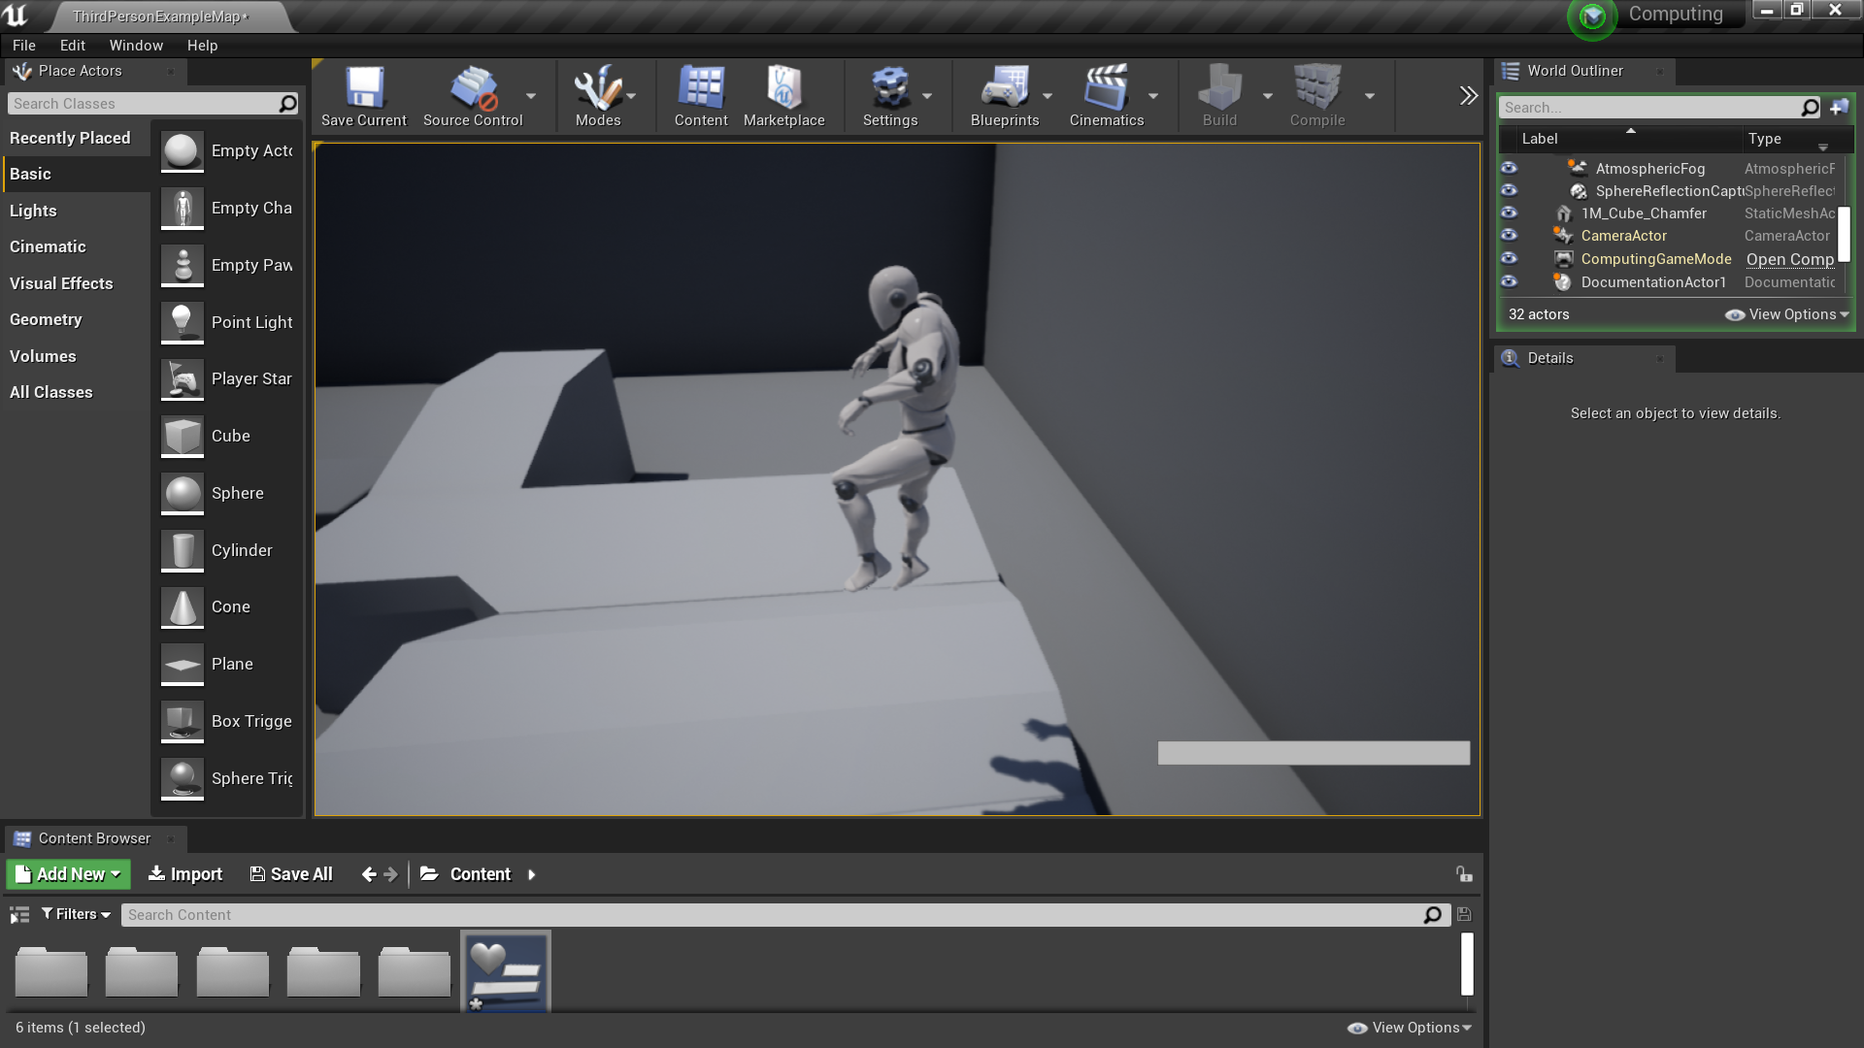

This worked-ish this is because the character was simply just floating

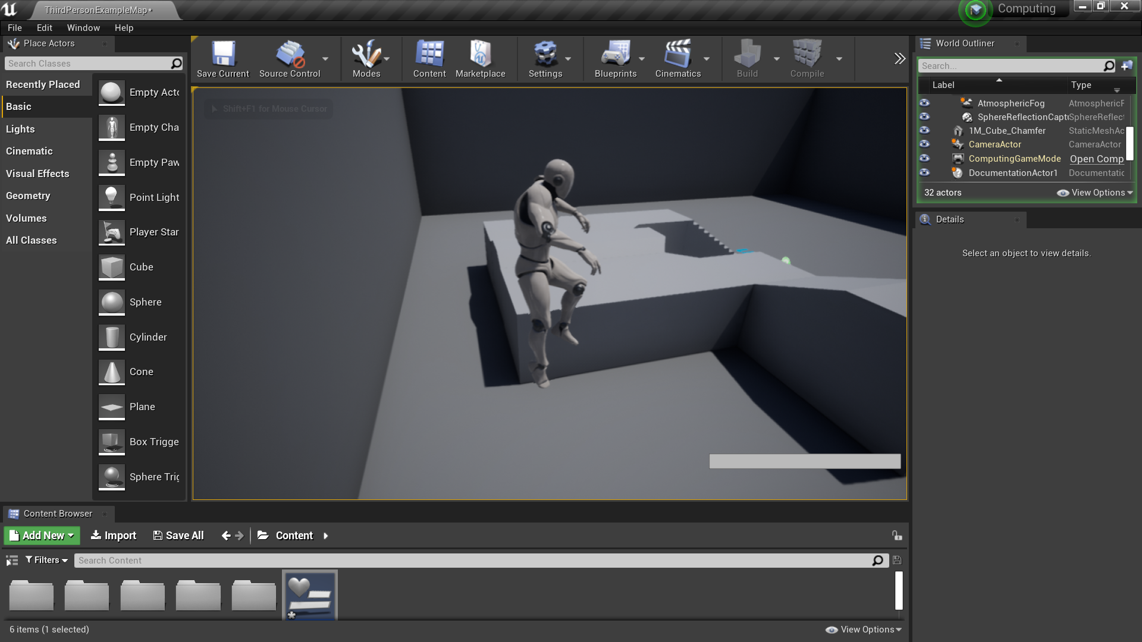

Adding a smaller value didn’t work either but when I did get close to the ground the characters animation glitched so I decided to go about this another way.

I then decided to add in the aesthetics of the jetpack using blueprint.

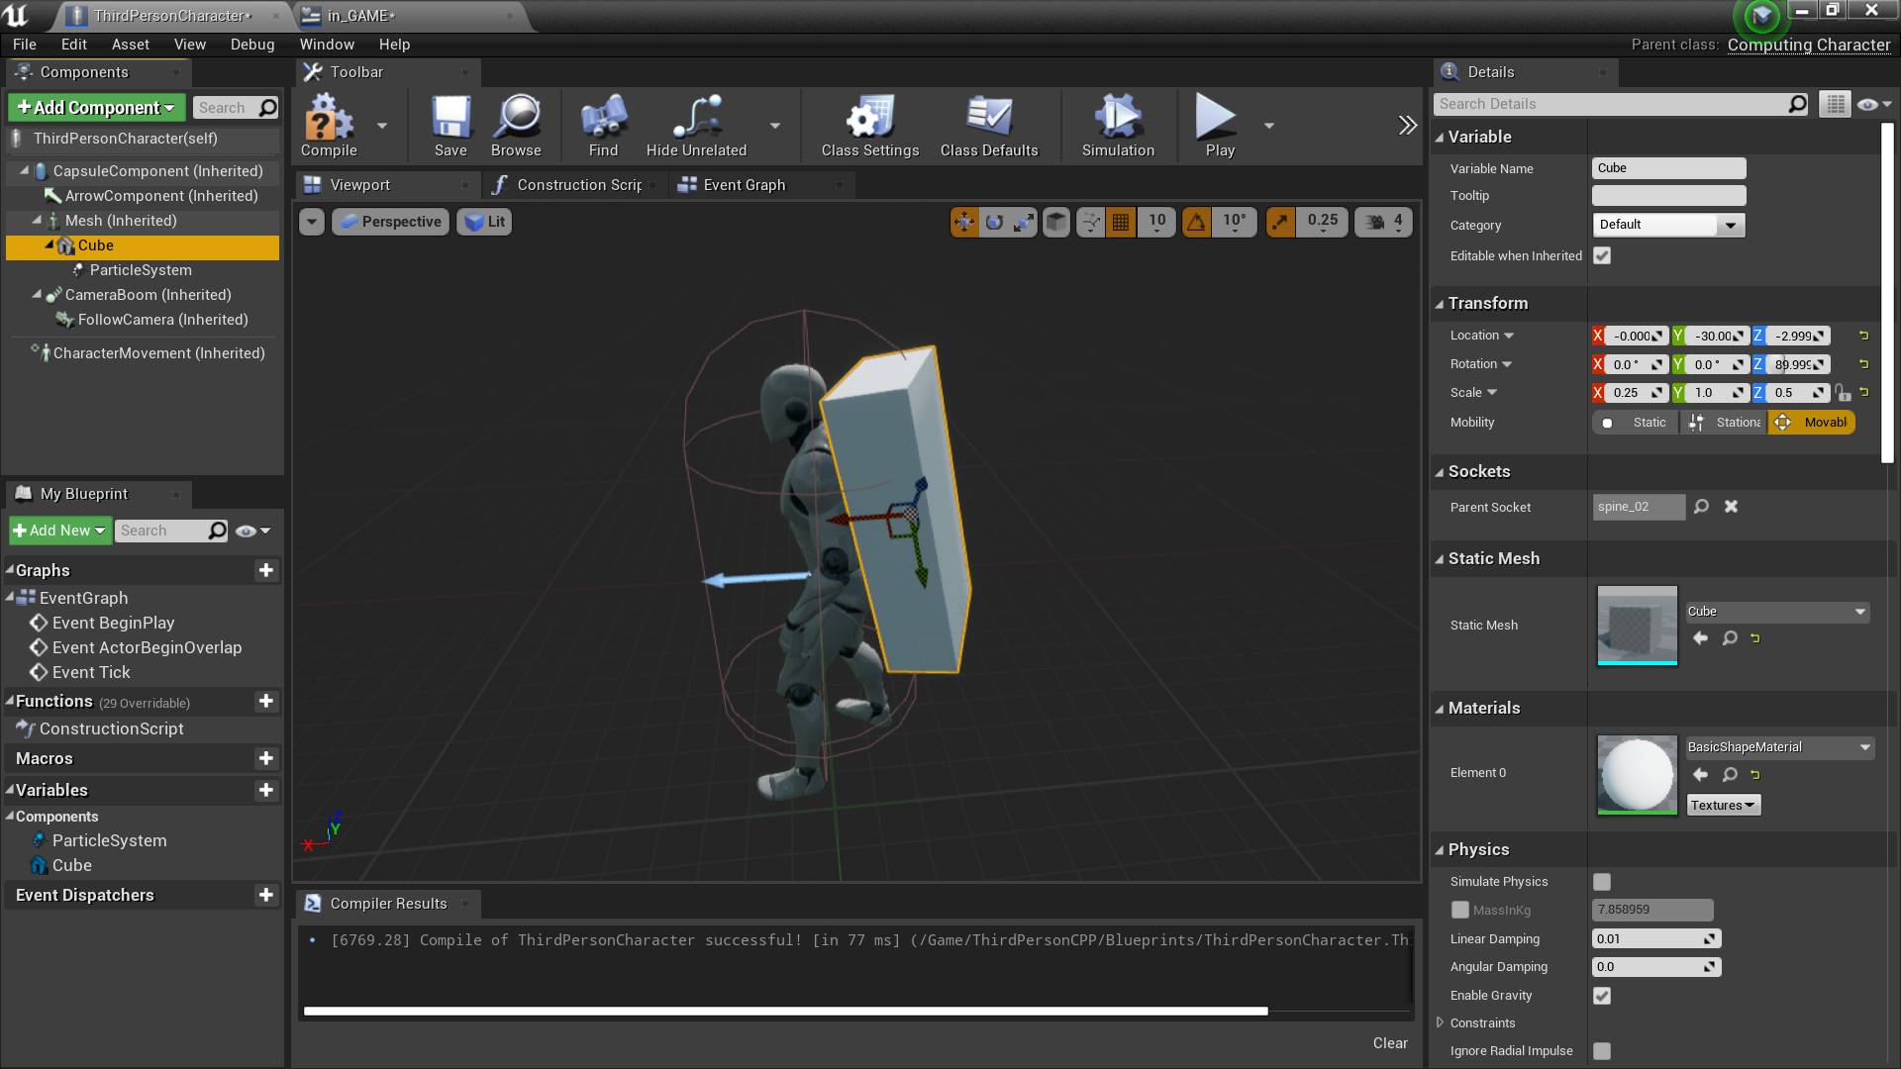

I made a cube and a particle system as temporary objects which I will change the look to later

I had to then move isSpacePressedDown to the public area of the cpp character file this is so that I can access it from it’s physical representation rather than making a new variable

Test 1:

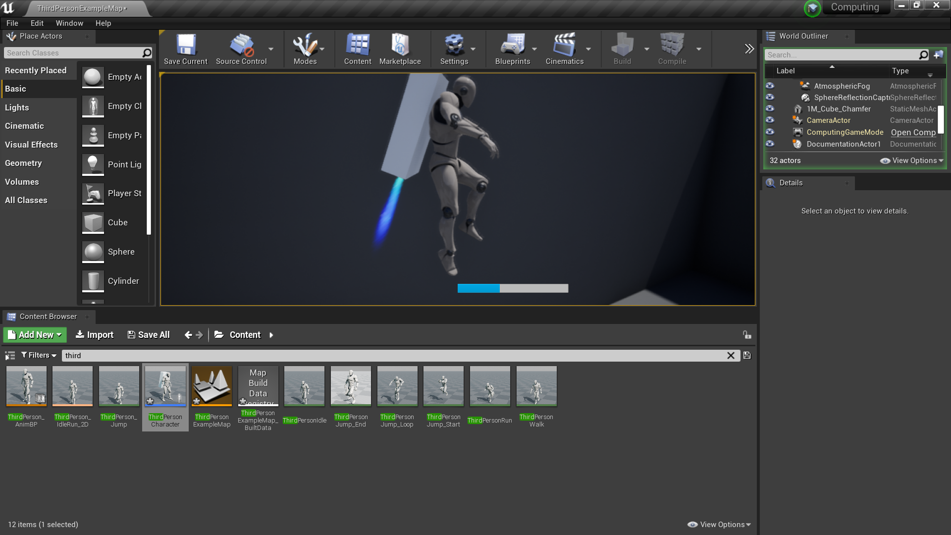

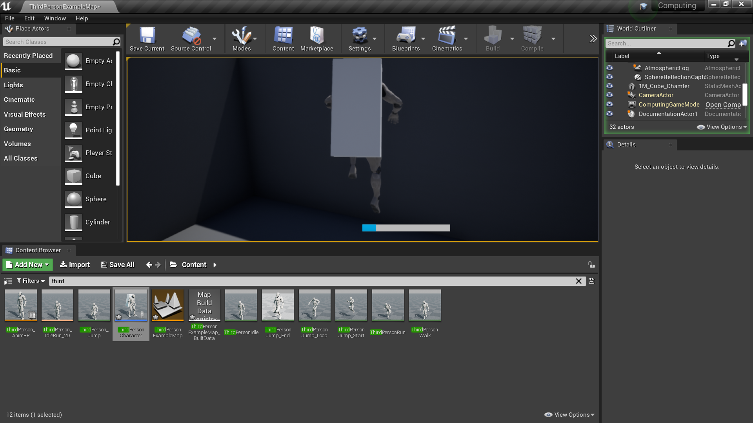

The animation worked perfectly except that I didn’t even have to use the isSpaceBarDown variable as the space bar input is already a variable within my physical representation file so I simply set that variable back to protected rather than global

### SUMMARY:

The overall jetpack was a great success it made the character go up directly and after multiple tweaks it was working perfectly, the only thing that would have had been useful to make the game more realistic would have been if I made the force be applied by the rigid body model due to the lack of time I didn’t get to do it however it would have looked like

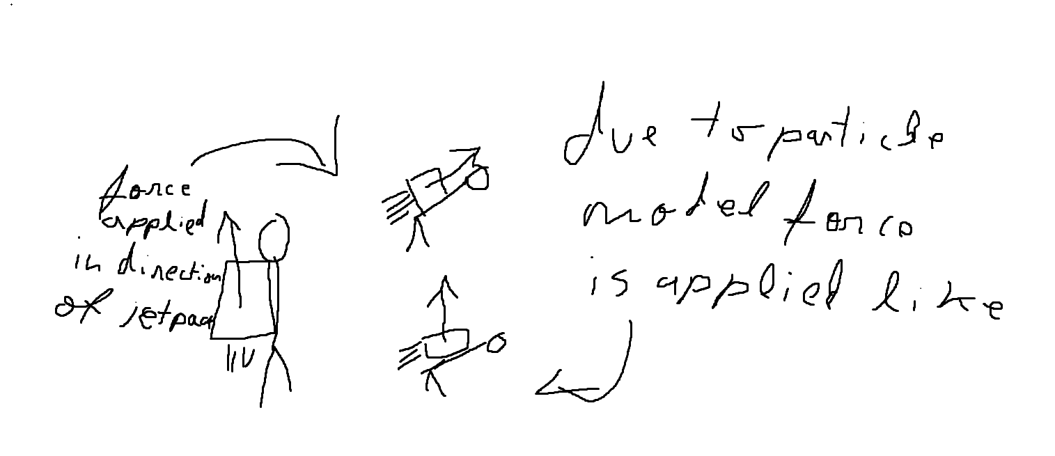

I applied a particle model of physics instead of a rigid body model which caused the force to only be applied upwards instead of the direction of the jetpack.

ACHIVED: Constant motion upwards**√** Player input**√** Rigid body physics **X**

## Bullet

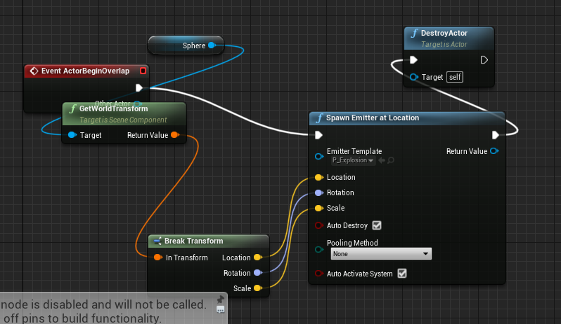

I made a simple piece of blueprint that tells the bullet to disappear and explode on collision

Test 1:

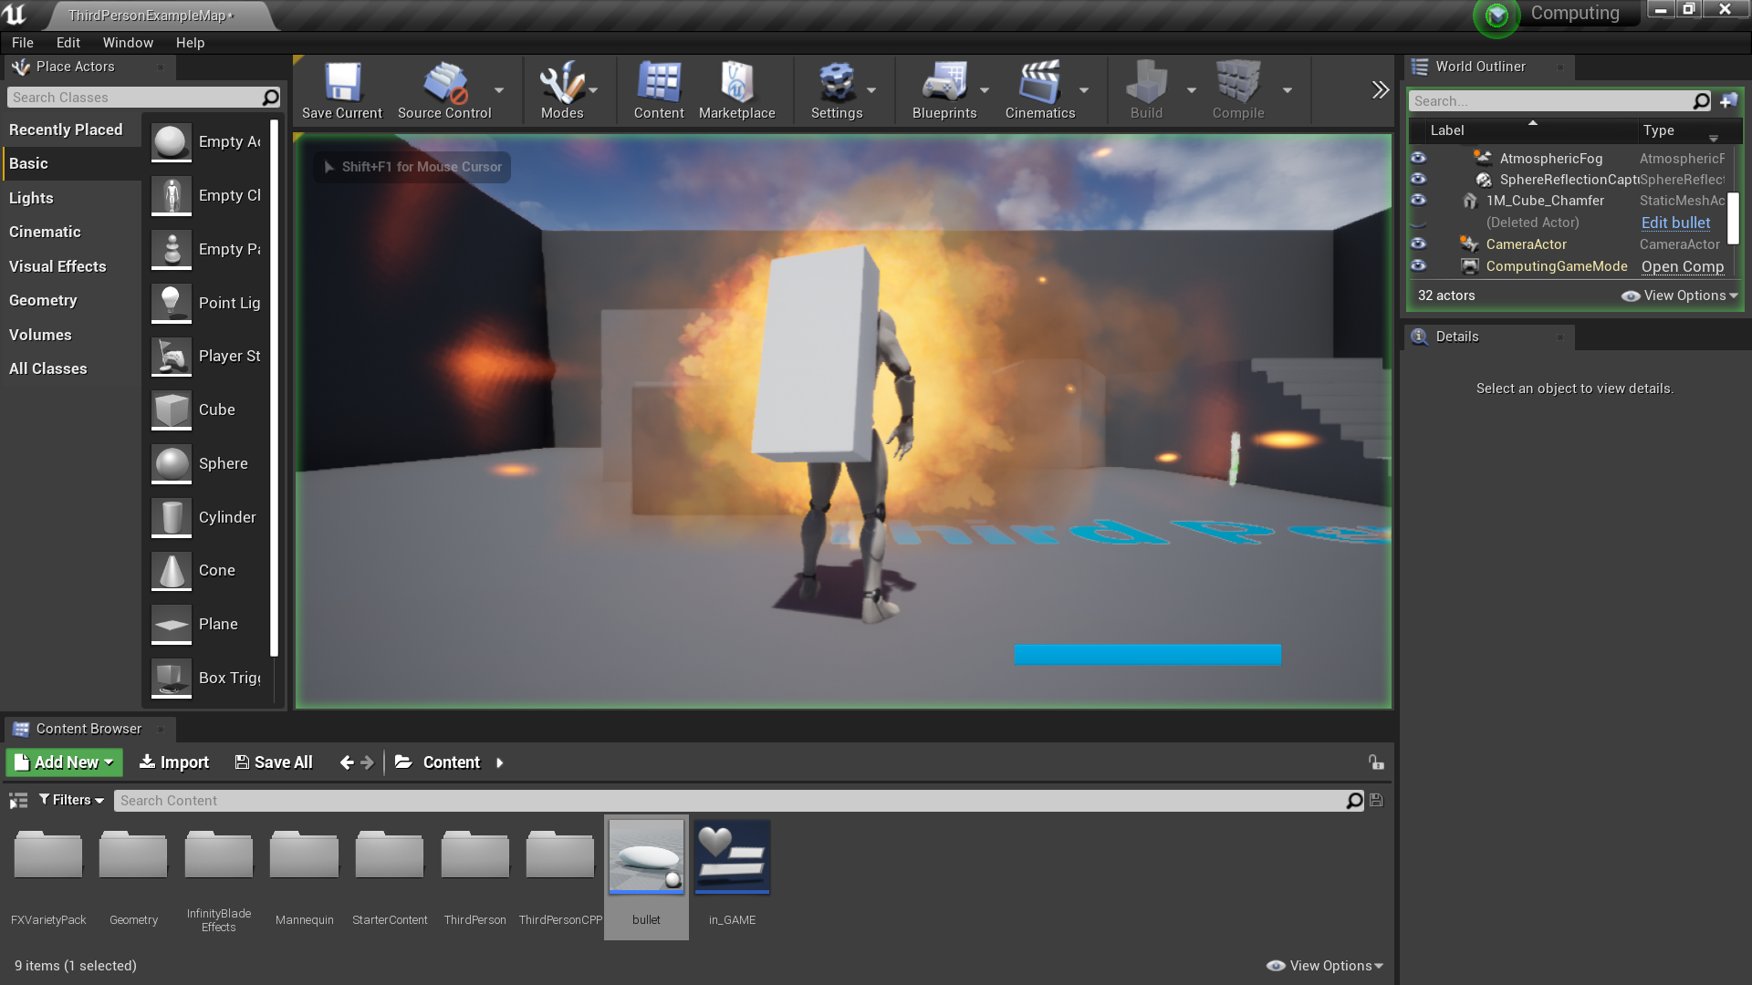

The bullet did the explosion I wanted maybe a bit too big but it does work. Time to actually do damage now.

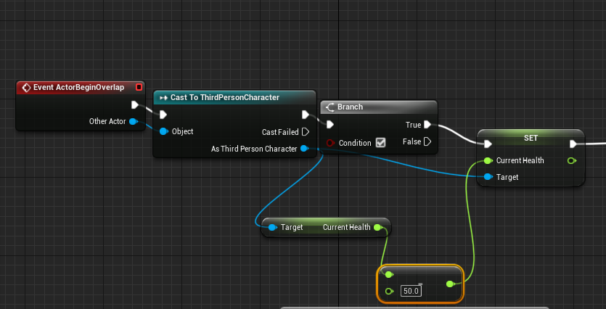

I can use the physical representation as it inherits from the C++ character it’s variables :)

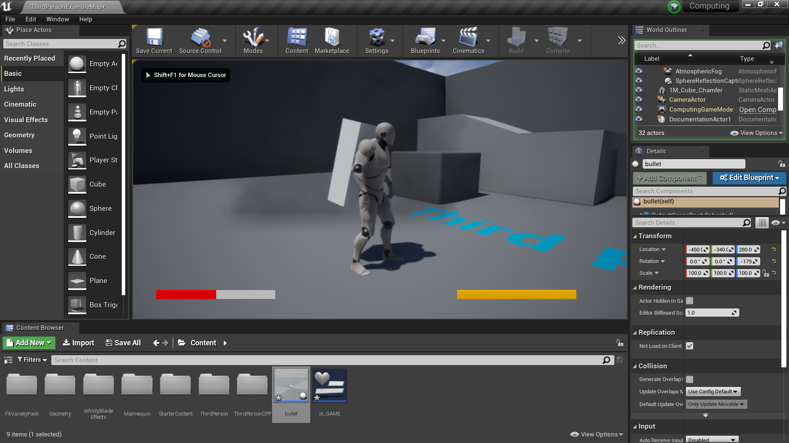

Damage to the player was done do it was a success.

### SUMMARY:

After tweaking the bullet was a very good success the bullet always did the intended amount of damage and the overall hit box of the player was always hit, there was no problem when implementing the bullet to ai classes, when fired the bullet acted as entirely intended to.

ACHIVED: Damage to the player**√** Implementation into other files e.g. ai**√** Variance in bullet types for multiple kinds of enemies and player guns X

## Health system

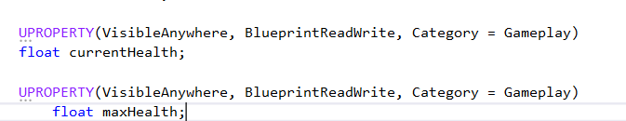

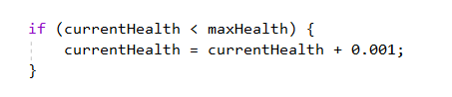



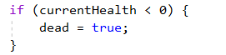

Created a dead variable so that when the player dies thing’s like a death title screen can appear.

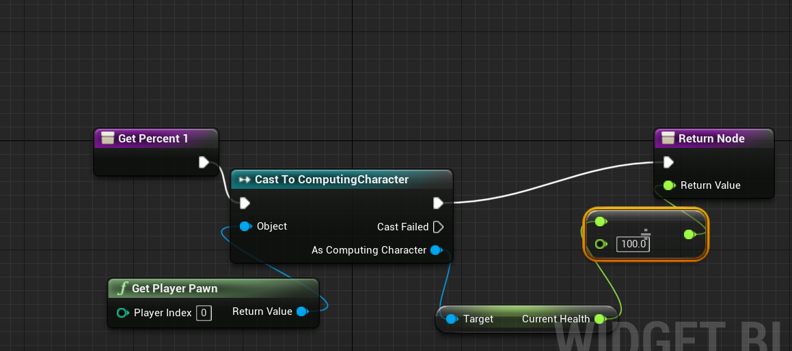

As you can see bellow the test was a success and the health showed on the progress bar.

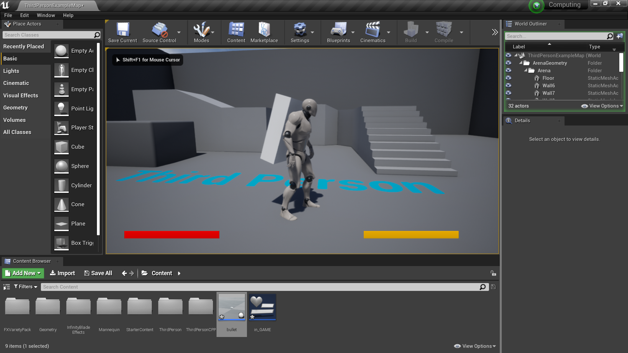

### SUMMARY:

The health system was a success, it displayed the health on the screen without any complications e.g. the two values being different.

ACHIEVED: Health is displayed on the screen**√** Health on the screen and the health value used in file sharing are both equal**√** Health regenerates over time**√**

## Missile

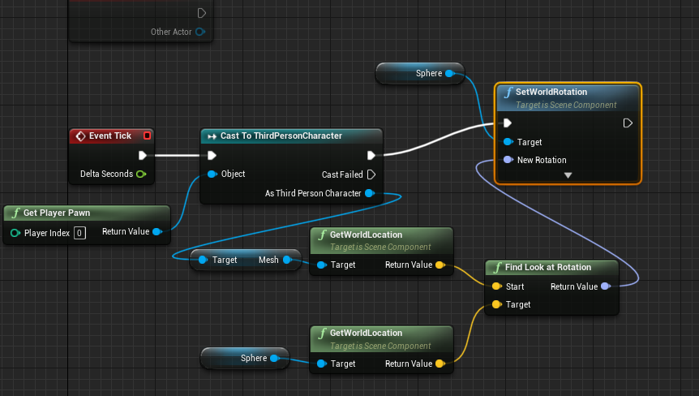

I first made a child actor in Blueprint of the C++ file I made it because it held the models of the C++ file like the static mesh so the access time of the rotation would be better rather than rotating it across files so the missile rotation was done in blueprint

Test 1:

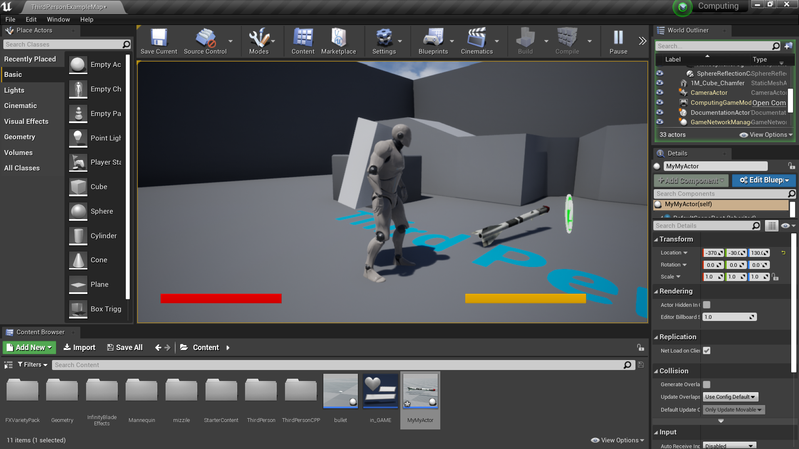

The missile did rotate towards the player except it rotated the wrong way around.

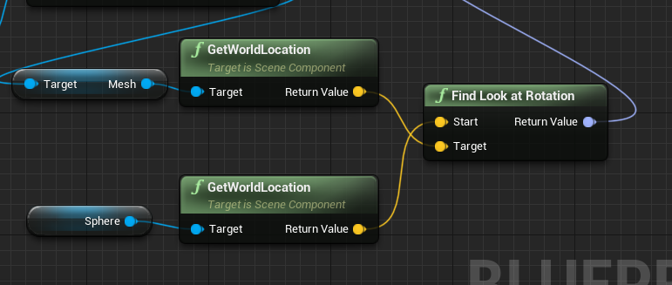

I needed to swap the start and target rotation silly me got it the wrong way around.

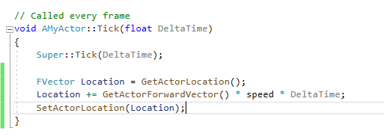

This is the parent classes tick function moving forwards according to the speed.

Test1:

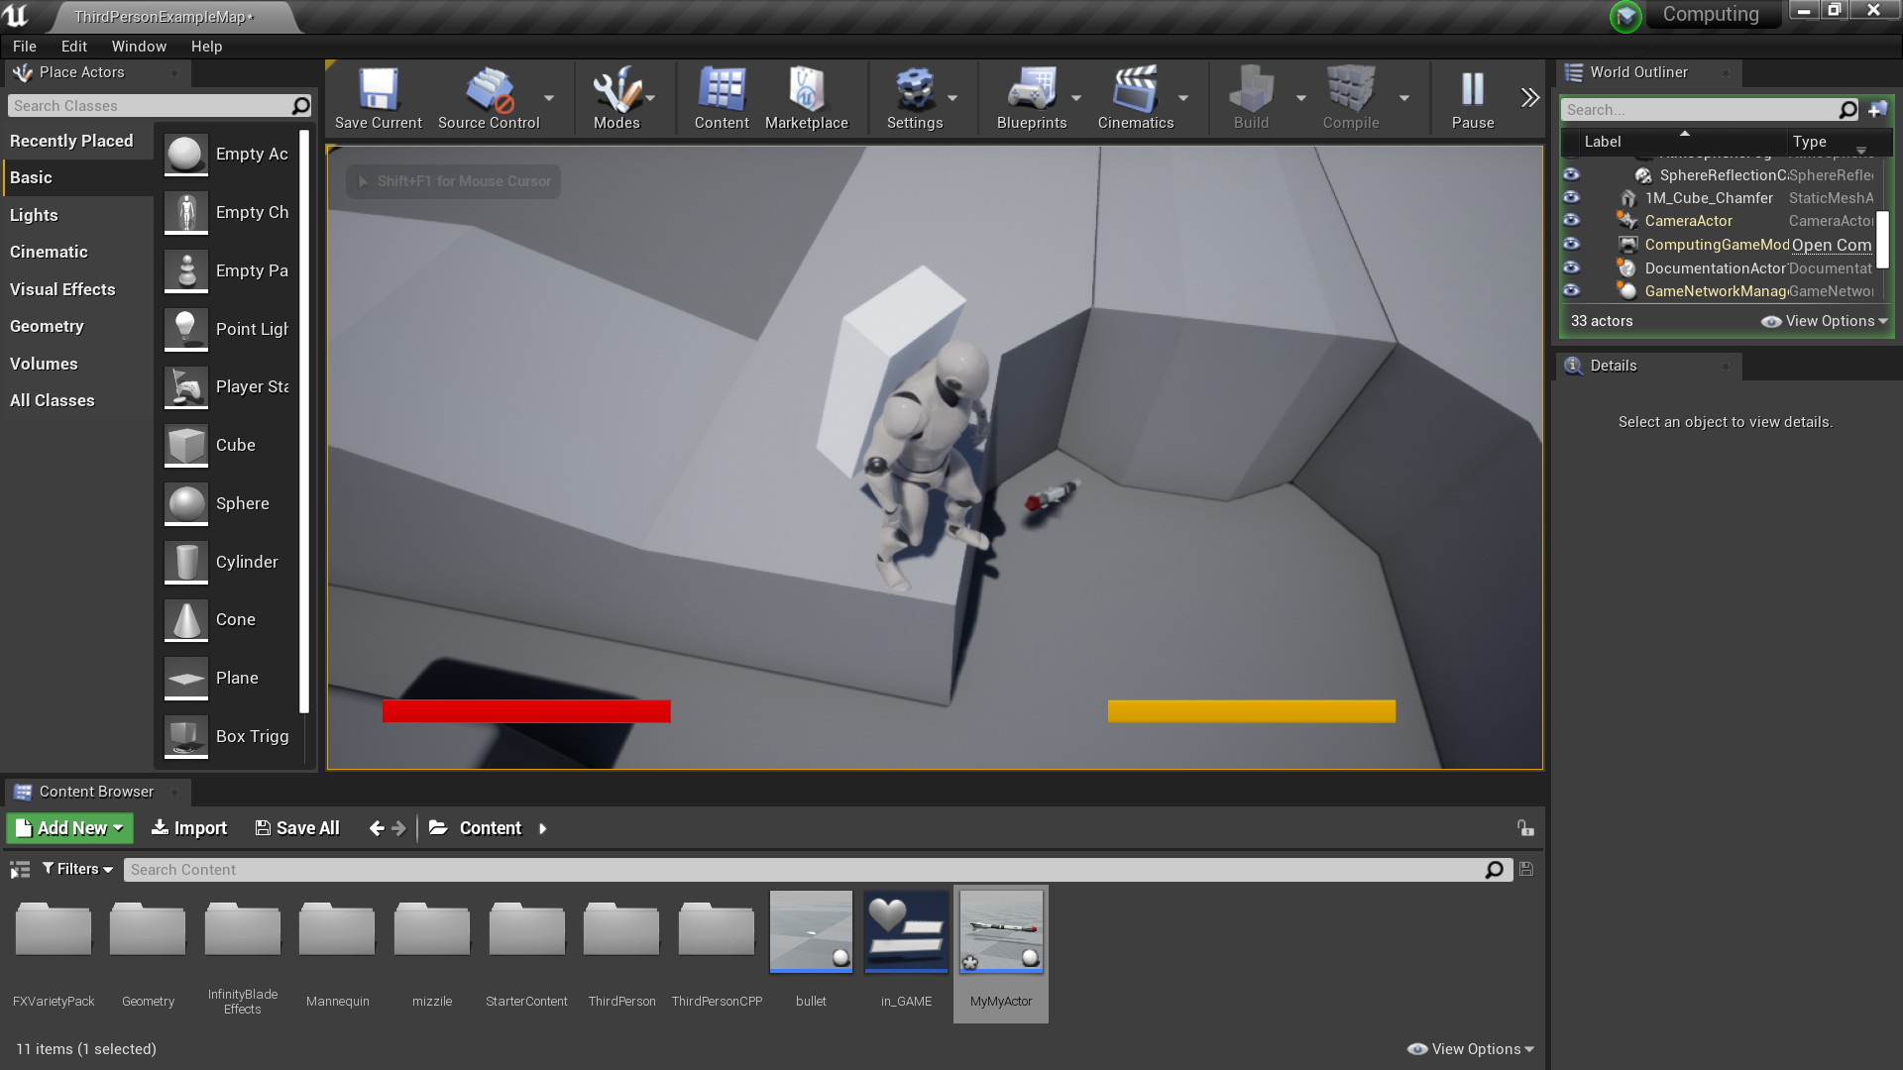

Missile is going forward however not towards player thankfully the fix was easy.

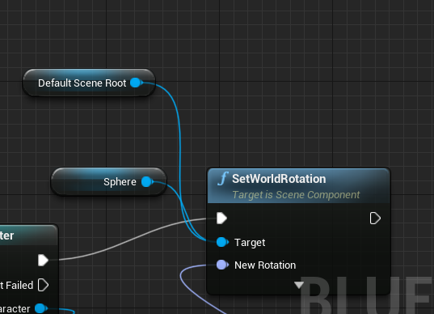

Just needed to set the look at rotation for the default scene root.

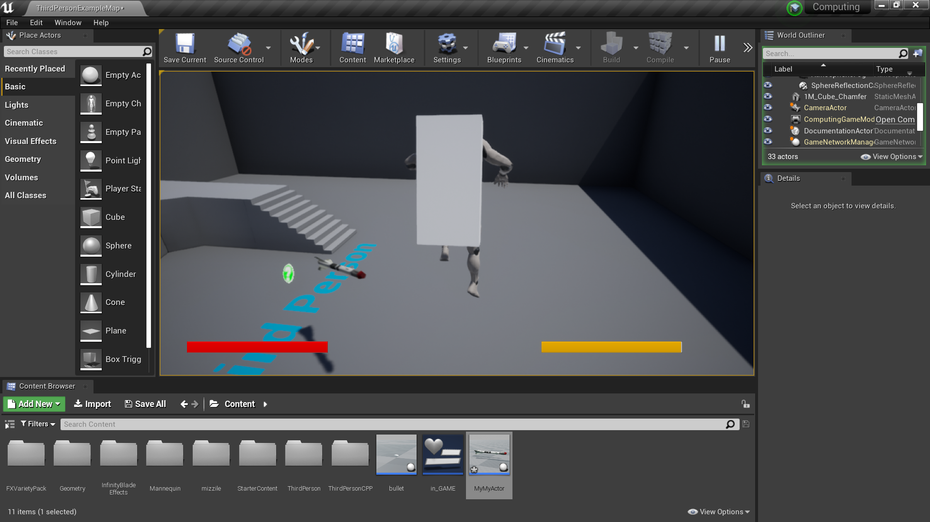

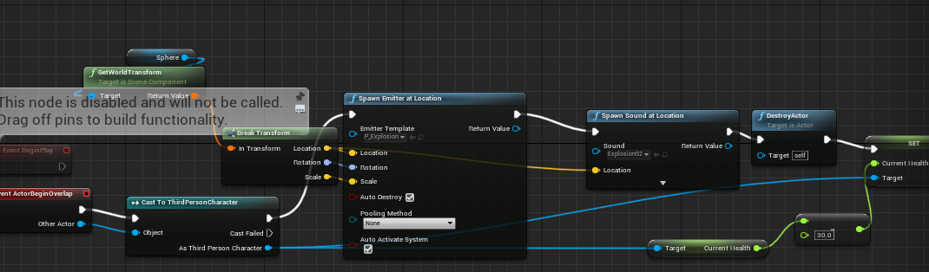

This piece of code essentially on contact explodes and reduces the health of the player.

### SUMMARY:

The overall missile was good, it appeared as a good adversary to the player as they had a hard time attempting to dodge it, one thing that I would change is that it was more of a ai following a player rather than a fast rocket fired in the general direction of the player

ACHIVED: Followed the player**√** Does Damage to the player**√**

## Dash

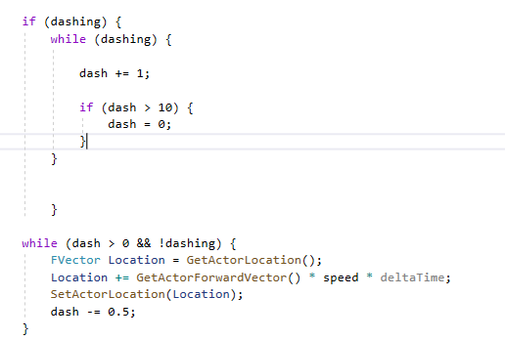

I tried doing the dash as a charge like system however the while loop caused the game to crash as it increased the speed way to quickly because I forgot to add a delay. Not only this but it automatically crashed on letting go of the alt button.

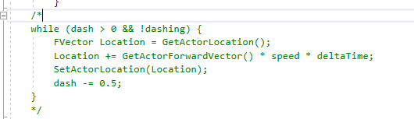

I put this bit of code in comments so that I could debug which bit of the program caused errors it appears to be the top if statement

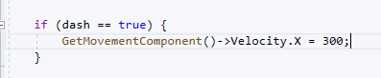

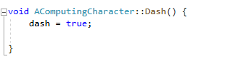

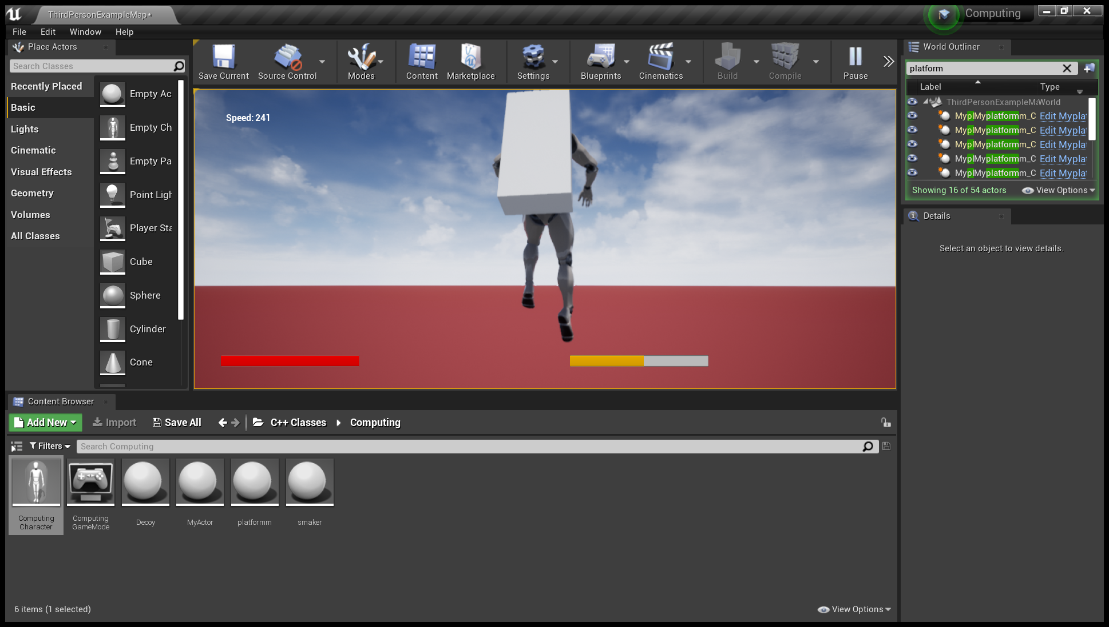

### SUMMARY:

The dash function worked perfectly fine it made the player move forward quicker, however it should have been more of a quick burst rather than a necessity, the large distances made this acceleration something the player constantly needed so I couldn’t just have taken jetpack fuel away from the main character this forced me to make it something you got unlimited access to.

ACHIVED: Player is propelled forward **√** Animation X Limited use X particle effect X

## DEAD

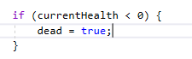

First I put this piece of code within the event tik, simple if statement to check if the character is dead or not after this I put a check for the healing and movement inputs to be turned off when the character has died this was simple as I only had to insert the != operand into every thing.

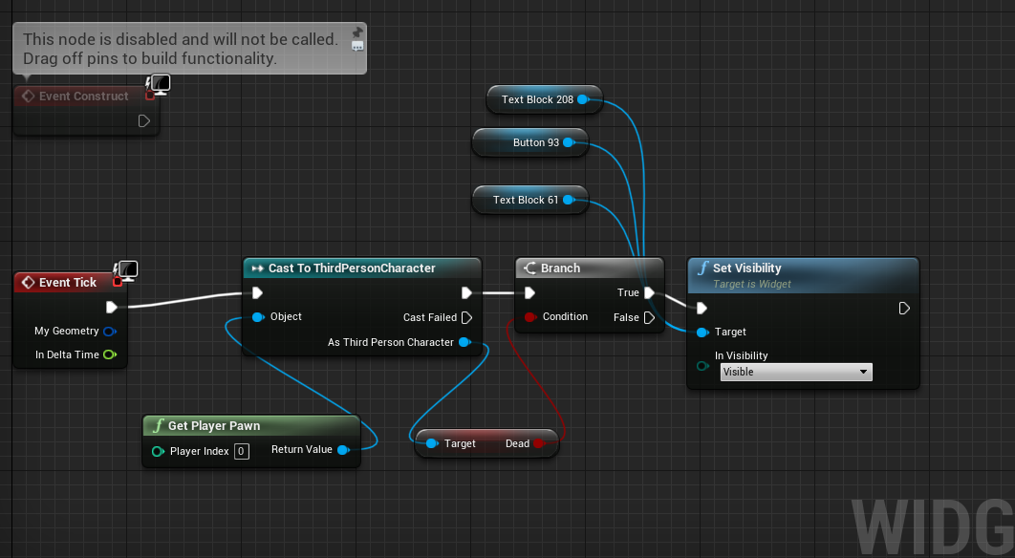

Then in the main widget I did a simple check to turn on the visibility of the button when the character dies.

Test 1:

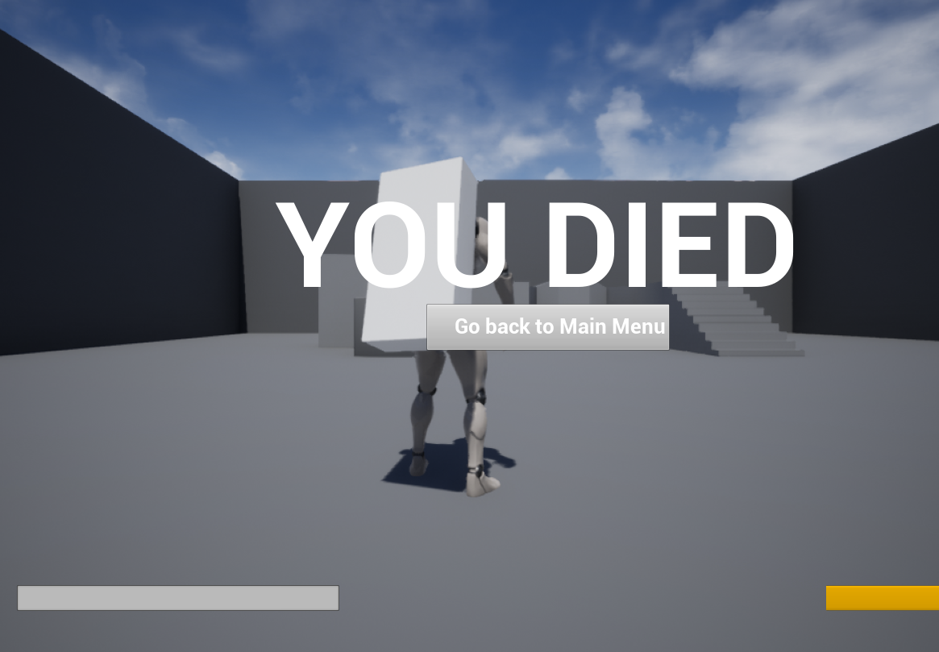

I am completely happy with the results the reason the widget doesn’t seem on centre is because of the aspect ratio of the editor however this is adjusted when the game is launched.

### SUMMARY:

The death screen was a very clear success, I would have removed the health and jetpack fuel bar however it did it’s job however it could have been improved graphically.

Achieved: Takes player back to main menu **√** Good graphics X

## Platforms

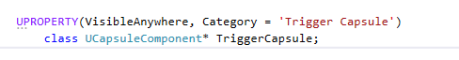



I thought by first starting off by adding a trigger component only capsule on the main character however this is not as supported in the new versions of the engines as it used to be. The only benefits that we could reap from this is that we can define what we call a overlap according to the capsule component of the character.

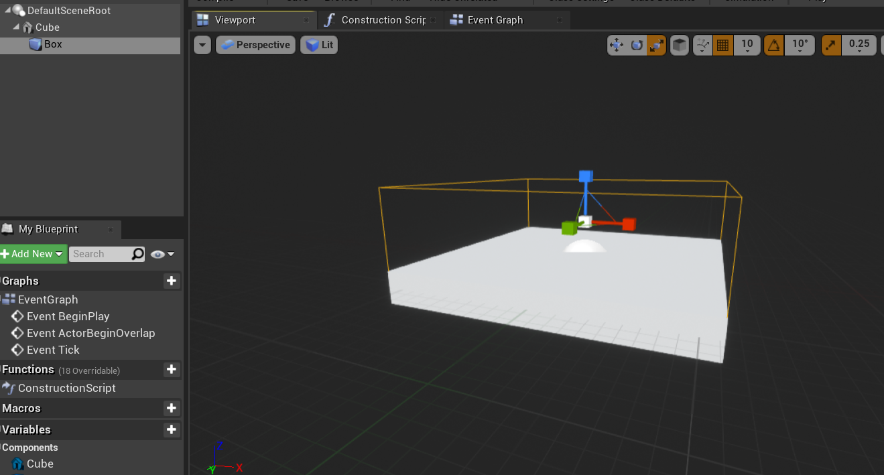

So I first started to make the platform by making a simple cube with a box collision, this is a child of the parent C++ component, this child will simply tell the parent when the main character has overlapped with the box collis*ion.*

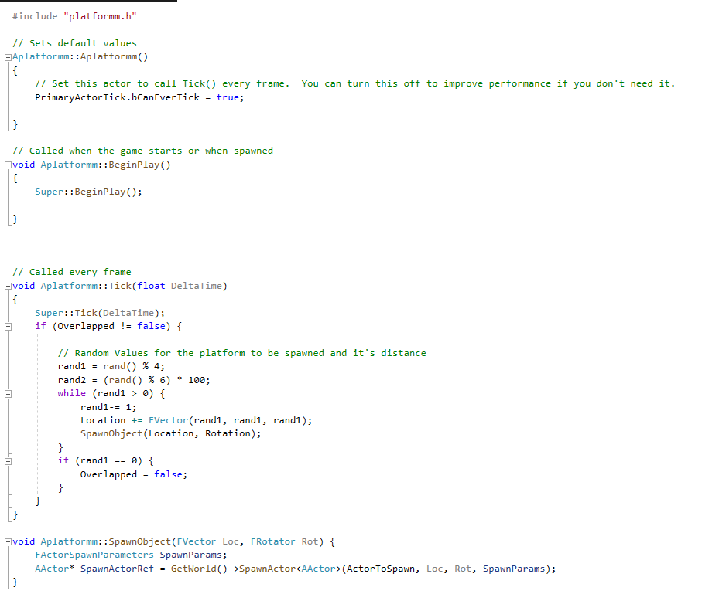

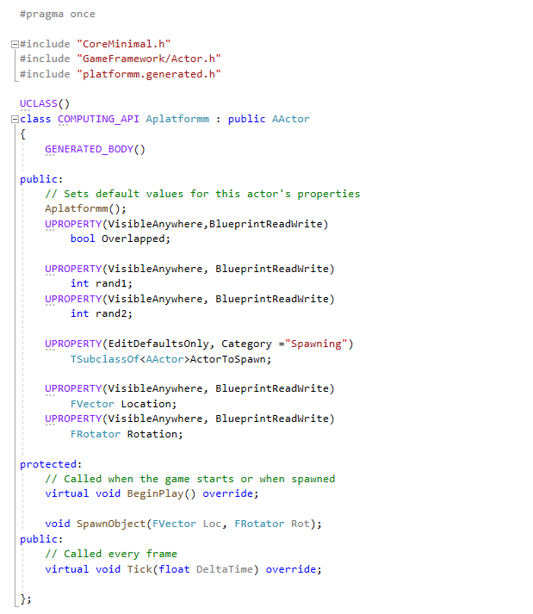

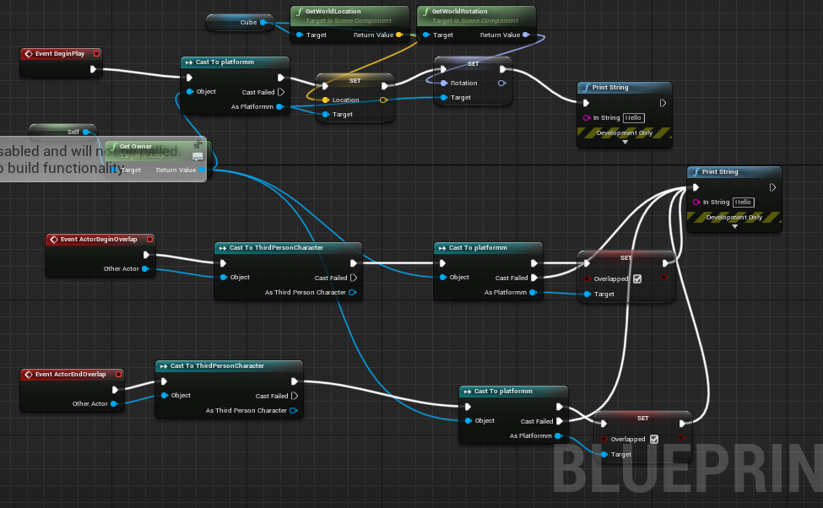

*The fir*st iteration provided a casting error the wijcard didn’t work however this was fixed very easily

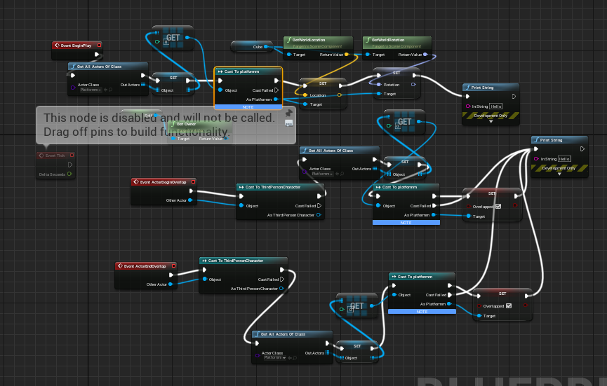

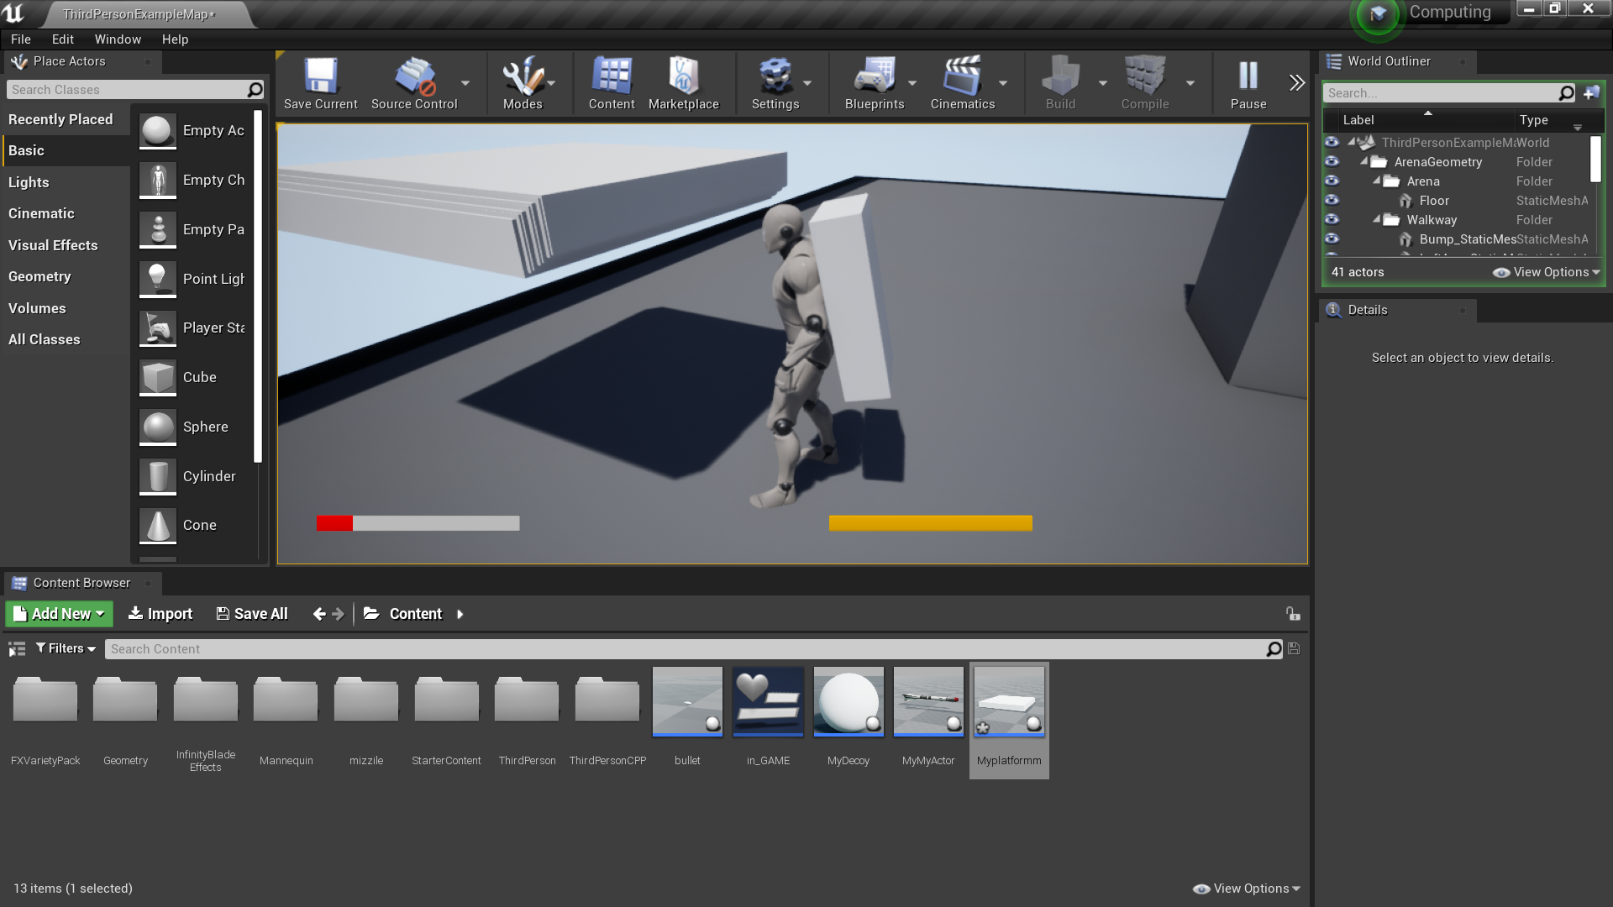

*After te*sting this I saw that platforms were being spawned however they were way way too close to one another

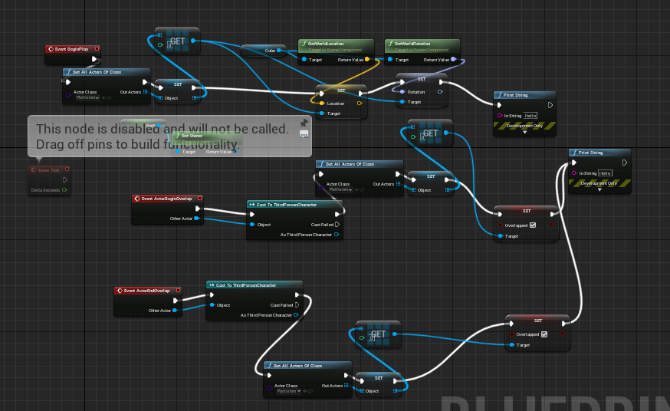

Recasting seemed redundant so I simply removed the previous cast nodes.

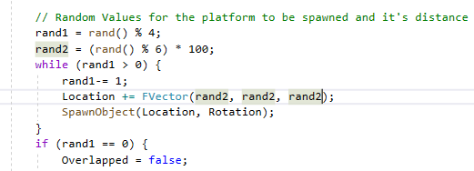

The distance inside the code was fixed via removing the rand1 inside the Fvector as I accidentally put that rather than rand2

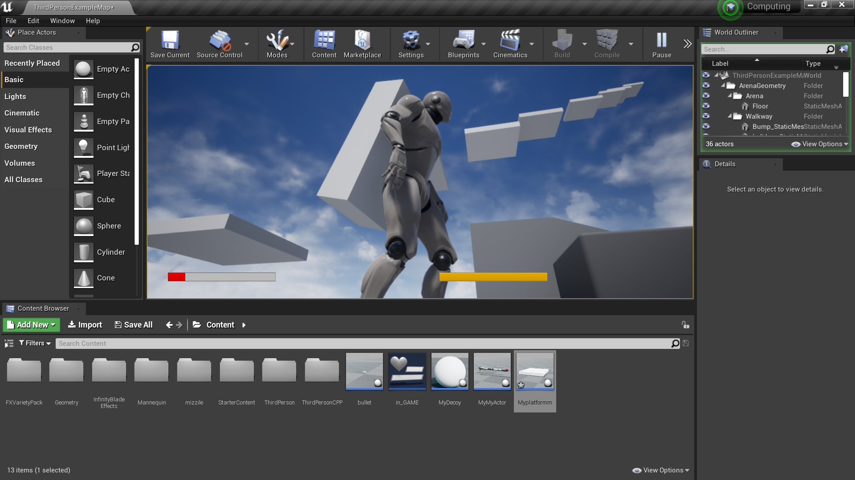

Second iteration made the platforms go up in the same direction

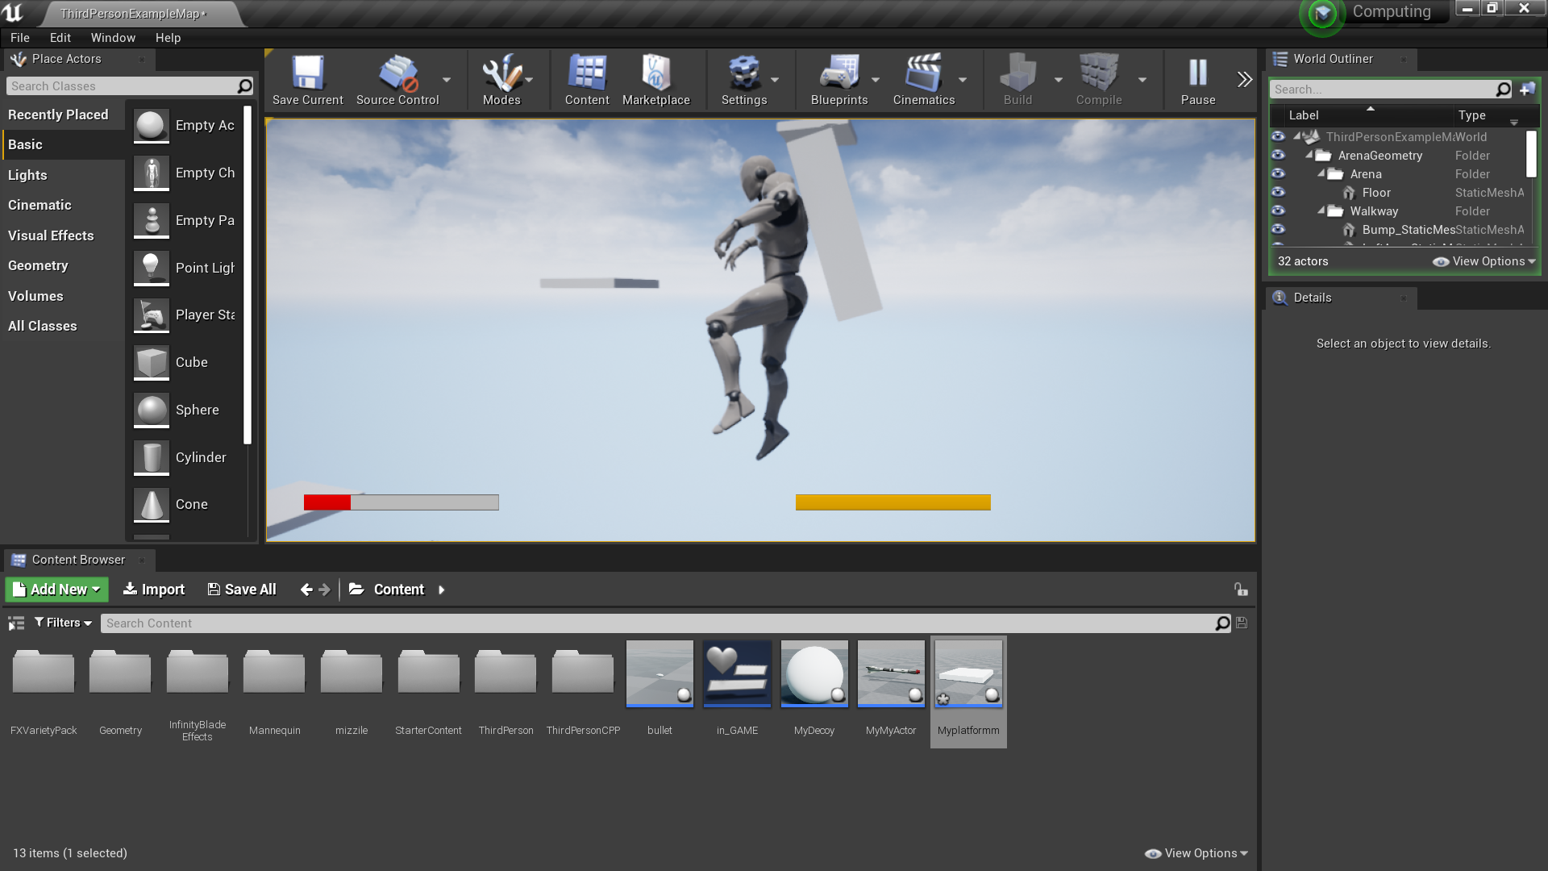

However they were very clearly at different distances to one another.

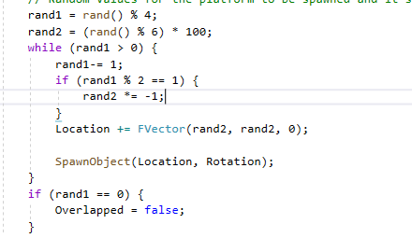

I then changed it and times it by -1 if rand 1 ended up being odd to make more directions the player could go in.

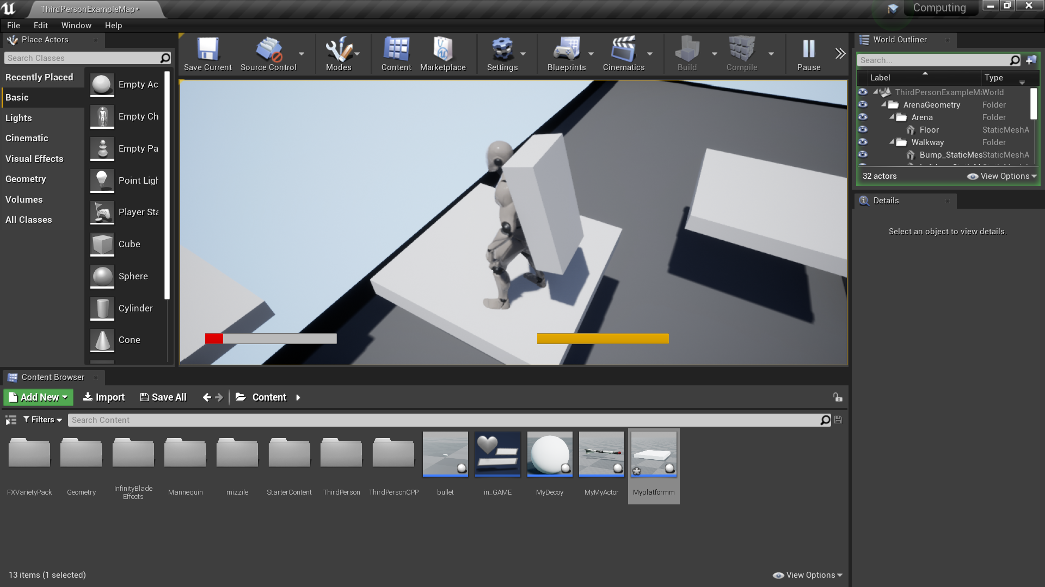

The player can now go into more than one direction.

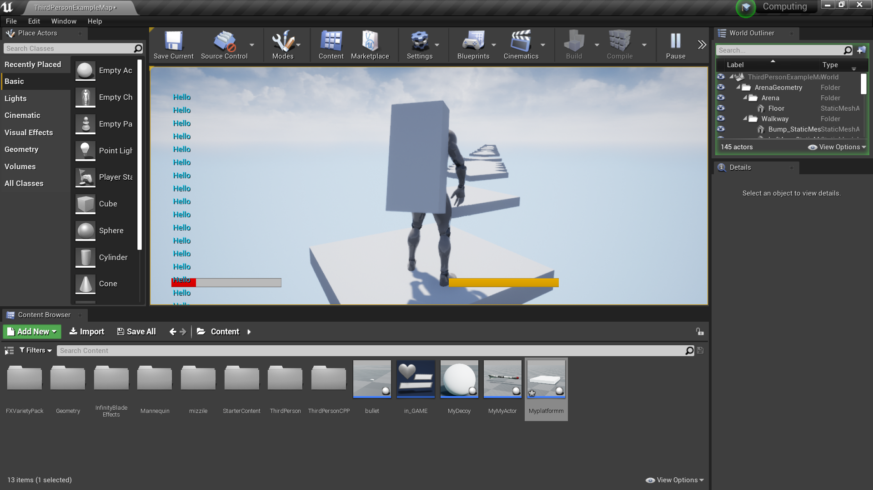

This mistake in the code made me realise that the location the new platforms spawn on is according to the location of the newest spawned platforms. Not only this but no change in rotation will not allow too many random directions.

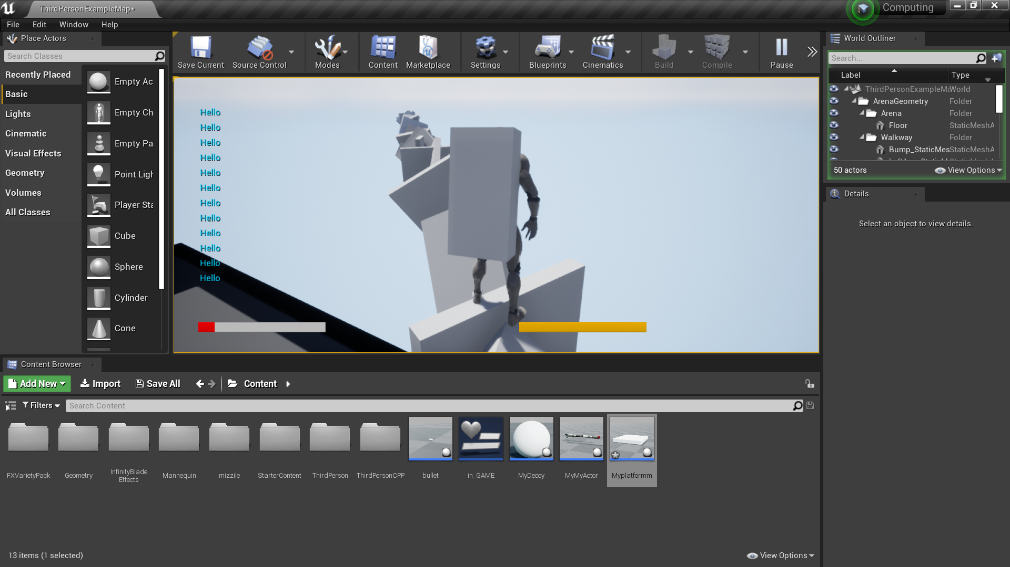

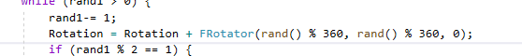

Random rotation was set however it was obvious that it was the wrong direction to rotate in

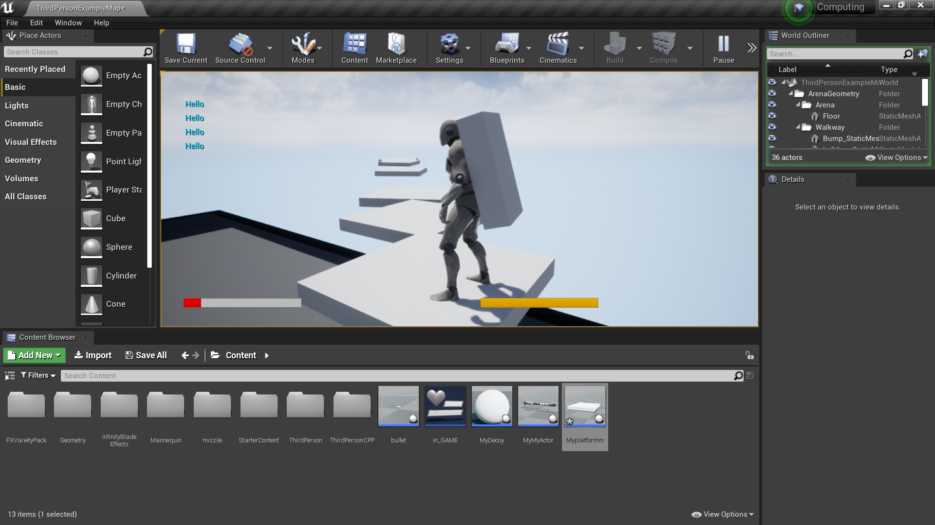

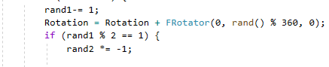

This was a quick fix

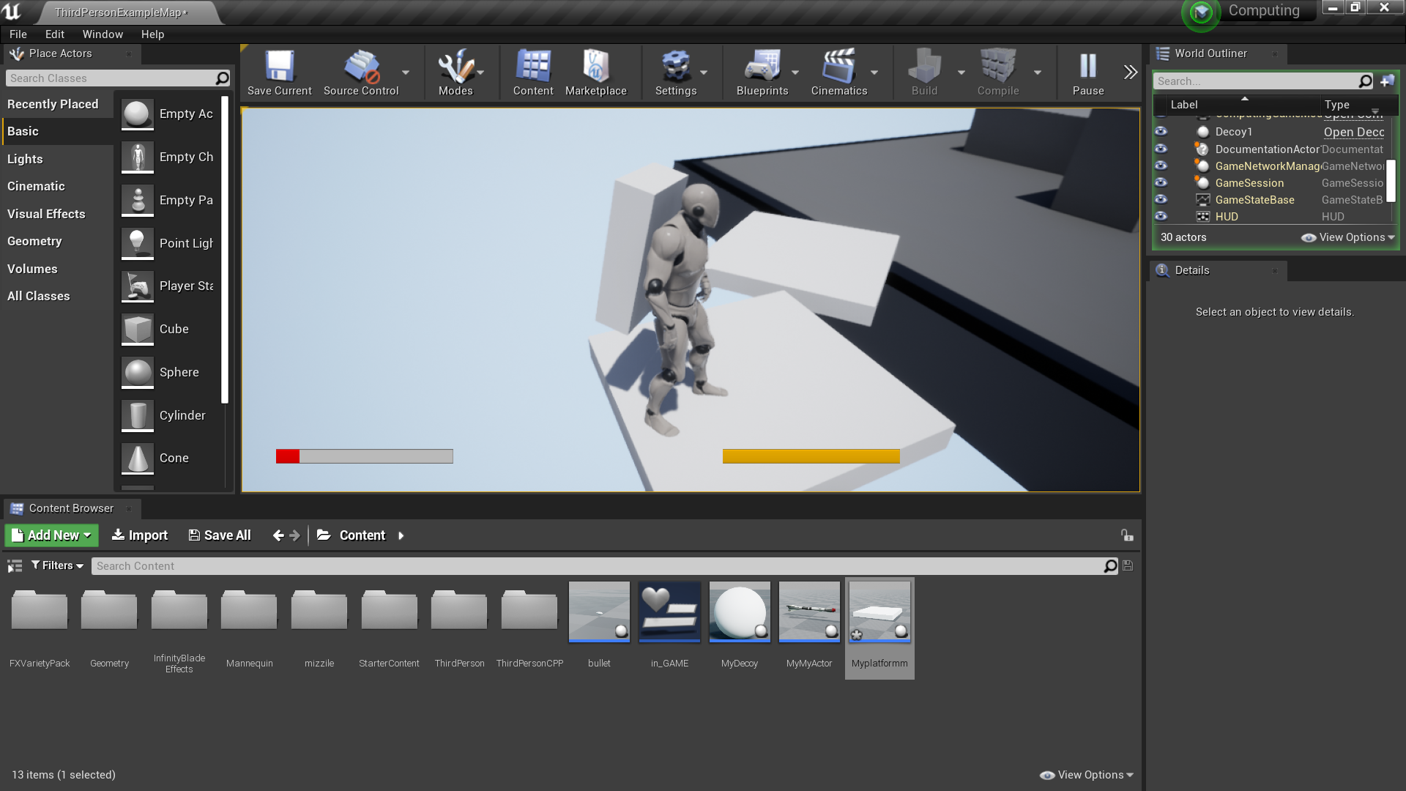

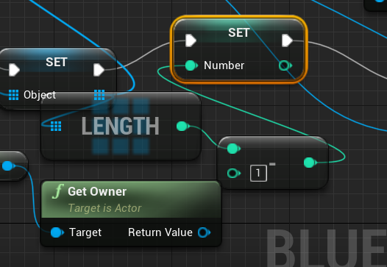

These nodes essentially tell the code that it should use the new C++ in game object representation rather than using the same C++ code file as the first platform, rather than having platforms working on a hive mind brain I made it so that they each get their own separate C++ file in a way.

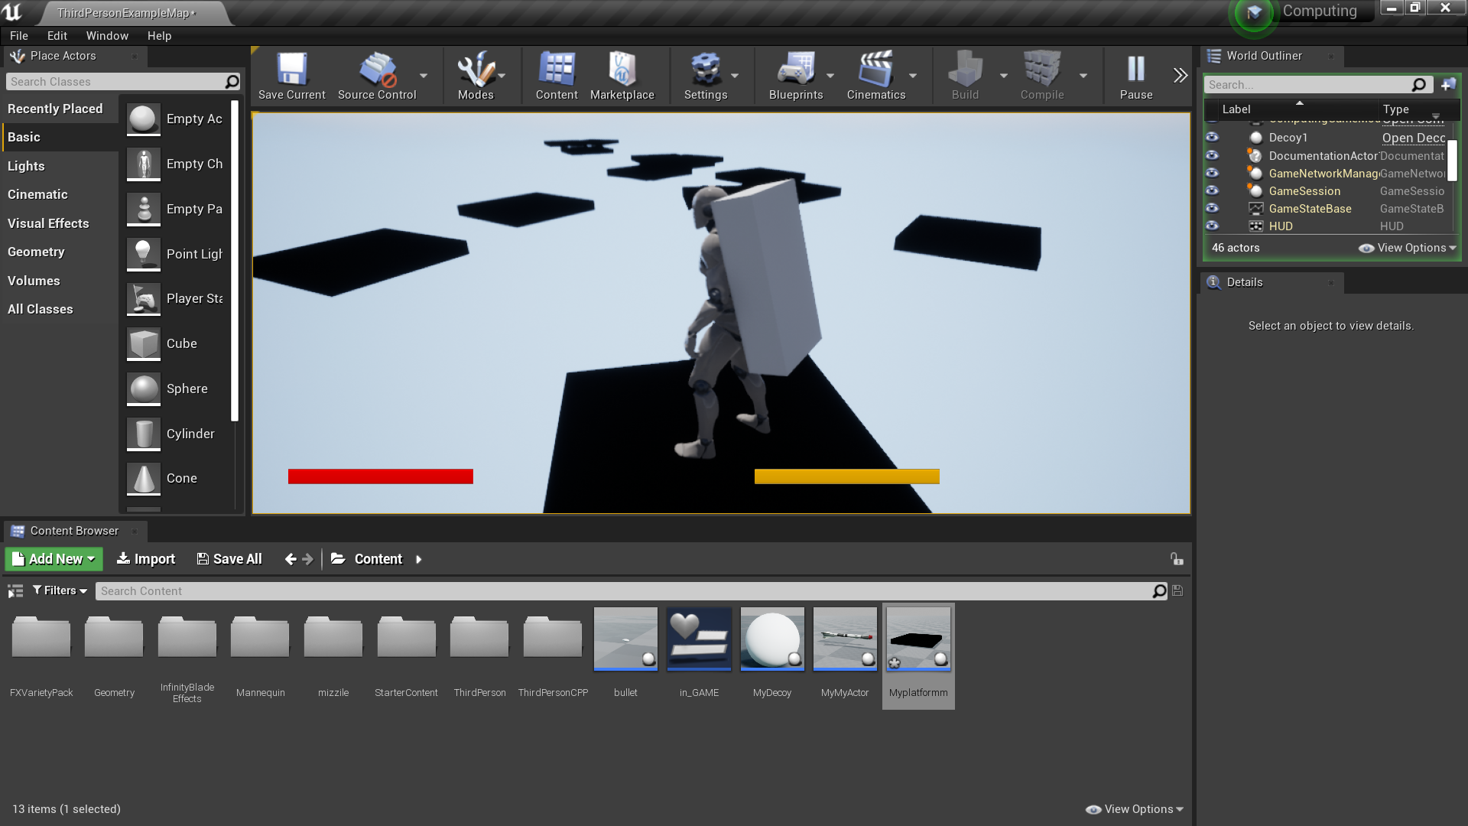

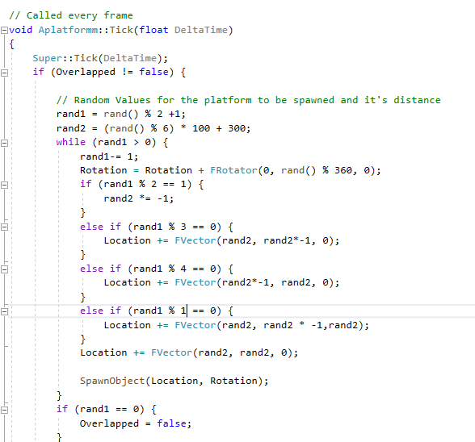

The random pattern the platforms was unintentional however I believe that these patterns are even better than what I wanted.

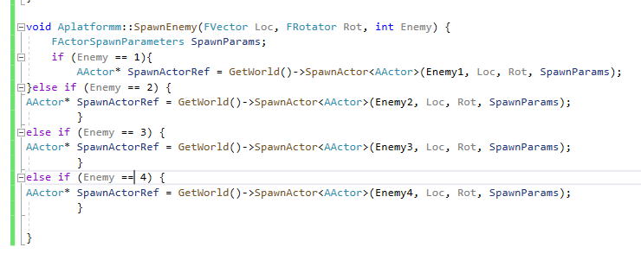

A function used to spawn in set enemies their value is set within the blueprint.

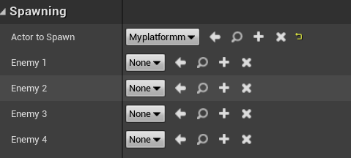

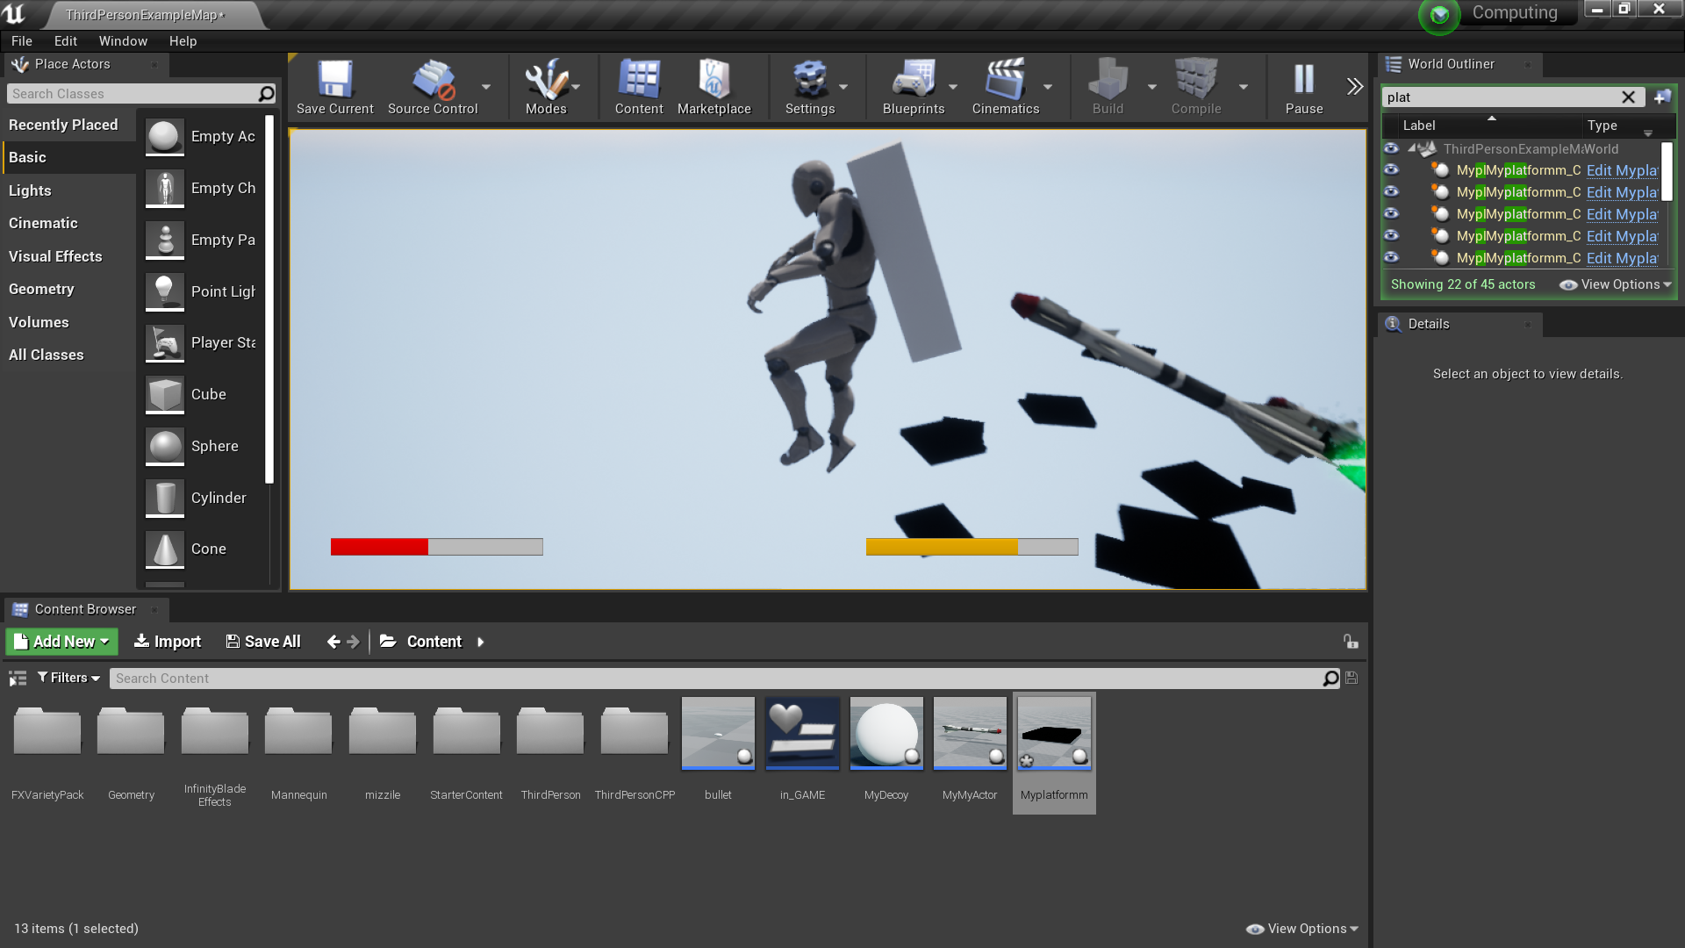

The platforms now have multi level spawning so some platforms spawn lower or higher and they also sometimes spawn in enemies which are these rockets, the amount of enemies spawning is quiet a lot so I decided to add health packs to the platforms.

##### Health packs

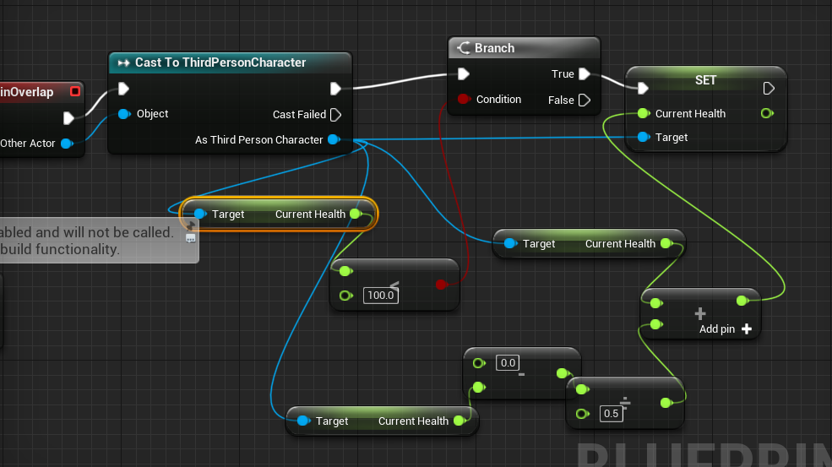

Tests worked on this overlap system.

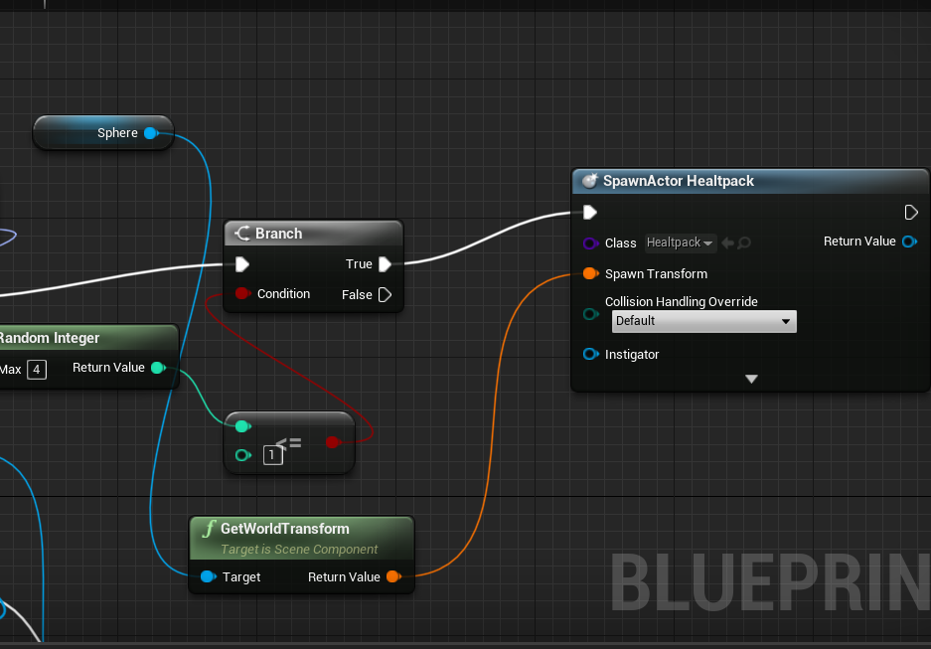

The spawning of set health pack

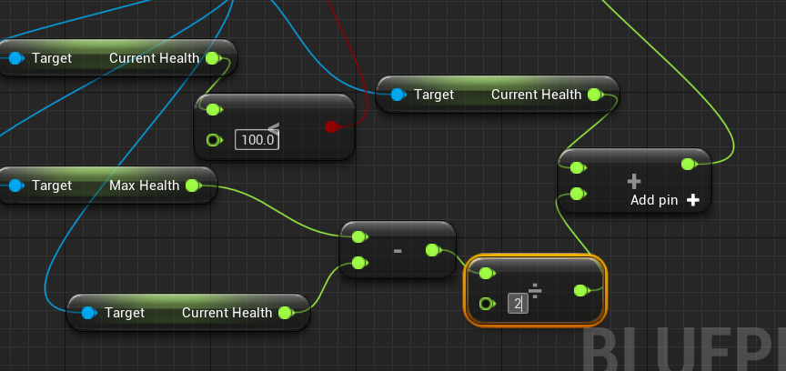

Noticed a error value must be set to two rather than 0.5

### FIXING THE PLATFORM ALGORYTHM

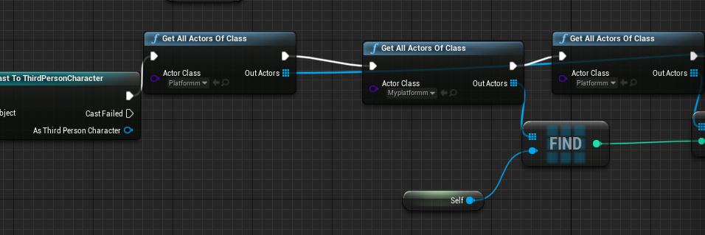

This simple fix has allowed each actor to have it’s own C++ actor class this should be able to clear up a lot of problems such as distance being too big.

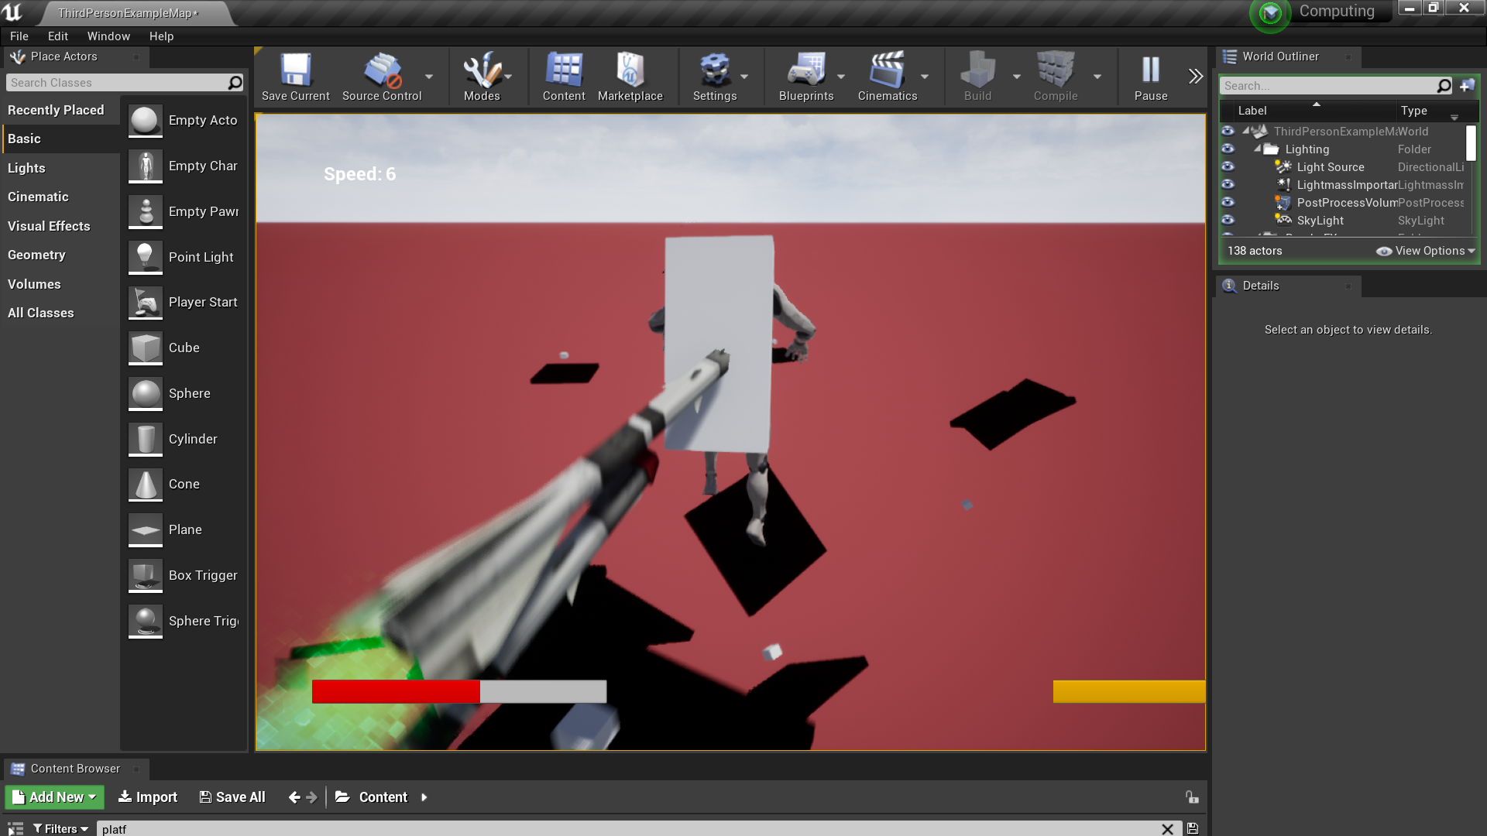

As you can see from the images this has allowed the platforms closer to each other

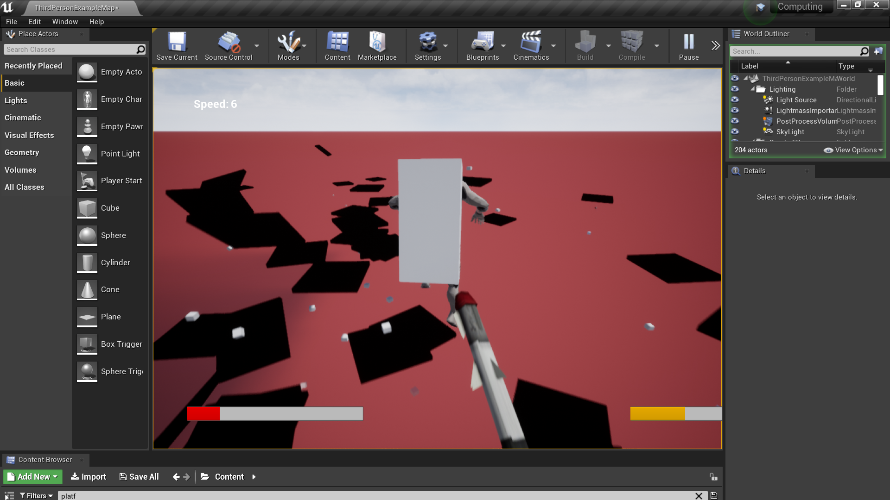

Not only this but with more variance they aren’t all in one direction.



I also decided to change the distance at which the platforms spawn to potentially be bigger



And also decreased the chance of a platform spawning

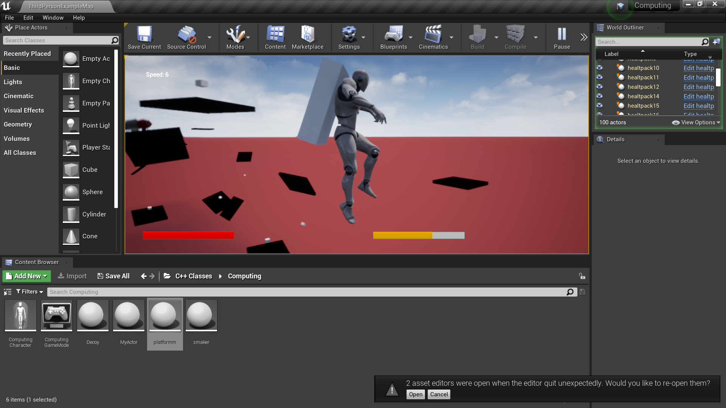

These platforms are now further apart which is very useful for making the game more challenging

### SUMMARY:

This is definitively more interesting to summarise because the overall platform turned our to be slightly different to what I previously wanted changing the whole game design however I’d say that is not actually negative and it made the game more fast paced rather than slow and casual, however the ai that I made nicely complemented with this change, ai in ue4 tends to act more violently towards the player rather than with slow movements like on unity however I found more creative freedom by doing it this way rather than making it slow like games such as legend of Zelda so I’d say that the platform random spawning algorithm was actually more of a success than I previously anticipated at the start of development. One thing I wished I had enough time to do is add more obstacles this would have been easy as I would have just made different size platforms with spinning blades, stationary turrets and landmines however I didn’t have enough time to finish this.

Achieved: Randomness **√** Size is big enough to support the player **√** Rotation of the platforms is randomised **√** Different platforms X

## Kill Volume

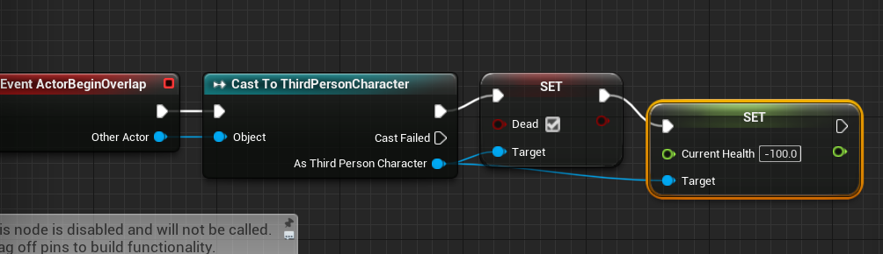

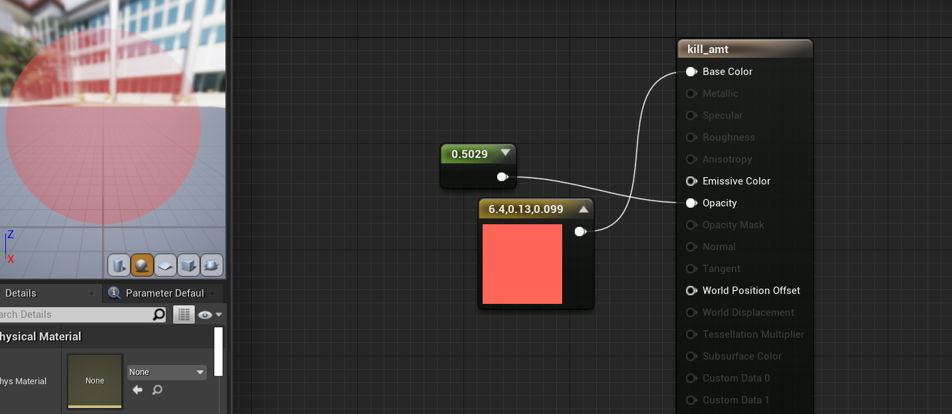

The material of the kill volume.

### SUMMARY:

The kill volume was a success, having two overlap sometimes caused issues however just having one seemed to work perfectly fine.

Achieved: Kills player**√** Clear that it kills you**√**

## Speedometer



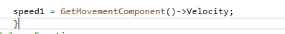

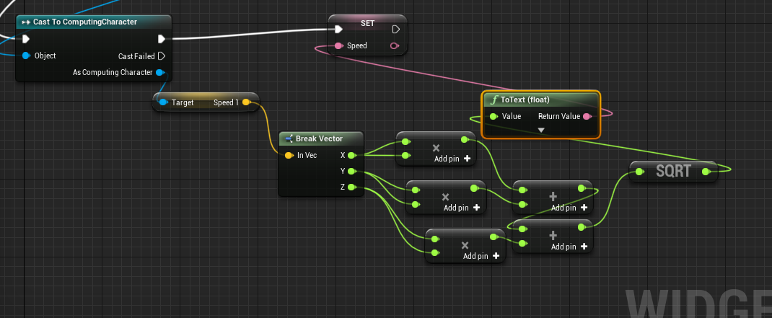

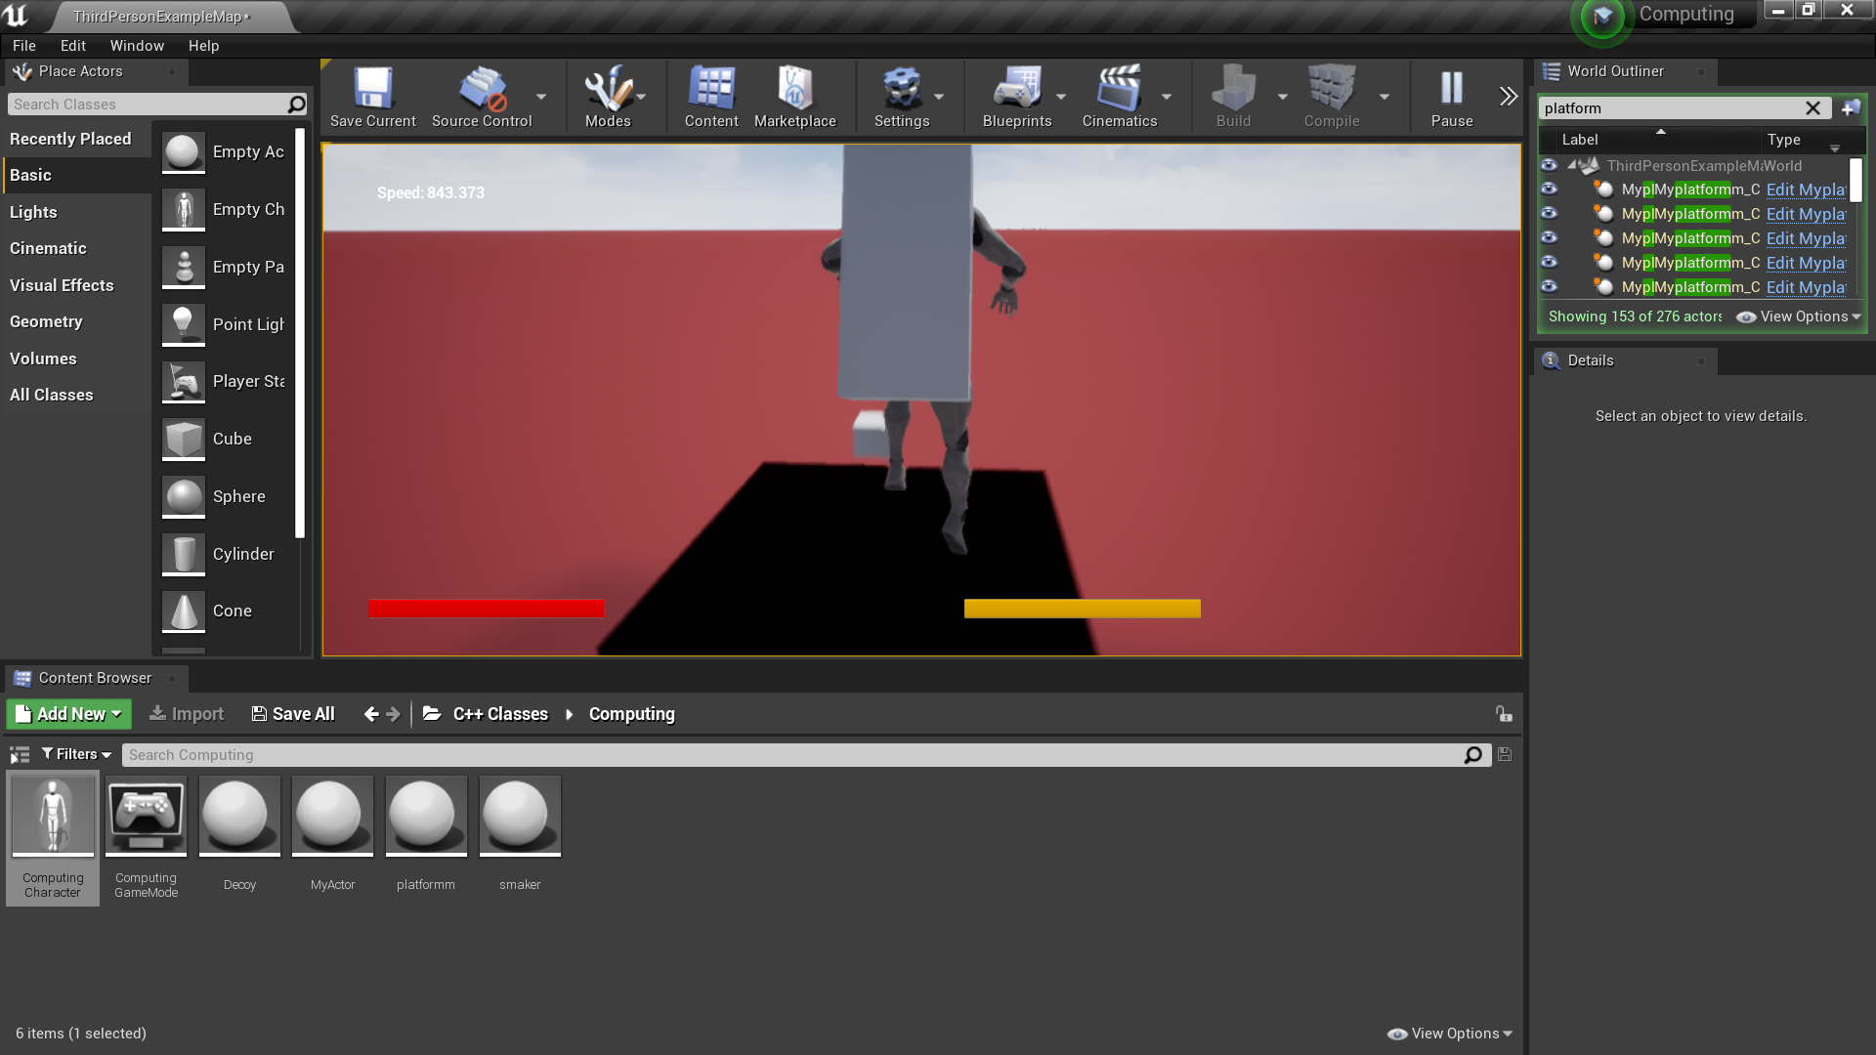

The value given was too precise and it wasn’t in meters:

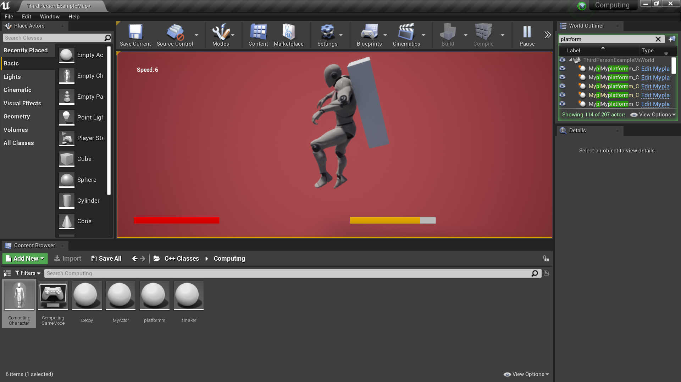

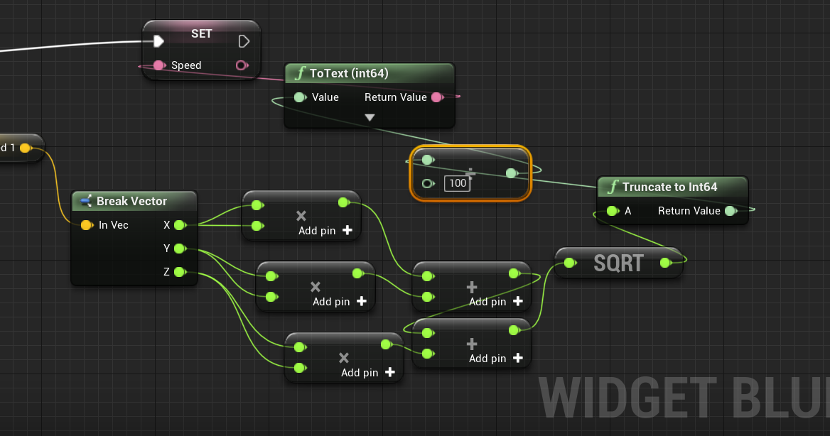

Problem fixed😊

### SUMMARY:

The speedometer displayed the speed of the player well I don’t have much to add other than that it successfully did it’s job

Achieved: Display of the persons velocity **√**

## Ramming Ai

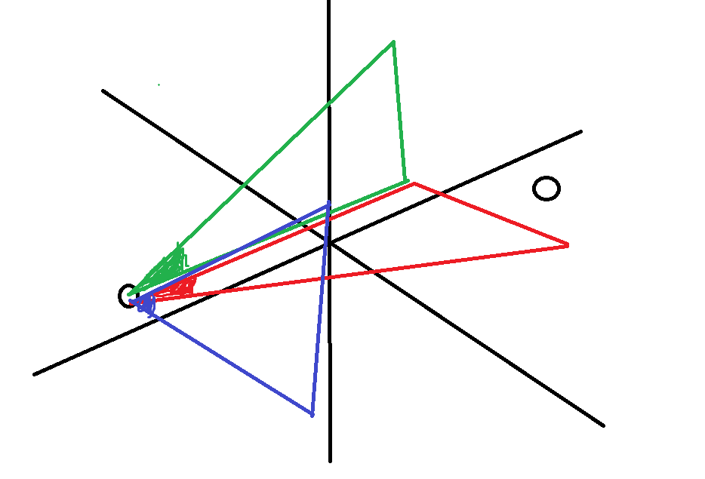

Using simple Trigonometry should allow me to find the turn to rotation my object should turn at this will allow my ramming ai to smack into the player.

The X rotation is simply Tan-1(X1/X2) the same idea works for the other lengths.

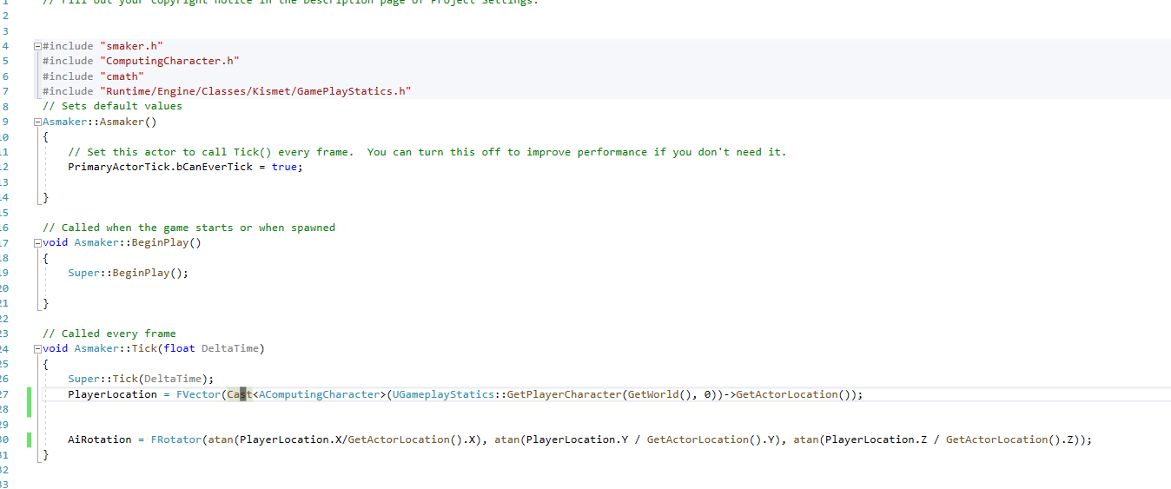

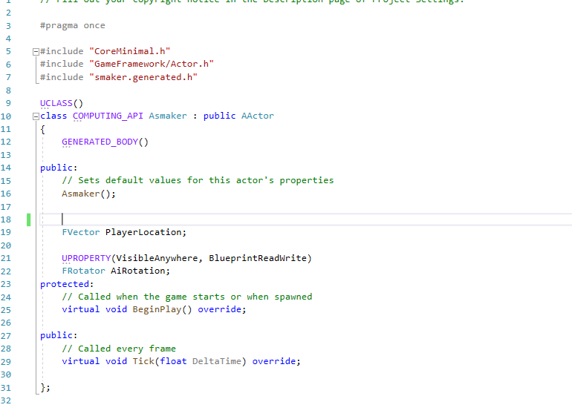

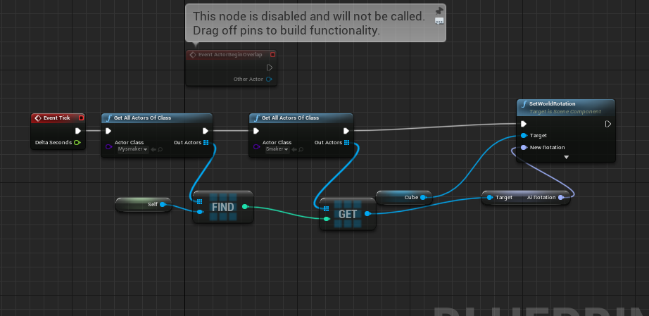

Lets now find how the code behaves in the game environment.

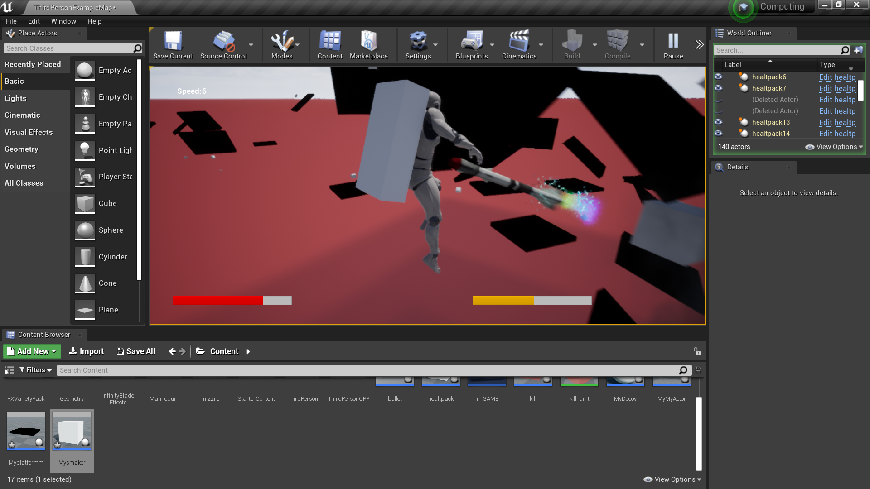

The smacker ai turns towards the player now it’s just time to make it actually move towards the player as well.

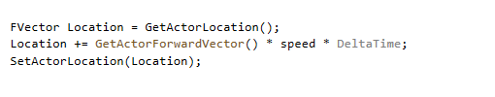

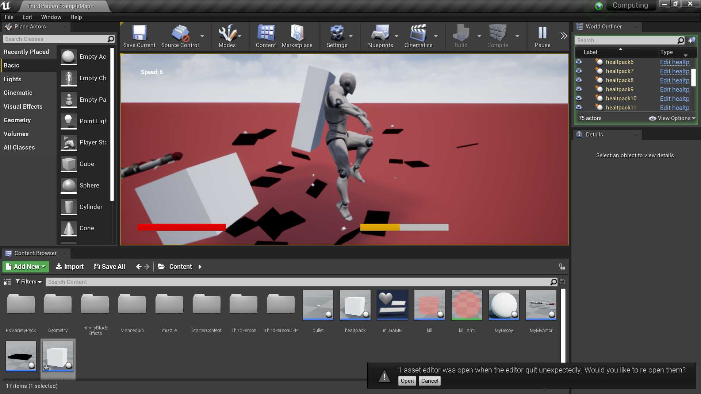

The ai works perfectly fine time to add it to the platform creator

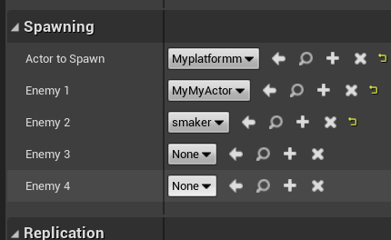

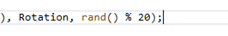

I also decided to change the chance of a enemy ai spawning to a smaller value.

### SUMMARY:

The ramming ai was overall great however to which extent it was effective at killing the player it rammed them and pushed them so it did the job however it can be used to actually aid the player as they can just ride the ai away.

Achieved: Rams player**√** Hindering the player???

# Shooting Ai:

I decided to add an ai which fires the previously made bullets to damage the player.

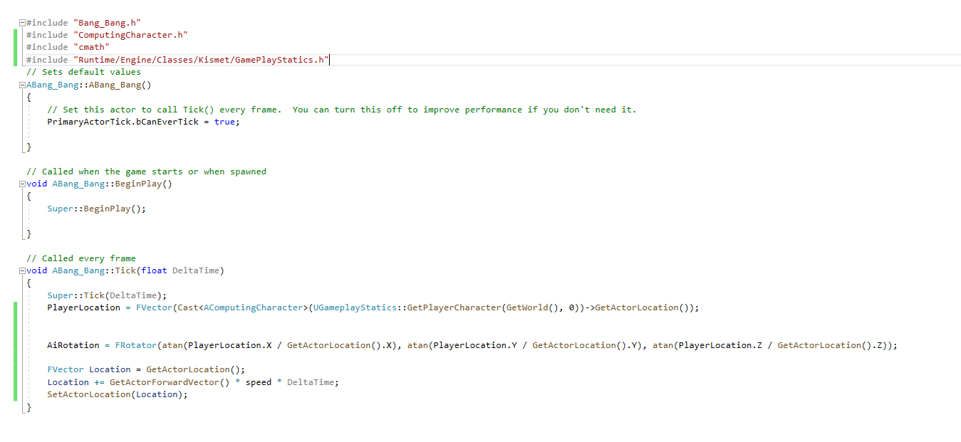

I decided to use the same exact piece of code as I used previously for the ramming ai for the actual movement of the ai.

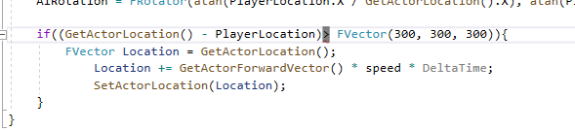

I added this check right here to make sure that the ai doesn’t get too close to the player

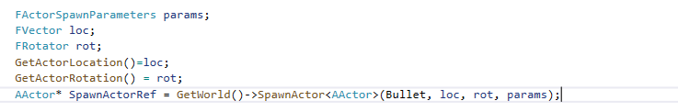

I had to put the GetActorLocation() and the GetActorRotation() outside the spawn actor function this was because the spawn actor function dosen’t work well with other pieces of code.

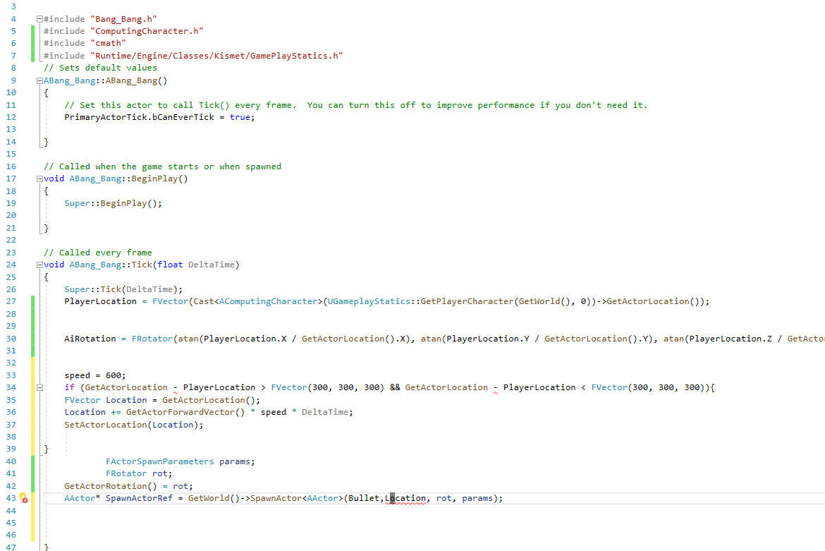

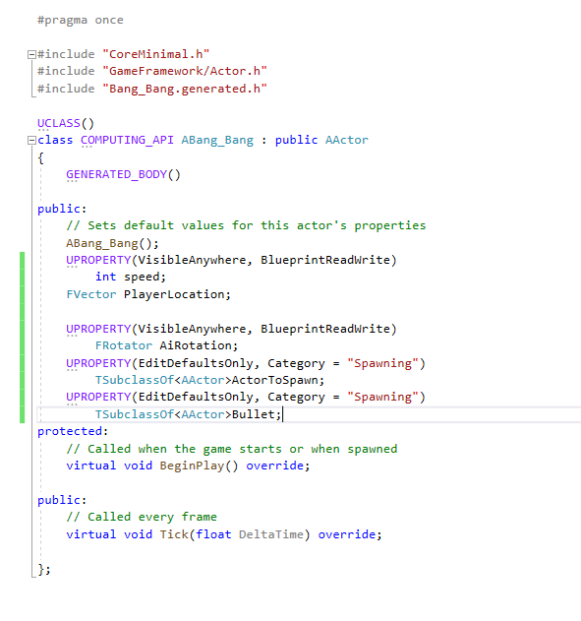

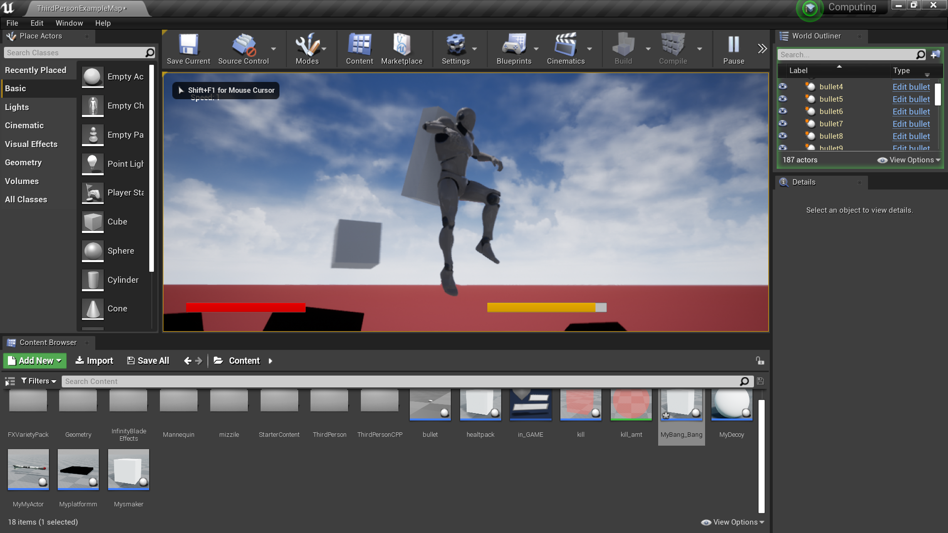

The code works perfectly fine the bullets are in the game they are a bit too quick but they are being spawned in the top right of the screen.

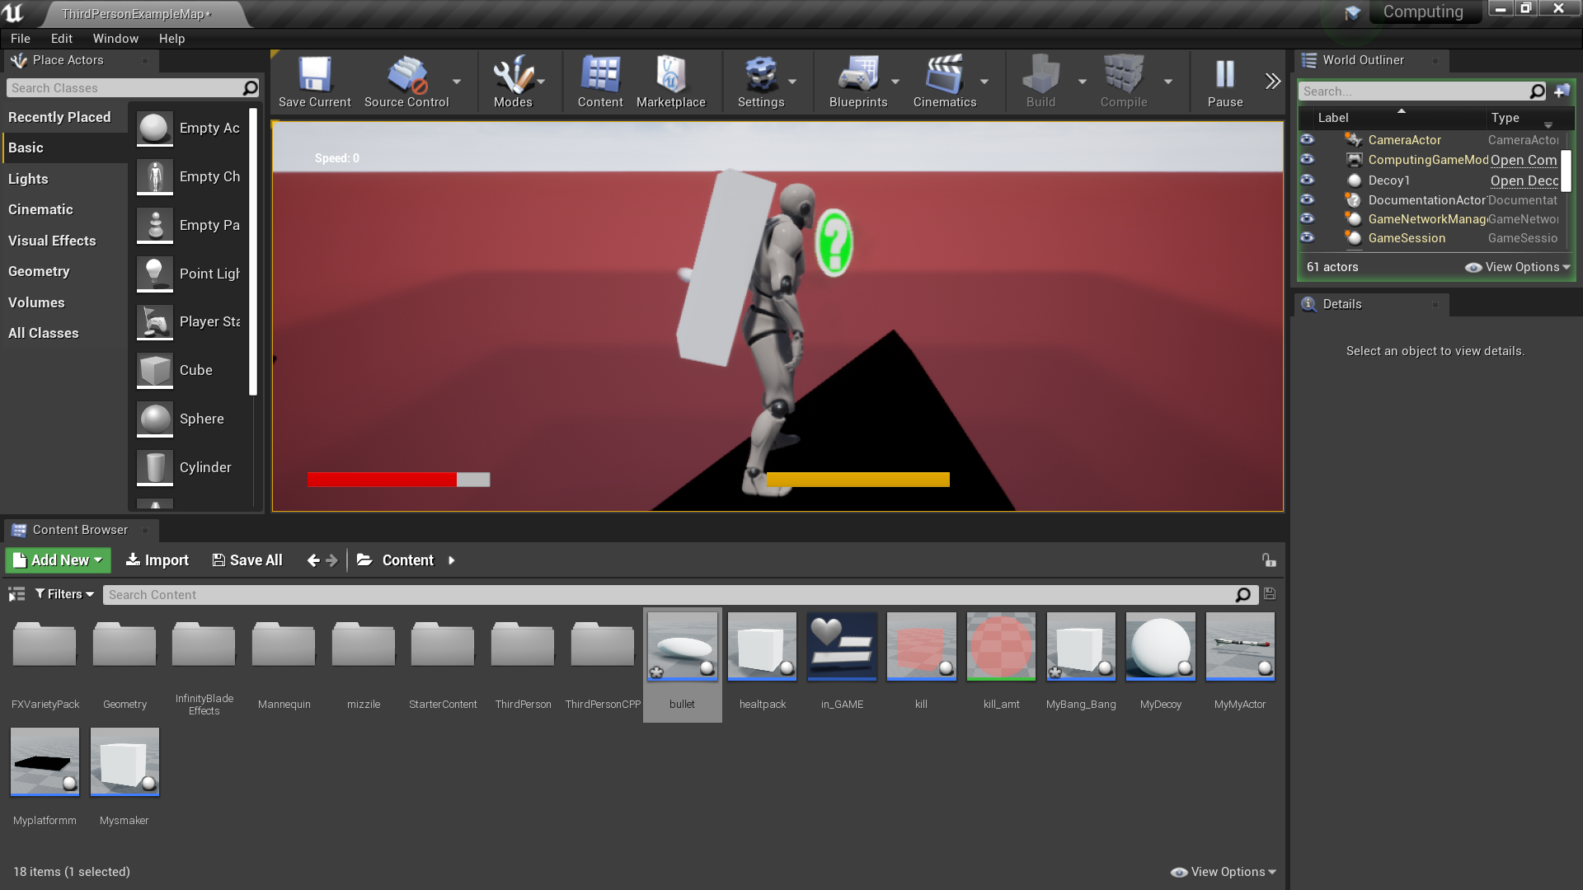

You can barely see a bullet passing by the character about to hit him this bullet causes damage and is spawned by the turret, the reason you can’t see the turret is because I’ve turned on the engines ability to simulate momentum so the turret doesn’t just turn instantly

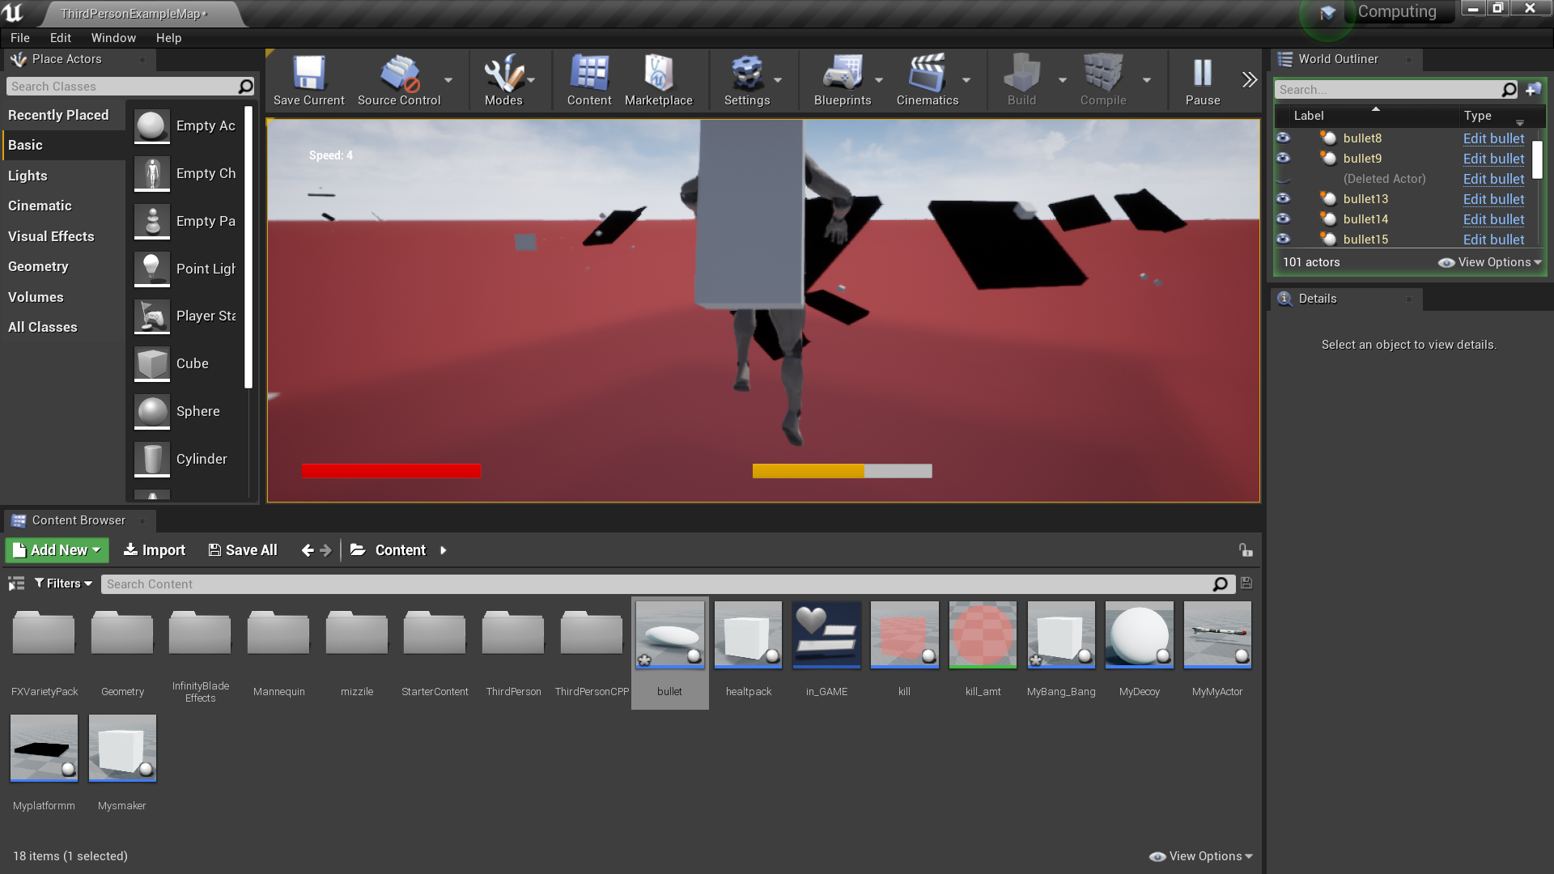

This is a much better picture.

### SUMMARY:

The shooting ai works just like the ramming ai and the targeting system seems to hit the player just fine, however if I was to improve it I would make sure the shots are precalculated to hit in front of the character instead so that they have a higher chance of hitting and damaging the player.

ACHIVED: Kills the player**√** Near perfect aim**√**

# Fire Mechanism



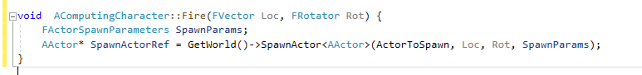

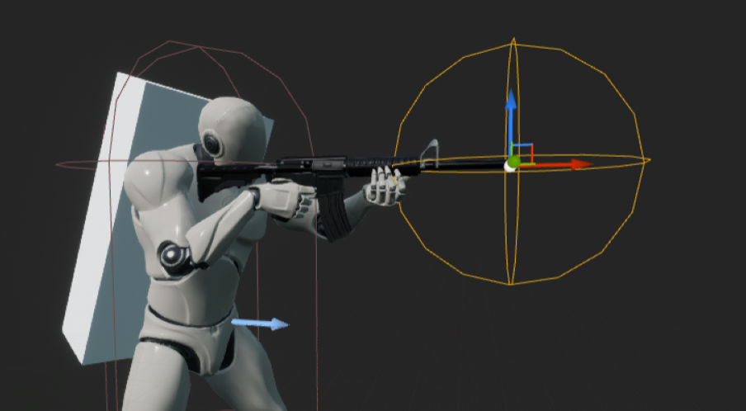

I then use a sphere collision to dictate the direction of where the bullet will be spawned from this was the x direction this is very useful as having bullets come from a setpoint which can be communicated to the main C++ function allows the code to work more efficiently as this is a point directly linked to the C++ file rather than a free point simply constantly noting the location of this value and sending it to the main C++ function was the easiest way around.

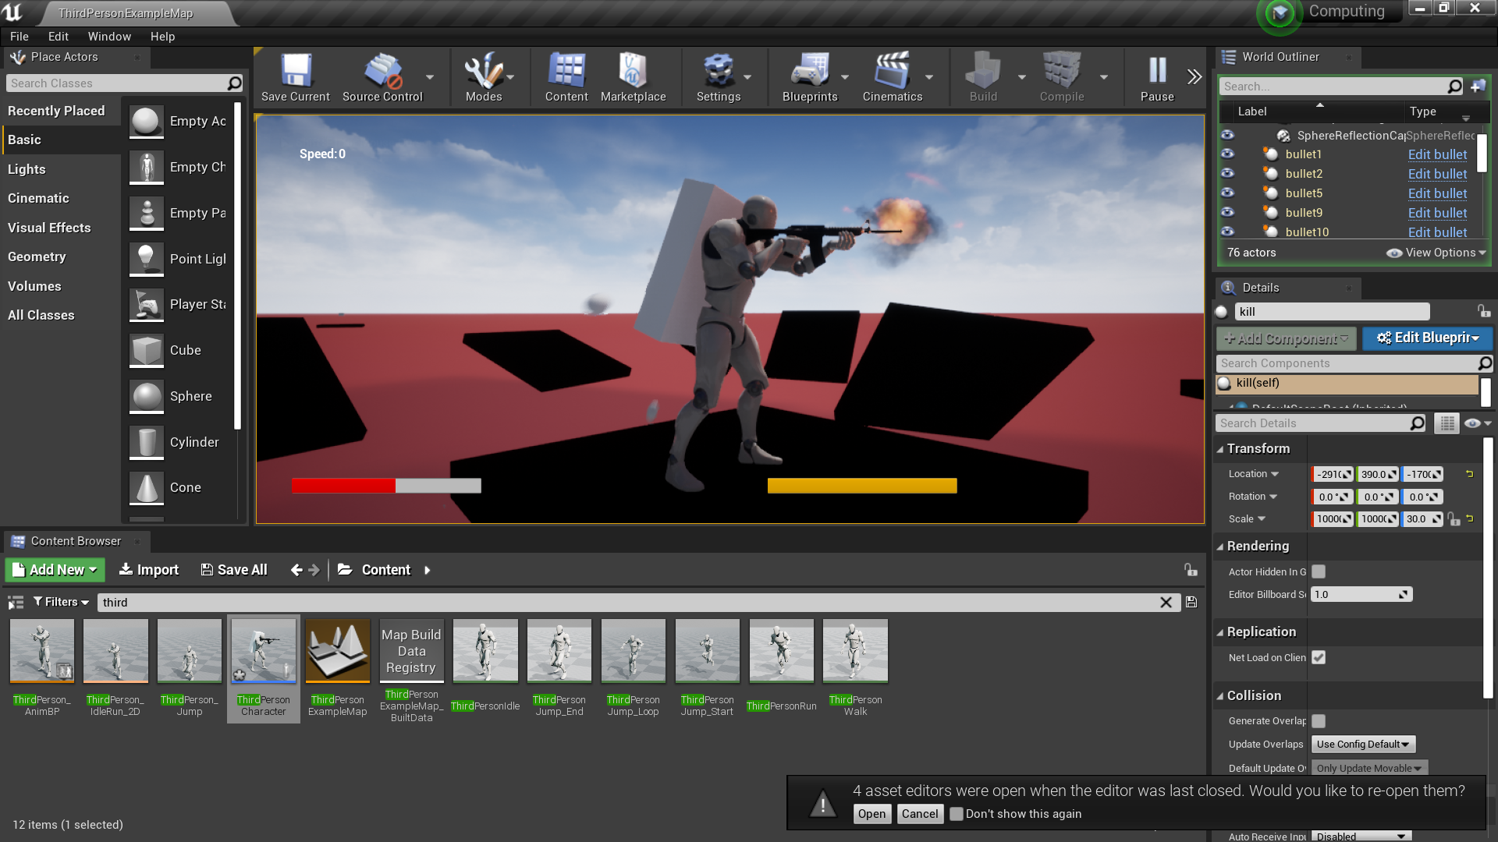

The bullet was fired but now it’s time to make a reloading mechanism and a ammo system.



I added this to the main Fire() function.

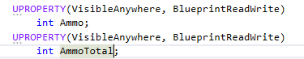

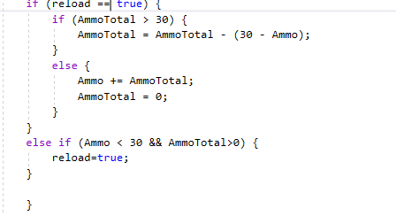

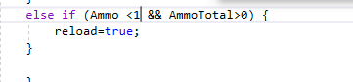

Change in code after testing just noticed that piece of code was wrong ^^^

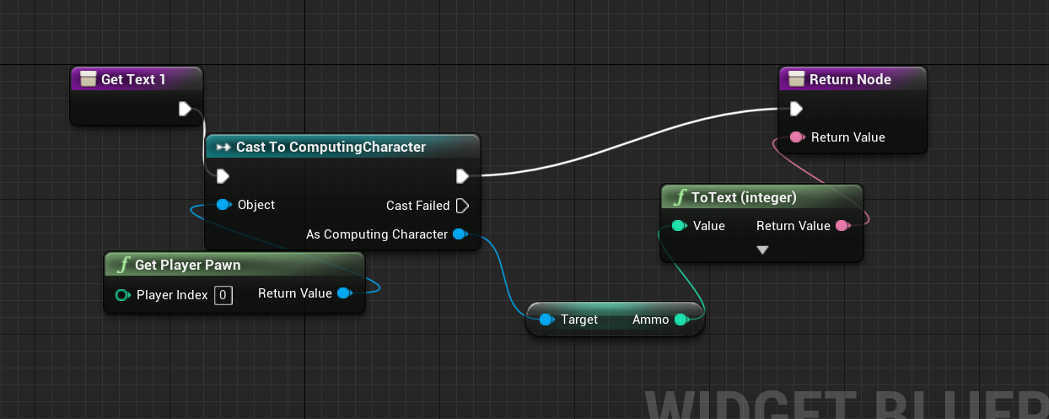

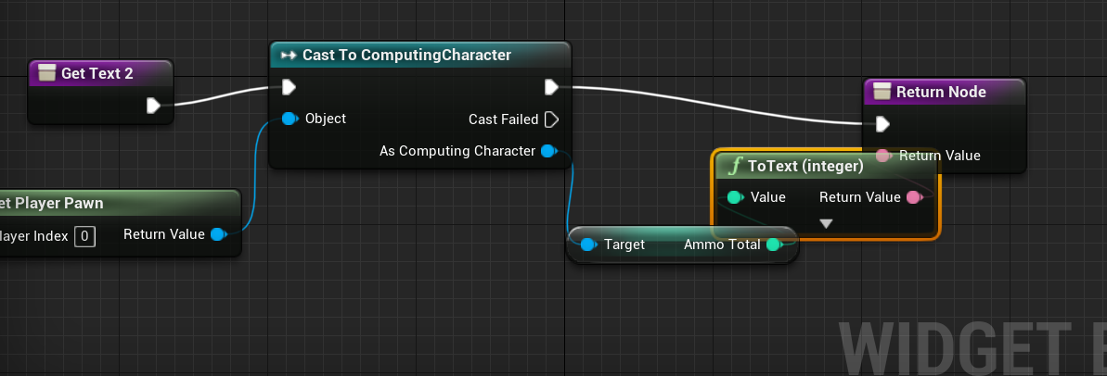

These were part of the user interface so that the total ammo the player has can be displayed on screen.

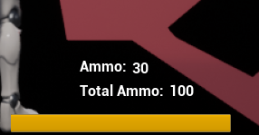

This is clearly displayed below :)

### SUMMARY:

The aim and overall trajectory was very good however the player might have had his aim too greatly improved it was essentially perfect shots on the enemy so it would have been good to maybe dial down and add some spread to the bullets.

Player Bullet

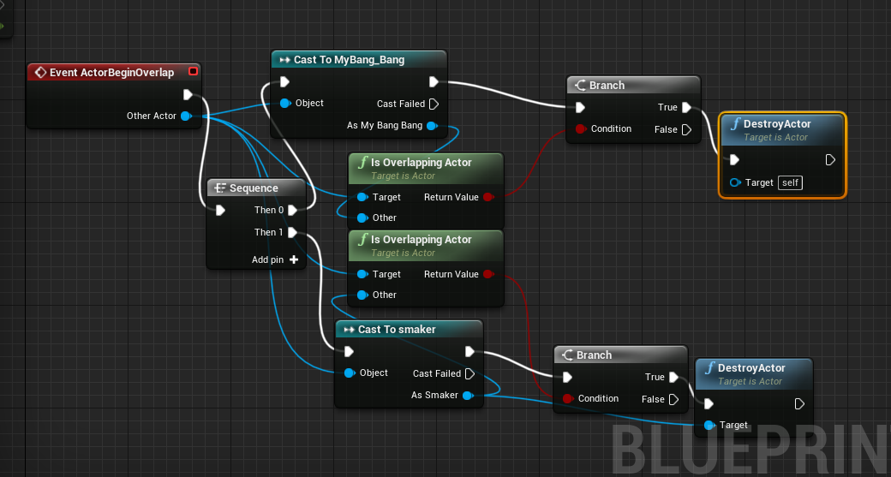

This algorithm does cause the enemy ai to get destroyed and disappear.

### SUMMARY:

It caused the player to kill a enemy ai when a hit happened it is pretty self explanatory 100% successful.

Kills enemy ai**√**

## ANIMATION

## Crouching



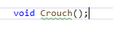



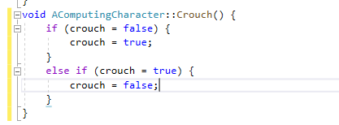

On crouch being touched- name of key binding, it will store that crouch is true this is so other files can take the information from one location, I also did it via a flip flop so that the same button is used to crouch and stop crouching.

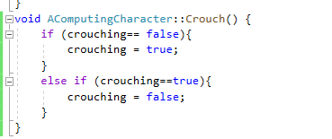

On compiling it first the code did not work as the variable name crouching was finicky within the engine so I changed the name.

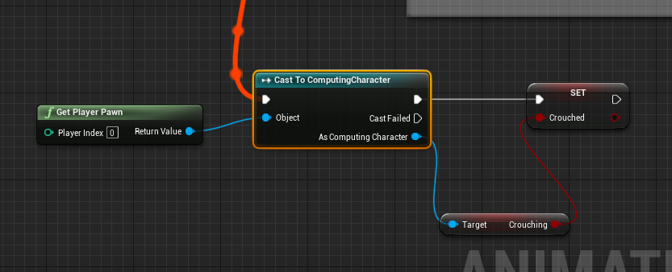

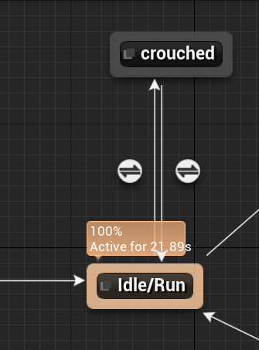

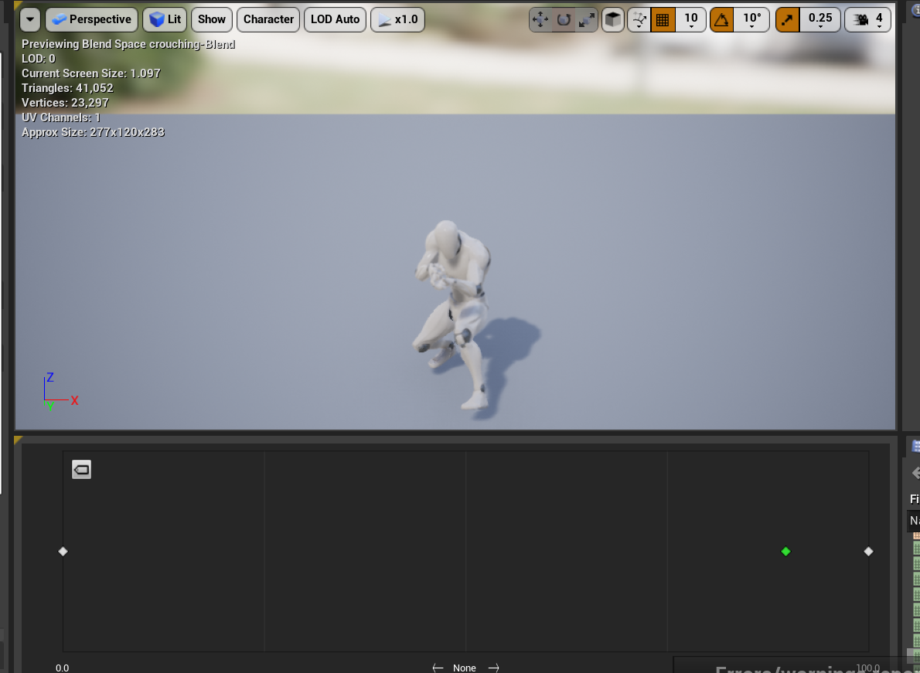

Test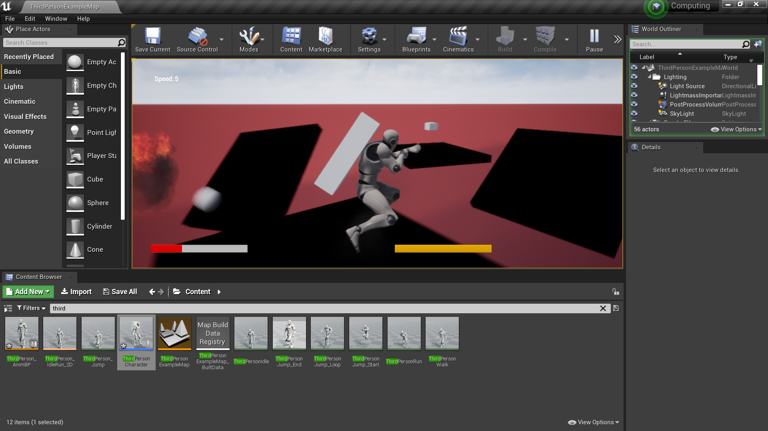

The test was a complete success however I must add one more thing to make the animation seem correct.

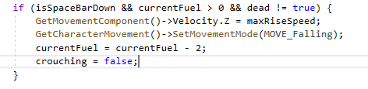

In the event of the jetpack turning on I think it would be better for the player to get up rather than keep crouching.

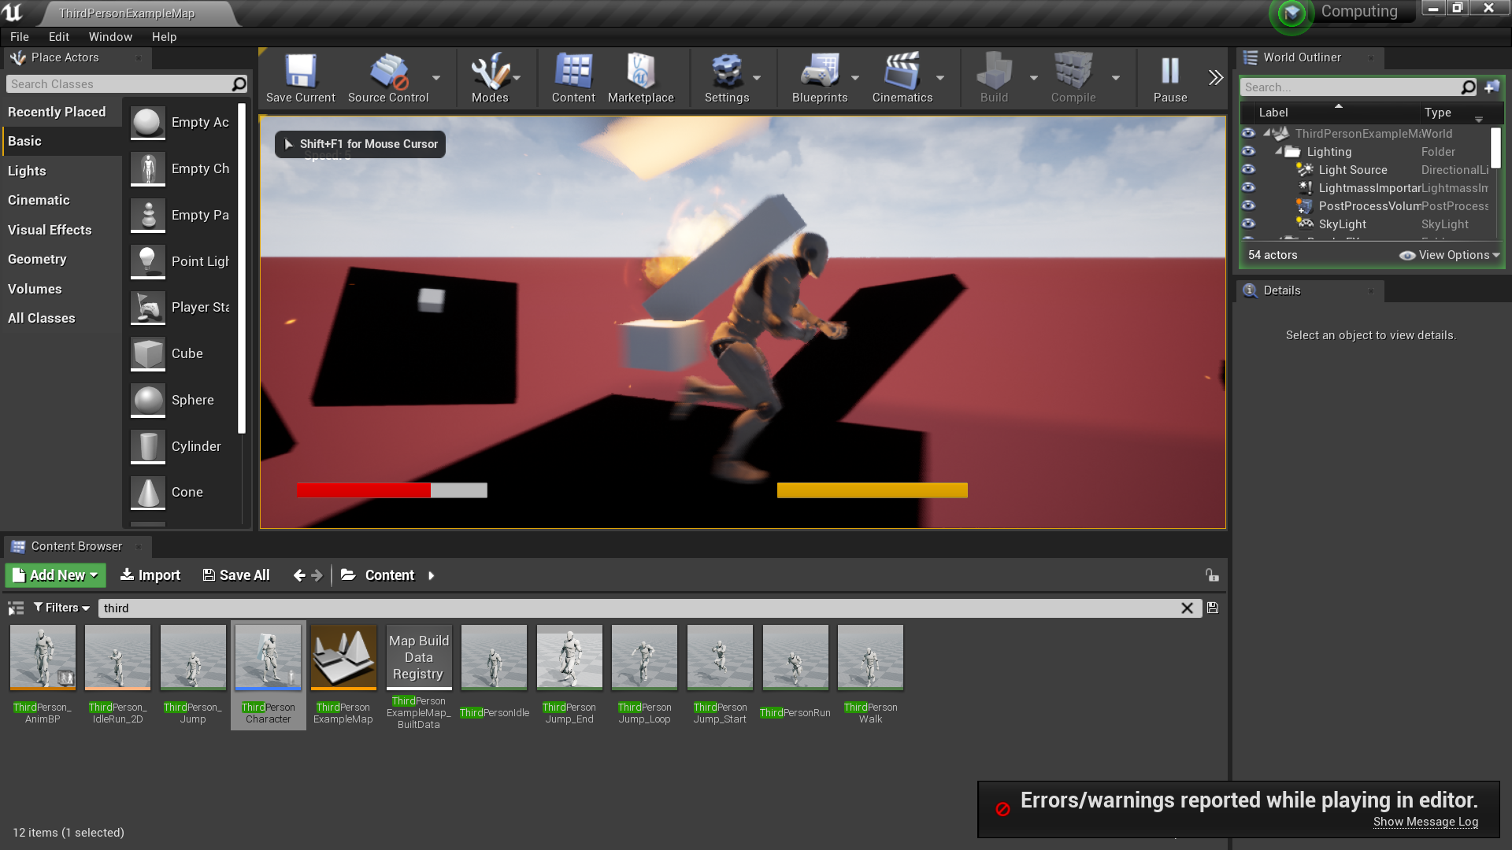

On top of that I also changed the normal blend space so that the character actually holds a gun.

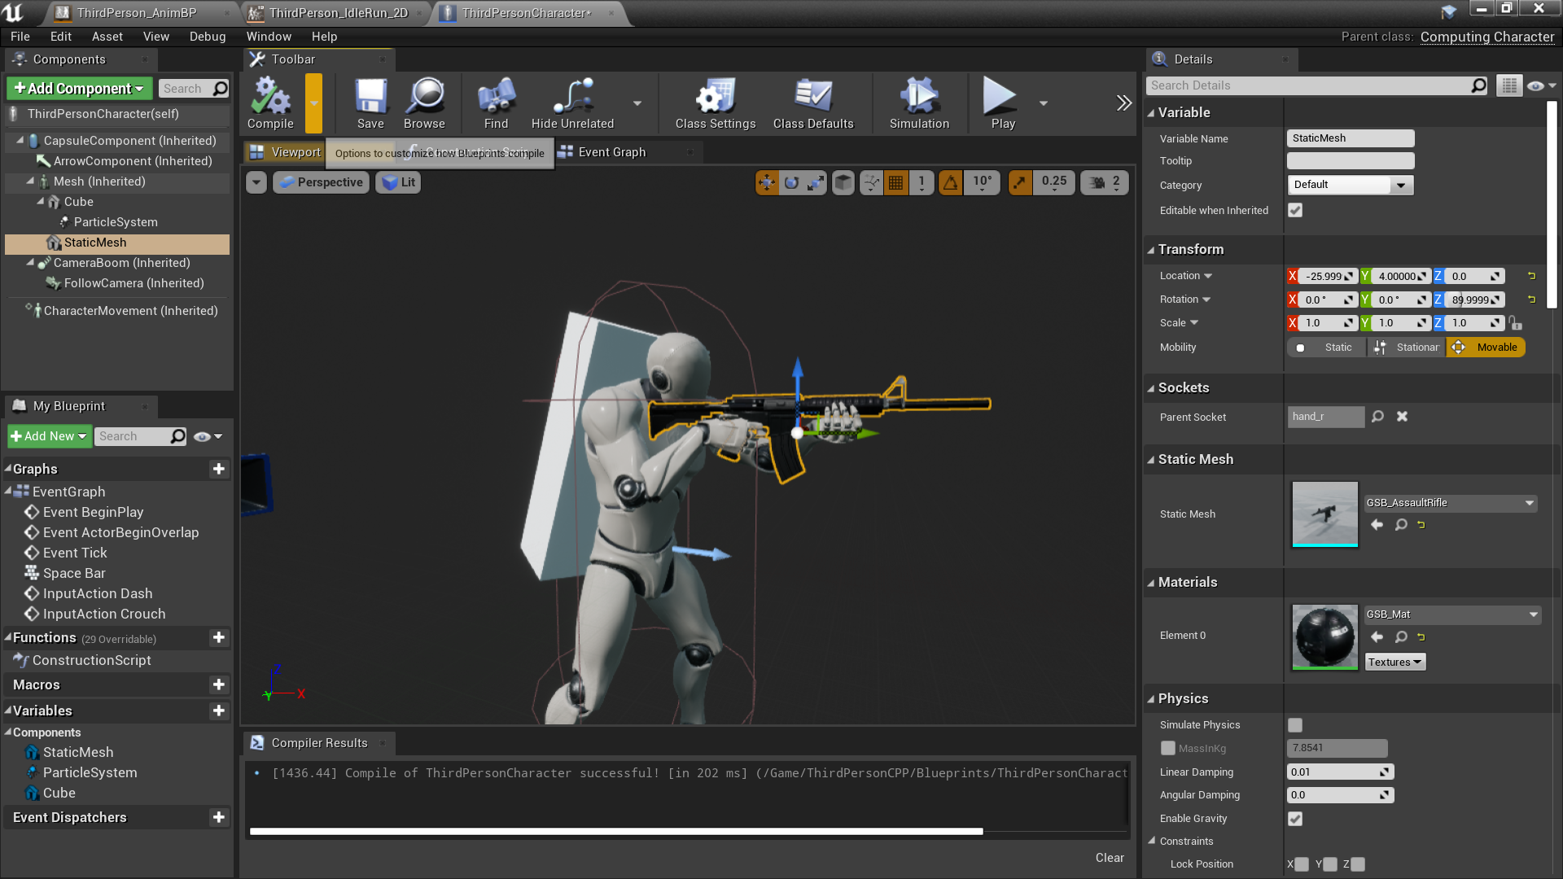

Actual gun mesh installed.

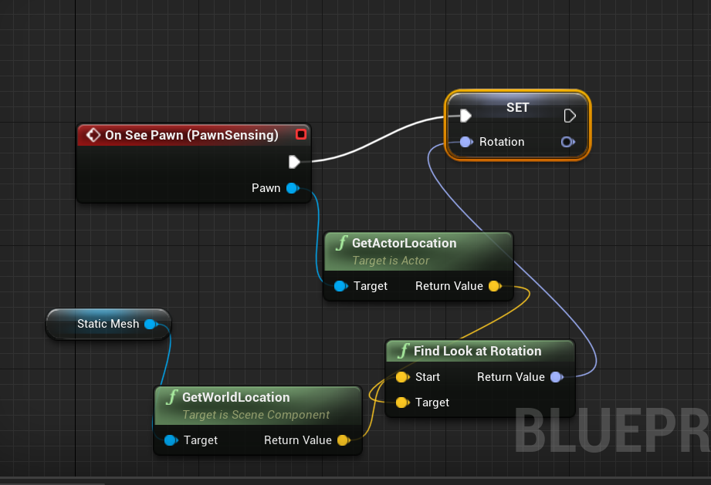

^^^^ this code right here is so that the character turns their body and aims at the enemies.

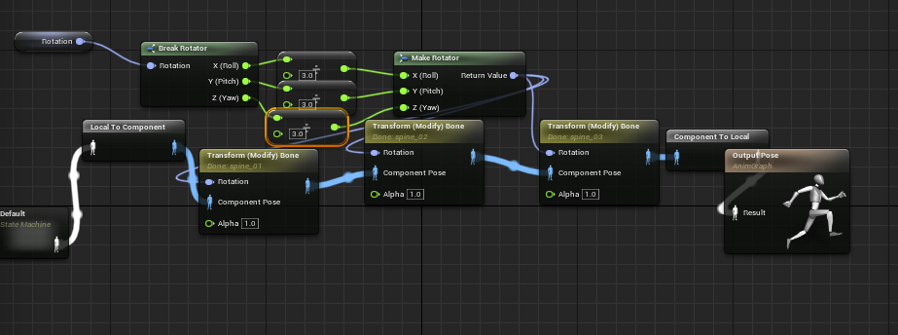

Reload Animation

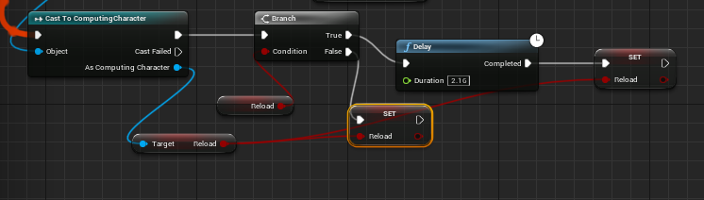

This is here so that when the animation doesn’t switch automatically back to the non-reloading animation, this is so that it only does so after the entire animation has played.

Test:

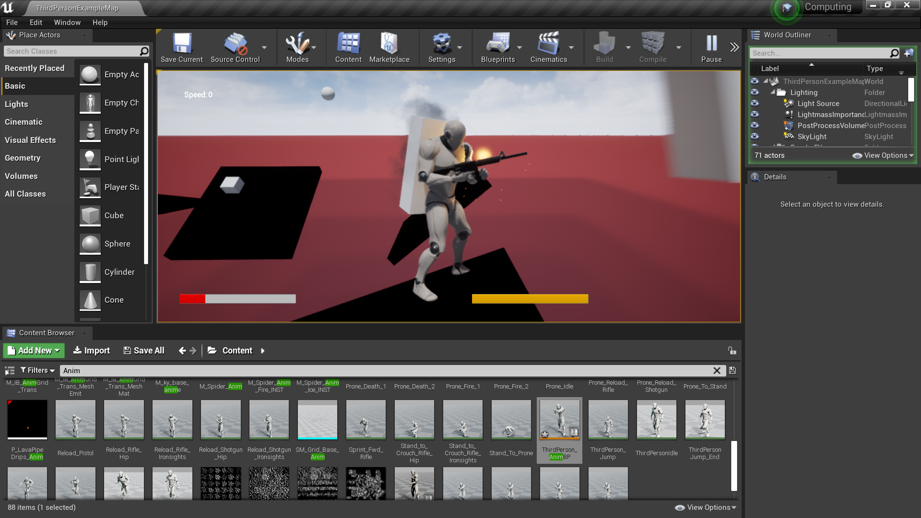

### SUMMARY:

The animation ended up alright if I was going to add attention to detail I would have made a clip actually come out the mesh and it exchanging behind the player however due to the pressure on time I just added the animation in which was good enough to suffice this game.

Achieved: No clipping**√** Animates at the right times **√**

Saving the game/Loading

Save_Load.CPP

#include "Save_LoadSubSystem.h"

#include"Serialization/Archive.h"

#include "Serialization/BufferArchive.h"

#include "Kismet/KismetSystemLibrary.h"

#include "UObject/SoftObjectPtr.h"

#include "Serialization/ObjectAndNameAsStringProxyArchive.h"

#include "Misc/FileHelper.h"

//creates the subsystem if the game actually exists

bool USaveLoadSubsystems::ShouldCreateSubsystem(UObject* Outer) const {

const UWorld* World = Cast<UWorld> Outer;

return World && World->IsGameWorld();

}

//save function

void USaveLoadSubsystems::Save(AActor* Actor) {

FString FilePath UKismetSystemLibrary::GetProjectSavedDirectory() + "player.Sav"

FActorSpawnInfo ActorData;

ActorData.ActorTransform = Actor->GetTransform();

ActorData.ptr = Actor->GetClass;

FMemoryWriter ActorWriter(ActorData.ActorSavedData, true);

FSaveArchive Ar(ActorWriter, true);

Ar << ActorData;

Actor->Serialize(Ar);

if (FFileHelper::SaveArrayToFile(ActorData.ActorSaveData, *FilePath)){

Ar.FlushCache;

Ar.Close;

}

//load function

void USaveLoadSubsystems::Load(AActor * Actor) {

FString FilePath UKismetSystemLibrary::GetProjectSavedDirectory() + "player.Sav"

TArray<uint8> BinaryArray;

if (!FFileHelper::LoadFileToArray(BinaryArray, *FilePath)) return;

if (BinaryArray.Nun() <= 0) return;

FMemoryReader FromBinary(BinaryArray, true);

FromBinary.Seek(0);

FSaveArchive Ar(FromBinary, true);

FActorSpawnInfo SpawnInfo;

Ar << SpawnInfo;

AActor* ActorOut = Actor;

ActorOut->SetActorTransform(SpawnInfo.ActorTransform);

ActorOut->Serialize(Ar);

FromBinary.FlushCache();

BinaryArray.Empty();

FromBinary.Close();

}

Save_Load.h

#pragma once

#include "CoreMinimal.h"

#include "Subsystems/WorldSubsystem.h"

#include "Serialization/ObjectAndNameAsStringProxyArchive.h"

#include "save_load.generated.h"

struct FSaveArchive : public FObjectAndNameAsStringProxyArchive {

FSaveArchive(FArchive& InInnerArchive, bool bInLoadifFindFails) : FObjectAndNameAsStringProxyArchive(InInnerArchive, bInLoadifFindFails) {

ArIsSaveGame = true;

ArNoDelta = true;

}

};

USTRUCT(BlueprintType)

struct FActorSpawnInfo

{

GENERATED_BODY()

UPROPERTY(EditAnywhere, BlueprintReadWrite, SaveGame)

FTransform ActorTransform;

UPROPERTY(EditAnywhere, BlueprintReadWrite, SaveGame)

TSoftClassPtr<class AActor> ptr = nullptr;

TArray<uint8> ActorSaveData;

friend FSaveArchive& operator <<(FSaveArchive& Ar, FActorSpawnInfo& ActorData) {

Ar << ActorData.ActorTransform;

Ar << ActorData.ActorSaveData;

Ar << ActorData.ptr;

return Ar;

}

};

UCLASS()

class SAVELOADOUT_API USave_LoadSubsystem : public UWorldSubsystem {

GENERATED_BODY()

virtual bool ShouldCreateSubsystem(UObject* Outer) const override;

public:

UFUNCTION()

void Save(AActor* actor);

UFUNCTION()

void Load(AActor* actor);

};

This algorithm essentially saves the entire game and all of it's values it does this by saving everything and saving it on a file with the user directory plus player.Sav at the end, this will save your most recent game.

### SUMMARY:

The saving algorithm worked perfectly fine one thing I would change is that it doesn’t save the whole game because when I only need to save the values for the key bindings it saves the entire game being costly on the users memory however this algorithm is perfect for autosaving or in-game saving so it did it’s job however due to the presser of the time available I used one single algorithm for the entire thing.

Achieved: Saves game**√** Specialized saving for different parts of the game X

Menu:

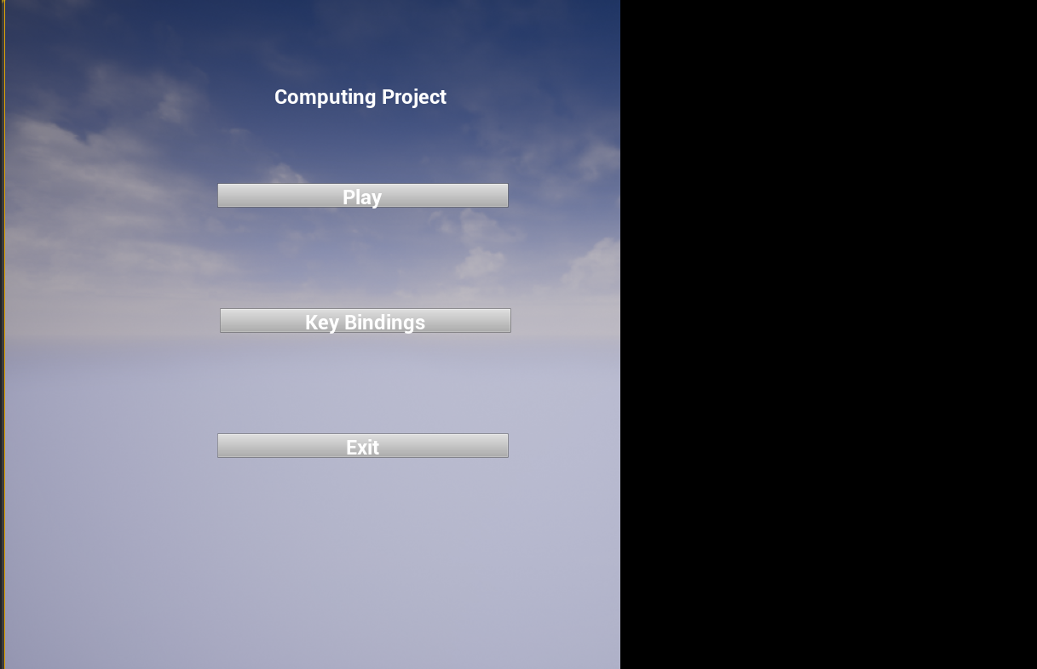

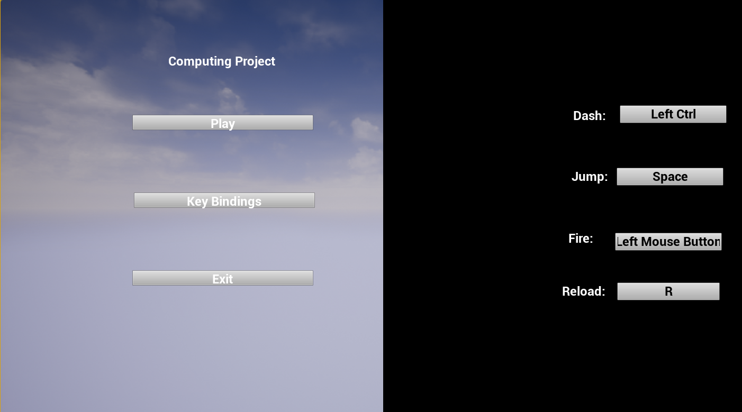

This is the menu all buttons when tested have worked on top of this I’ve put my saving algorithm in to save key bindings and that does work as you would just get the default key bindings on the other side of the level

### SUMMARY:

The menu works perfectly fine it does it job, it would have had been nice to add a bit more options to add a bit more key bindings etc however the menu does the basic requirements I had of it.

Key bindings**√**

## TEST PLAN:

### Menu:

|  |  |  |  |
| --- | --- | --- | --- |
| What is to be tested: I will check if the mouse is free to move on the interface of the menu | Input Data: I will move my mouse around on the screen | Expected Outcome: if the mouse can move and it doesn’t disappear which happens due to the nature of ue4 then it is good | Actual outcome: The mouse clearly remained on the screen without it disappearing and I was able to move it around |
| What is to be tested: The menu buttons | Input Data: I will click on each button to see what they output and to see if they are taking in the right input | Expected Outcome:  The buttons should do their assigned function such as the exit button should exit and close the game | Actual outcome: The outcome for this test was exactly as intended |
| What is to be tested: The quality of the about page is good enough | Input Data: I will show it to someone | Expected Outcome: The person to clearly understand how the game works and its features | Actual outcome: The person who read it understood how the game works however they would have wanted a tutorial instead and it may have been influenced by me being there |
| What is to be tested: I will test the buttons to see if they act differently if other buttons are clicked | Input Data: I will click the buttons on the menu whilst holding down other buttons such as ctrl and shift etc | Expected Outcome: The buttons should still work regardless of which button is pressed down, this is because there is no need for other buttons to actually be added | Actual outcome: The actual outcome was great it only checked if the left mouse button was held down and it ignored if other buttons were held down which was the wanted outcome. |
| What is to be tested: I will check how to exit button works if its overloaded, this is to see if it will crash or not if I used auto clicker on it per say | Input Data: I will use a auto clicker on the exit button to see if there is a potential crash when it is overloaded by a auto clicker | Expected Outcome: The game should close nicely without slowing down the machine or crashing weirdly. | Actual outcome: Thankfully unreal engine is very good at closing instantly and when my auto clicker hovered over the button it closed instantly |
| What is to be tested: I will check if the about menu and the settings menu overlap when both open | Input Data: I will use my auto clicker program to click on one button and then another one a couple milliseconds after | Expected Outcome: The settings menu should close and the about menu should open | Actual outcome: I was surprised but it actually worked so there is no need for a second check to see if both are open, lowering the amount of the workload on the system |
| What is to be tested: I will test if the play button can be overloaded and caused to be crashed if I used a auto clicker | Input Data: I will put a auto clicker over the play button | Expected Outcome: The game to open smoothly | Actual outcome: The game opened fine except only when using a auto clicker it caused the cursor to be shown on screen and would only disappear when you clicked out and back in of the game, seeing as human being don’t click at 50 clicks per second on a button this is a fine outcome and doesn’t need adjusting |
| What is to be tested: I will check if the key binding buttons work properly even when using a button auto clicker | Input Data: I will set my auto clicker to set the key bindings to random values very quickly | Expected Outcome: The buttons should save properly | Actual outcome: this caused heavy heavy lag however this is to be expected when you are making the entire game saved hundreds of times, a fix for this would be to either make a specialised saving system for each area not just call a general one or either add a button which saves only when pressed |
| What is to be tested: I will test  if the key bindings are caried onto the next game | Input Data: I will input random values into the key bindings and see if they are the same in the actual game | Expected Outcome: the key bindings to be carried over | Actual outcome: The key binding actually work so nothing more needs to be added. |

### General movement algorithm

|  |  |  |  |
| --- | --- | --- | --- |
| What is to be tested: For the actual player to move forward on w being pressed whilst other buttons are pressed | Input Data:  W to be pressed with another random button | Expected Outcome:  Player to still move directly forward without any other issues | Actual outcome:  The player moved forward |
| What is to be tested: For the actual player to move left on a being pressed whilst other buttons are pressed | Input Data:  A to be pressed with another random button | Expected Outcome:  Player to still move directly to the left without any other issues | Actual outcome: The player moved left |
| What is to be tested: For the actual player to move right on d being pressed whilst other buttons are pressed | Input Data:  D to be pressed  With another random button | Expected Outcome: Player to still move directly to the right without any other issues | Actual outcome: The player moved right |
| What is to be tested: For the actual player to move backwards on s being pressed whilst other buttons are pressed | Input Data:  S to be pressed with another random button | Expected Outcome:  Player to still move directly backwards without any other issues | Actual outcome: The player moved backwards |
| What is to be tested: I will check if the player can move diagonally | Input Data: I will press a and s then a and w then d and w and d and s | Expected Outcome: The player to move in the correct diagonal direction | Actual outcome: The player actually moved in the right diagonal direction |
| What is to be tested: Check if moving in opposite directions causes the player to stop | Input Data: I will press w and s and a and d | Expected Outcome: The player should not move at all when both buttons are pressed as the velocities should cancel out | Actual outcome: The velocities of opposite directions cancelled out the directions the player moved in |
| What is to be tested: Check if the player can move whilst in the air | Input Data: I will attempt all the previous tests while in the air | Expected Outcome: The player should still be able to move whilst in the air | Actual outcome: The player could move in all directions whilst in the air |
| What is to be tested: I am going to test if the player moves relative to the direction of the camera or the character | Input Data: Turn the camera at a perpendicular angle and do the exact same test | Expected Outcome: The character should move relative to the character rather than the direction of the camera | Actual outcome: The expected outcome happened which is exactly as how I wished to design the game to be like |

### Jetpack:

|  |  |  |  |
| --- | --- | --- | --- |
| What is to be tested: The actual elevation effect of the jetpack | Input Data: I will hold down the space bar | Expected Outcome: The player should zoom off quiet quickly | Actual Outcome: The player flew on the press of the jetpack |
| What is to be tested: The particle system of the jetpack when the jetpack is actually flying | Input Data: I will hold down the space bar and see if the jetpack particle effect is present with every press of the spacebar | Expected Outcome: the particles should appear at the bottom of the jetpack and it should be fire particles | Actual Outcome: The selected particle effect appeared at the bottom of the jetpack |
| What is to be tested: The collision of the jetpack should be checked | Input Data: I will spawn in a enemy projectile aimed at only the jetpack not the player | Expected Outcome:  The jetpack should not be accounted for and it should not cause the player to take damage from it being hit | Actual Outcome:  The player didn’t take damage the no collision pre-set meant that it didn’t cause the event for the player to take damage to happen |
| What is to be tested: The jetpack follows the players back | Input Data: I will spin around in game very quickly | Expected Outcome: the jetpack should follow and be attached to the player and not lag behind | Actual Outcome:  The libraries of unreal engine worked well enough so this is not a problem |
| What is to be tested: Check that the jetpack only adds vertical velocity | Input Data: I will hold down the space bar for a while | Expected Outcome: the player character should not move horizontally at all if only the space bar is held down | Actual Outcome: the jetpack only added vertical velocity |
| What is to be tested: The jetpack fuel system works | Input Data: I will hold down the space bar until I don’t go up anymore and then wait a while and check if I go higher on the second try or not | Expected Outcome: the player should go up the same distance each time | Actual Outcome: this was the exact outcome |
| What is to be tested: The GUI fuel system works | Input Data: I will hold down the space bar and check if the GUI and player fuel work the same | Expected Outcome:  The GUI to obey the actual values of the fuel of the player | Actual Outcome: expected outcome occurred |

### Dash:

|  |  |  |  |
| --- | --- | --- | --- |
| What is to be tested: Check if the player forward velocity is multiplied | Input Data: I will turn in multiple directions and click dash multiple times to check in which direction the velocity is multiplied | Expected Outcome:  Where the character looks should be the direction that is multiplied | Actual Outcome: This would take more physics calculations to do accurately it only multiplies the current velocity rather than getting a velocity in the forward direction so it somewhat does the job |
| What is to be tested: Does this work off different angle platforms. | Input Data: I will move forward and the use the dash function to accelerate myself off a angled platform | Expected Outcome: the dash should still work and the player should be flung up | Actual Outcome: expected outcome occurred |
| What is to be tested: Is the key binding for it carried over | Input Data: I will input a key binding in the menu | Expected Outcome: the key binding to be carried over to the main game and for it to work | Actual Outcome: This was the case |

### Ai:

|  |  |  |  |
| --- | --- | --- | --- |
| What is to be tested: Does the ai accurately track the player | Input Data: I will jump around in game and I will look at how the ai follows the player I will constantly move around the ai and change direction | Expected Outcome: The ai should follow the player regardless of location and rotation of the ai | Actual Outcome: I kept running around twisting everywhere and the ai still accurately got to my location |
| What is to be tested: I will see if the ai movement is momentum based | Input Data: I will go very far at high speeds and then slow down | Expected Outcome: the ai should zoom past and slow down as it changes directions towards me rather than instantly turn | Actual Outcome:  This was the case for the rammer and the shooter ai however the rocket ai didn’t do this(the rocket ai wasn’t meant to) |
| What is to be tested: Check if the rocket ai is destroyed on contact with the player does damage and also explodes | Input Data: I will ram myself into a rocket | Expected Outcome:  On contact there should be a explosion which damages the player | Actual Outcome:  The expected outcome was the case |
| What is to be tested: Check if the projectiles of the shooter ai do damage | Input Data: I will stand still allowing the shooter ai to shoot me accurately and then if it works I will run and turn about | Expected Outcome:  I should take damage on being shot by that ai | Actual Outcome: The projectile hit me and did damage potentially for future development it would be good if being shot in the leg did less damage than the head |
| What is to be tested: Check if ai is destroyed after a while | Input Data: I will wait and see if ai seem to disappear after being spawned for too long | Expected Outcome: the ai should disappear after a while | Actual Outcome: the ai got deleted after a while |
| What is to be tested: Check if the ai is killed by player bullets | Input Data: I will shoot the ai and check if the player is killed | Expected Outcome:  Ai dies | Actual Outcome: the ai died after being shot |
| What is to be tested: Check if ai kill the player well | Input Data: I will use testing on participants to see if they kill the player well enough | Expected Outcome:  Participants should feel greatly hindered by the ai | Actual Outcome: the stake holders agreed that the ai was hard to get around and was challenging |
| What is to be tested: Check if the ai spawn in large values | Input Data: I will keep jumping on a lot of platforms causing a lot of ai to spawn | Expected Outcome:  The ai to absolutely overwhelm me | Actual Outcome:  This was the case as many user agreed in the previous test |

### Gun module:

|  |  |  |  |
| --- | --- | --- | --- |
| What is to be tested: I will check if the player can aim and kill the enemy ai | Input Data: I will turn the gun and see if the bullets are shot accurately at the closest ai | Expected Outcome: the auto aim helper to shoot the enemy ai for the player | Actual Outcome: the auto aimer killed the ai for the player |
| What is to be tested: Make sure that the only ai being shot at are somewhat in front of the player(character doesn’t shoot backwards) | Input Data: move forward very quickly and shoot | Expected Outcome: if the enemy ai were not within the collision box they simply weren’t shot at | Actual Outcome: Expected outcome is what happened |
| What is to be tested: Make sure that the gun doesn’t clearly clip the player mesh | Input Data: move around reload etc | Expected Outcome:  The player gun to not overlap the player mesh | Actual Outcome:  This was the case however it wasn’t noticeable due to it being in 3rd person it may be more noticeable in first person |
| What is to be tested: The player character animation turns as the player changes direction of aim | Input Data: spin around whilst shooting | Expected Outcome: see if the player body turns to shoot that ai | Actual Outcome: the player turned and shot the enemy ai as expected |
| What is to be tested: The player should loose ammo and have to reload | Input Data: shoot the gun for a while and wait to reload | Expected Outcome: The player should automatically reload and a change in the GUI should be seen | Actual Outcome: This occurred |
| What is to be tested: The reload animation stops when moving or falling | Input Data: I will reload and then move forward | Expected Outcome: the player should stop reloading as they move forward and no ammo should be added in the clip | Actual Outcome: The player stopped reloading and then went back into the animation after ceasing from moving |
| What is to be tested: Does the gun stop firing when you let go of left mouse button or assigned key binding | Input Data: clicks left mouse button and then lets go | Expected Outcome: the gun stops firing | Actual Outcome: gun stopped firing |
| What is to be tested: Does the gun shoot out bullet shells | Input Data: I fire the gun and I look for bullet shells | Expected Outcome: bullet shells spawn | Actual Outcome: They did. |

### Platform algorithm:

|  |  |  |  |
| --- | --- | --- | --- |
| What is to be tested: Do they spawn | Input Data: I play the game and step on a platform | Expected Outcome: they appear | Actual Outcome: they appeared and loaded in fully |
| What is to be tested: Can I stay on them and not fall through | Input Data: I sit on them | Expected Outcome:  The player character to be able to rest on the platforms | Actual Outcome:  The player could lay on the platform without staying through |
| What is to be tested: The platforms spawn in other platforms when they are stepped on | Input Data: I will proceed to jump on multiple platforms so that I can see what occurs when multiple platforms are stepped on | Expected Outcome:  Platforms to be spawned in with ease. | Actual Outcome: the platforms spawned in just fine |
| What is to be tested: I want to see if ai is spawned in by the platforms when stepped on them and if the amount that do and which is random | Input Data: simply jump from platform to platform multiple times | Expected Outcome:  Ai to be spawned in randomly | Actual Outcome:  The expected outcome accurately describes the output |
| What is to be tested: Do platforms spawn in ammo and health packs | Input Data:  I will jump from platform to platform | Expected Outcome:  Only some of the platforms to spawn in ammo and health packs | Actual Outcome: The expected outcome is the same as the actual outcome |
| What is to be tested: Are health packs interactable with e.g. do they disappear on touch | Input Data: I will walk into the health pack and ammo pack I will also attempt to overlap it with the camera as the camera also has a collision body which could cause the pack to disappear wrongly | Expected Outcome:  They should disappear on overlapping between the player body and the health pack nothing else | Actual Outcome: Thankfully it only interacted with the player mesh, I rammed my camera into the ammo and health pack numerous times I also added a message saying if the camera collided with the item however it only deleted itself on interaction with the player mesh |
| What is to be tested: I will test to see if the ammo and health is added to the player | Input Data: I will have a simple algorithm which outputs the real value of the health and ammo to the console I will walk over the items and on the interaction occurring I will check if the values have changed at all | Expected Outcome: The health and ammo should increase by pre set algorithms | Actual Outcome:  The ammo and health system worked as they should they reported back the correct value to the GUI so the whole process was successful |
| What is to be tested: I will test if the kill volume to see if it deletes the platforms | Input Data: I will jump from platform to platform until a platform spawns in the kill volume and gets deleted | Expected Outcome: the platform to spawn in the kill volume and then disappear after a couple of seconds | Actual Outcome:  The platform did disappear however when overlapped by two kill volumes it caused a false error in the console e.g. trying to delete something that isn’t there. |

# 

# Final tick testing:

|  |  |  |
| --- | --- | --- |
| Platform spawning algorithm: | Expected outcome: mostly random spawning in multiple directions | Final Test: Overall the spawning of the platforms appear to be random however one problem within the code is that they sometimes went into a diagonal, this is a mostly arithmetic issue as the chance to go up down and in another direction entirely is a bit smaller than backwards and forwards |
| Smacker ai: | Expected outcome: A big cube to smash into the player so that it makes them fall off the platform | Final Test: Overall the smacker ai was pretty successful as it smashed into the player and always hit directly it also used momentum like physics and it’s velocity varied with it’s proximity to the player, the only negative thing I have to say about is that the player could have simply used it to ride around and get places so it didn’t entirely push the player off however other ai attacked the player and if it didn’t shoot set ai they would die however shooting aim’s at the closest enemy ai so this would be the smacker ai the player was riding. |
| Shooting Ai | Expected outcome: A orbiting enemy which shoots at the player | Final Test: Overall the shooting ai was extremely successful it moved faster and faster on the relative distance of the player and it was a extreme nuisance to the player, only thing I would change is that I would make the shots of the ai be lead forward and shot in front of the player to actually hit him better as shots didn’t arrive at the player instantly |
| Shooting Mechanism of the player | Expected outcome: the player character to aim at the enemies and cause them to die on bullet impact | Final Test: Almost complete success only thing I would add is to stop the clipping of the player character from happening so much. |
| Pick up items: health pack & ammo pack etc | Expected outcome: player gains more health and ammo | Final Test: Complete success no other comments needed, only better models than just cubes maybe… |
| Jetpack | Expected outcome: for the player to be displaced on pressing space | Final Test: It certainly made the player go up only thing I would add is to make it more realistic it would be good for the jetpack force to be applied in the direction of the tilt of the jetpack not just blindly upwards |

|  |  |  |
| --- | --- | --- |
| Reload Animation | Expected outcome: A simple and nice reload animation to be played | Final Test: This was a success only thing I would add is transition stages between the reload and falling and etc not just for it to change instantly however UE4 makes it very smooth |
| Sprinting Animation | Expected outcome: the movement to change from running to walking according to speed | Final Test: this was pretty well done as I used a blend space which depending on the velocity it played a certain percentage of two animations that it happened to change in between. |
| Music: | Expected outcome: music to be of good quality and suitable for the game | Final Test: sadly I didn’t have time to find the most suiting music for the game so I had to use some from a fantasy pack it’s better than nothing, one thing I would also wanted to add is the ability to turn off the sound and change at how loud it is |
| Saving/  Loading | Expected outcome:  The game to save and load from the same point | Final test: This was done towards the end so it was done a bit late however the game did save and load the newest file, only thing I would add if give the player the ability to change if he want’s to autosave or not however this algorithm did the job of saving the key bindings so it did its job, another thing I wished I would have added is to save the high score however due to the limit on time I couldn’t get it done |
| Emitters | Expected outcome: Appropriate emitters depending on the thing they are used for | Final test: The emitters were overall good only thing I would change is that I should have added actual different emitters for everything however I just kept using a free explosion emitter for mostly everything |
| Optimising | Expected outcome: The least amount of useless data to be kept in | Final Test: I should definitively fix this if I wanted to make the game sellable as it has a lot of data which is not needed especially in the amount of shaders just staying there doing nothing. |
| Error Checking | Expected outcomes: no errors to be left behind | Final Test: the only things that I still have are ‘’false’’ errors which have occurred from things like a platform trying to delete a med kit that is no longer there, these may cause the game to be slowed down however a check will probably slow down the game even more as the player doesn’t pick up all the med kits |
| Running speed | Expected outcome: the game to run smoothly | Final Test: I’d say that the game does run pretty smoothly only thing I would like to add to the remarks is that you need a better computer to be able to handle the amount of random projectiles flying around. |

# FINAL TEST STAKE HOLDER TEST:

Qualitative questionnaires

The game is somewhat enjoyable and very challenging the biggest improvement would have to be that you can actually fight the enemies compared to your previous game as it was hard getting a high score otherwise.

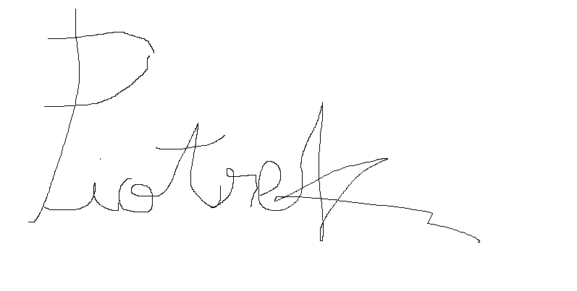

The game is both annoying and addictive and I guess it’s what you wanted to make it into, maybe less enemies please!!!

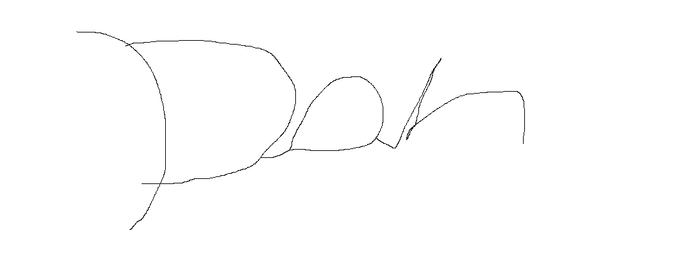

Pretty challenging!!! But also addictive, maybe the music was a bit out of place a better music track would be nicer too ominous.



How was the accuracy of the main player character?

Piotrek:

The overall character aimed alright maybe a bit too accurate for my liking to make the game even harder it would have been good for the player character to sometimes miss however the limit on bullets certainly made it a big challenge.

Dan:

Sometimes the character would clip at the waist so maybe the maximum turning angle of the main character should be tweaked but it wasn’t extremely noticeable so it’s fine.

Tiff:

Completely fine however it should be less accurate when running it looked a bit unnatural to have the same exact accuracy.

How was the death of the player character was the transition alright?

All my stake holders remarked on:

It was overall alright however you should have inputted a death animation and allowed the player to leave the game instantly rather than take them back to the menu.

How was the main menu?

Again all remarked on that it could have had better aesthetics and the option to change the volume of the sound?

How was the saving of the game?

All remarked:

We would have liked to be able to save in game not just in-between the menu level and game level.

If you could change one thing about the game what would it be?

Tiff:

The lack of weapons makes it hard to tackle enemies, it would be great to have more weapons.

Pio trek:

I would make the ai slightly smarter rather than have many, strength in numbers seems a bit overwhelming

Dan:

I would make the platforms more interesting rather than just big black squares.

### QUANTATIVE

Sample of questionnaire:

|  |  |  |
| --- | --- | --- |
| 1.Did the game open? | Yes(1)no(0) | Comment: |
| 2.Did the buttons on the menu screen work? | Yes(1)no(0) | Comment: |
| 3.Were the buttons on the menu screen appropriately placed? | Yes(1)no(0) | Comment: |
| 4.Was the menu information helpful? | Yes(1)no(0) | Comment: |
| 5.Did the actual game open? | Yes(1)no(0) | Comment: |
| 6.Did the platforms spawn in? | Yes(1)no(0) | Comment: |
| 7.Did the ai spawn in? | Yes(1)no(0) | Comment: |
| 8.Did the weapons work? | Yes(1)no(0) | Comment: |
| 9.Could you take damage? | Yes(1)no(0) | Comment: |
| 10.Did the jetpack work? | Yes(1)no(0) | Comment: |
| 11.Did the ammunition system work? | Yes(1)no(0) | Comment: |
| 12.Was the ai competent? | Yes(1)no(0) | Comment: |
| 13.Did the kill volume work? | Yes(1)no(0) | Comment: |
| 14.Did the game give you a death screen upon death which took you back to the main menu? | Yes(1)no(0) | Comment: |
| 15.Did you enjoy the game? | Yes(1)no(0) | Comment: |

1. Everyone answered yes to this however this doesn’t provide me with full evidence to say this works, all of the people I asked I know have higher end devices this is not representative of people who have devices which don’t particularly have as high processing power.
2. This was a generic question and everyone again answered yes however with it being quantitative it doesn’t provide a clear view of if it worked flawlessly , yes the option to comment was offered however as anyone trying to get people to do surveys they most likely ticked yes without adding anything there as they were to bored to offer full feedback (I don’t blame them I’d do the same!!!).
3. Most again said yes however when asking them even though they didn’t actually comment they did say the buttons were rather boring they were just Gray on a uninteresting background so that would be a good thing to include for future development.
4. All said yes, when answered they said they couldn’t be bothered to read it however they said it was fine, from my personal experience of games I also usually skip the tutorial as I expect games to be the same as others.
5. All said that the actual game where you moved around opened some said it was a bit laggy at the start so it would be of upmost importance to optimise the game so that it loads in smoothly or at the very least add a loading screen break in-between so that players don’t have to witness the start up of the code,

6-14. All said yes which thankfully works this would be a very very big problem if it didn’t.

15. This isn’t a good question to put in a quantitative questionnaire however I thankfully have

nice friends however this isn’t perfectly representative of what other users may think.

### Critique of game and critique of questionnaire

I am very happy that my friends could actually enjoy the game however my critique of the questionnaire that I did was that quantative research is not good at identifying problems, it is good for getting a quick picture however it is not perfect, the qualative research was somewhat helpful however the substance extracted out was only so helpful as friends tend to soften blows and aren’t as critical as the comment section of online video games would be so only some issues were touched on.

My critique of the game would have to be that simply the time was too short to code it however it is a good bare bones template, if I was to actually sell this game it would be more as a unreal engine marketplace piece of code as it offers pretty good coded content however it doesn’t offer a game which would be successful on the market place simply due to the lack of visuals.

# EVALUATION

Success criteria:

Met?

|  |  |  |
| --- | --- | --- |
| **The ability for the player to actually play the game e.g. it can actually launch like a normal game** | | **Yes** |
| **A player character which has the ability to move around in numerous ways: eg: dashing jetpack running etc.** | | **Yes** |
| **Enemy ai which have a big variance in what they do from aiming and shotting down the player with projectiles to actually ramming the player** | | **Yes** |
| **A platform which spawns in other platforms which may or may not spawn in with pick up items** | | **Yes** |
| **A weapon which the player can use to deal with enemy ai.** | | **Yes** |
| **A clear boundary of the game** | **Somewhat it was previously aimed for the platforms to be bigger however air ai seemed to be ‘’funner’’to go against so the only real boundary is the death volume if you fall off** | |
| **A save algorithm** | | **Yes** |
| **A reloading mechanism with animation** | | **Yes** |
| **Informative information for the player to get some understanding of the game out of** | | **Somewhat** |
| **A purpose to play the game** | | **Somewhat** |
| **The ability to change Key bindings** | | **Mostly met** |
| **The ability to change the difficulty** | | **Not met but to be included in future development** |
| **Appropriate animation** | | **Yes** |
| **The beginning of implementing models into the game** | | **I introduced gun models but not much else(and particle effects)** |
| **The ability to play iteratively( doesn’t close goes back to main menu so player can play again)** | | **Yes** |
| **Death screen** | | **Yes** |
| **The game has the ability to be developed e.g. new features would make sense to be added to the game it isn’t just a dead end** | | **Yes** |

Evidence:

**From this picture you can clearly see that the game can be launched and played as a normal game:**

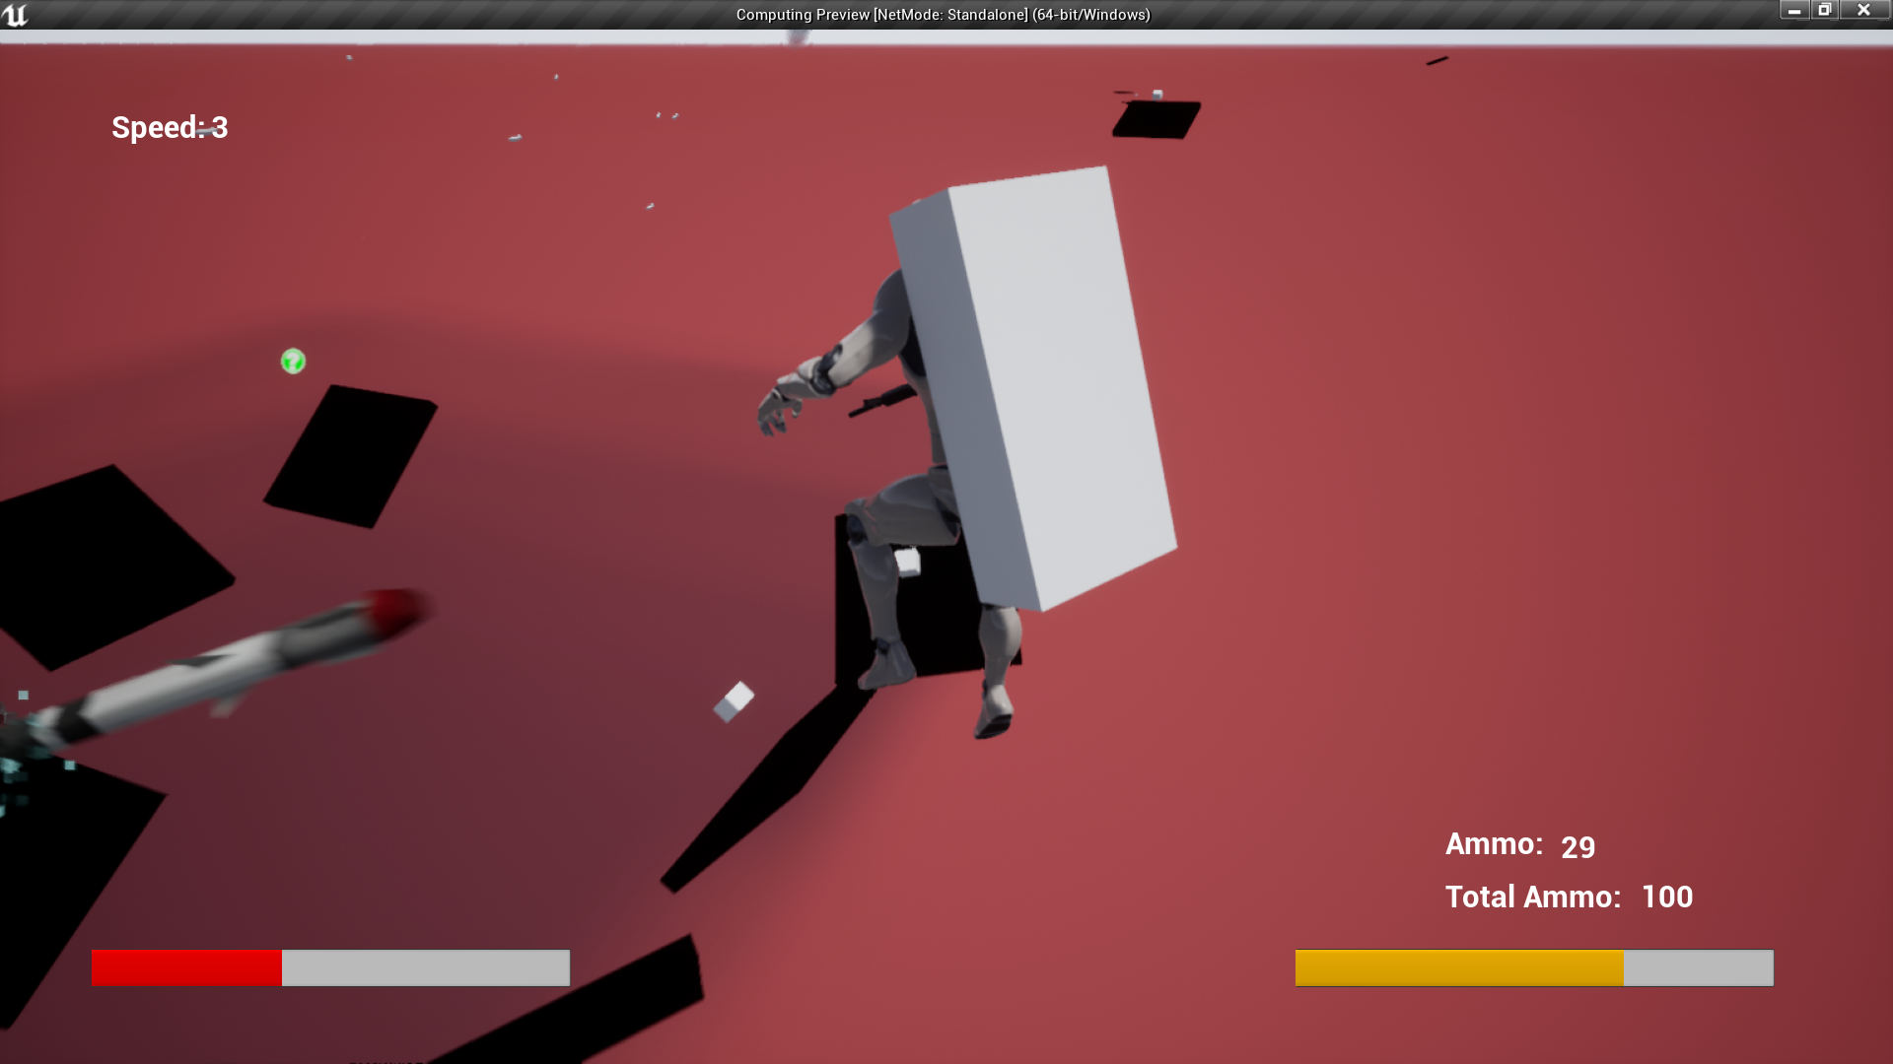

**I have made a very clear jumping and jetpacking algorithm in this picture the player can clearly be seen falling from the sky and the shadows coming form the platforms below him can be seen**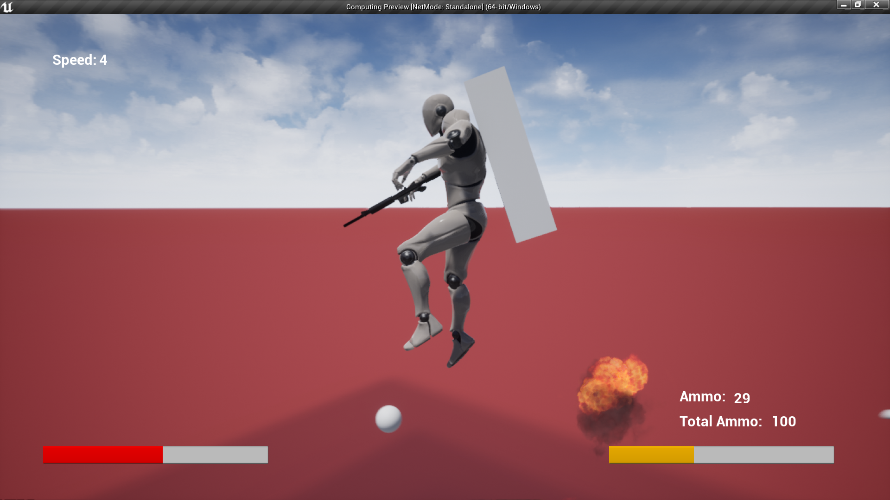

**From the picture below and many of the others you can see the platforms are spawning in other platforms this can be seen in pretty much all of the pictures as they spawn in each other on every time they get stepped on**

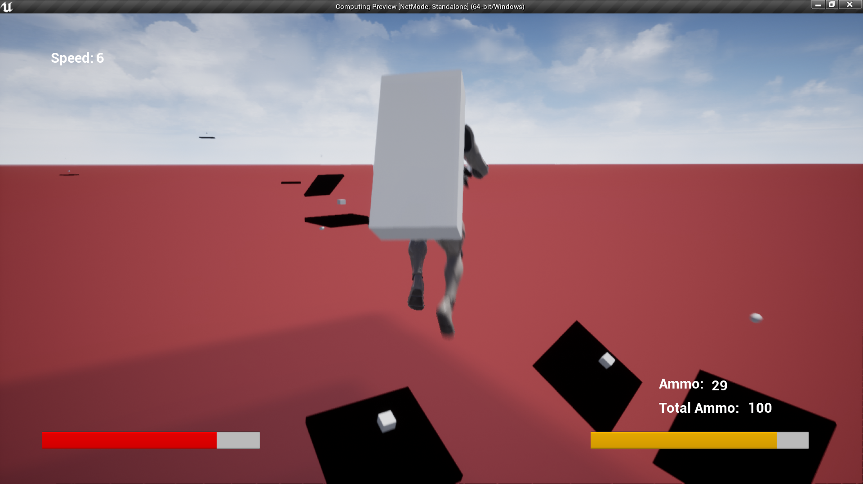

**From the picture below you can see that the player is being attacked by multiple types of ai two rockets behind him a shooter block and multiple smasshers moving towards the player to ram them**

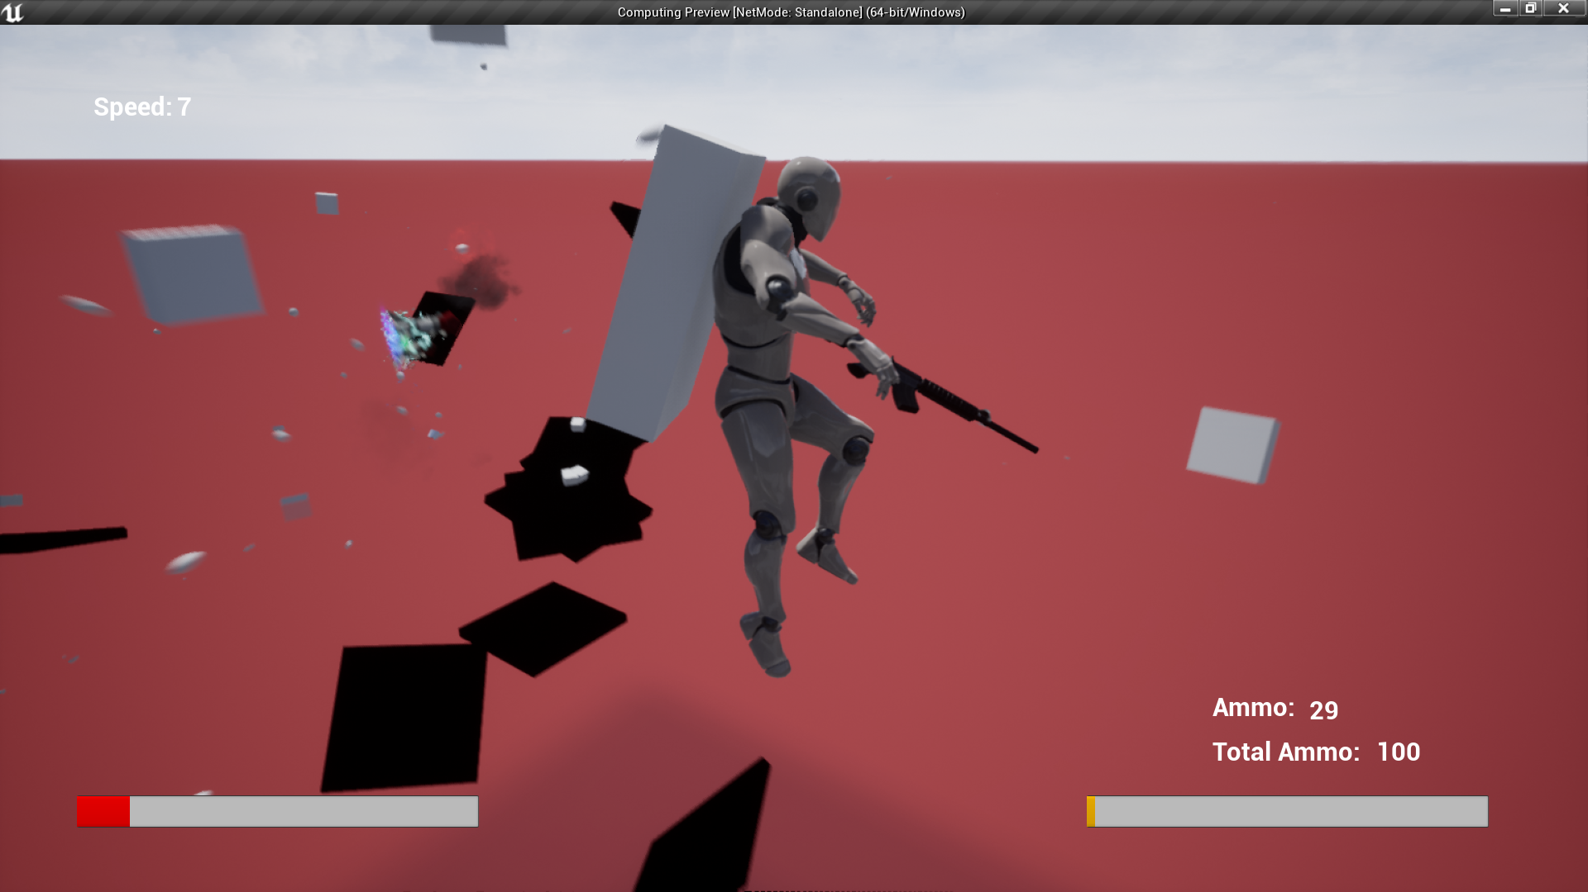

**The player can be seen reloading their weapon the animation is very clearly playing after it was finished the player got their ammo back up to 30**

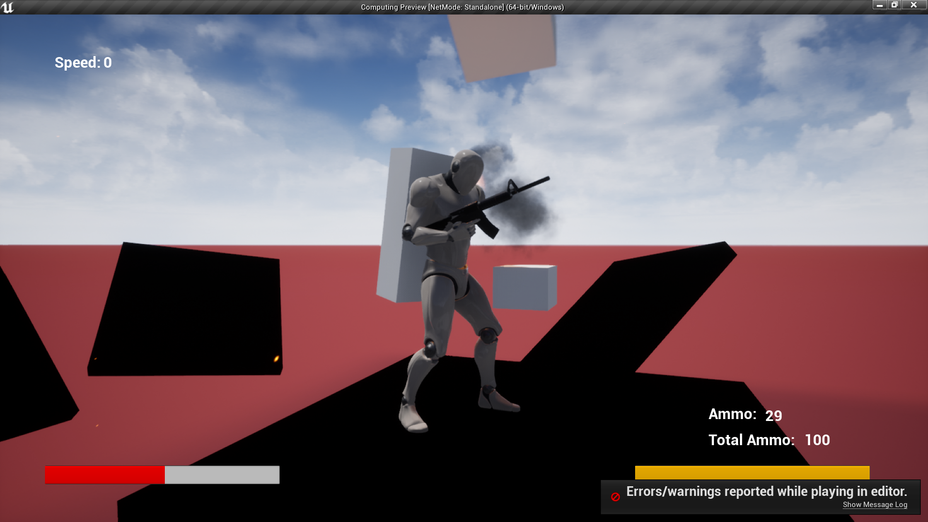

**This picture is evidence of the death menu and the clear boundary, stepping into the red volume will kill you automatically so there is a clear height border**

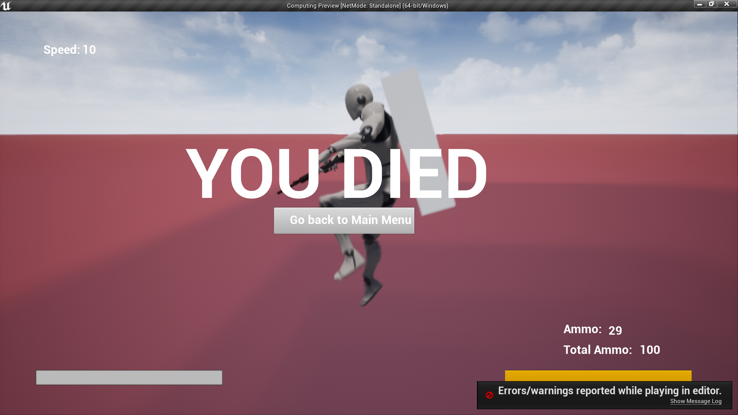

**From the picture below you can see a enlarged bullet which was slowed down and enlarged for this picture only you can see that it went in the relative direction of the enemy ai in front of the player (inside the game the bullet would kill the ai however to show the bullet hitting the ai is impossible at this slow speed)**

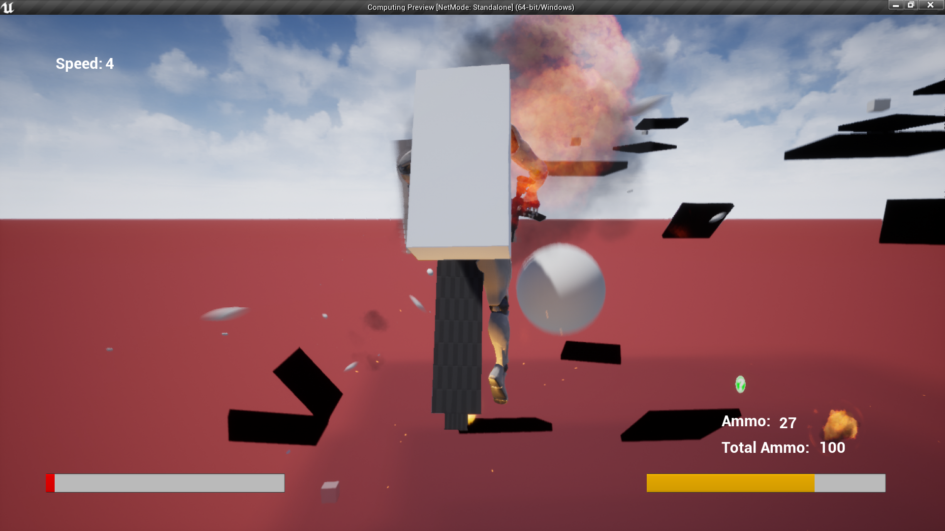

### Usability

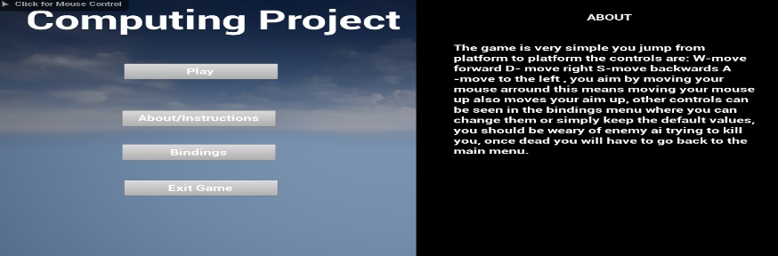The font used was generally large I also decided to use easy to see colour combinations like a bright white on black and black and white on a grey which is very easy to notice

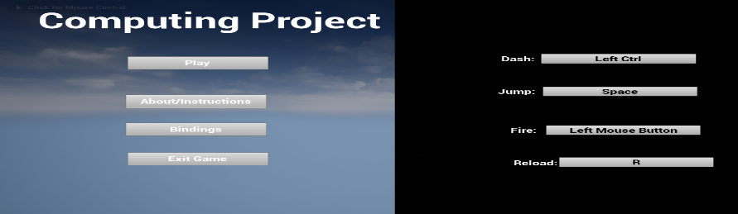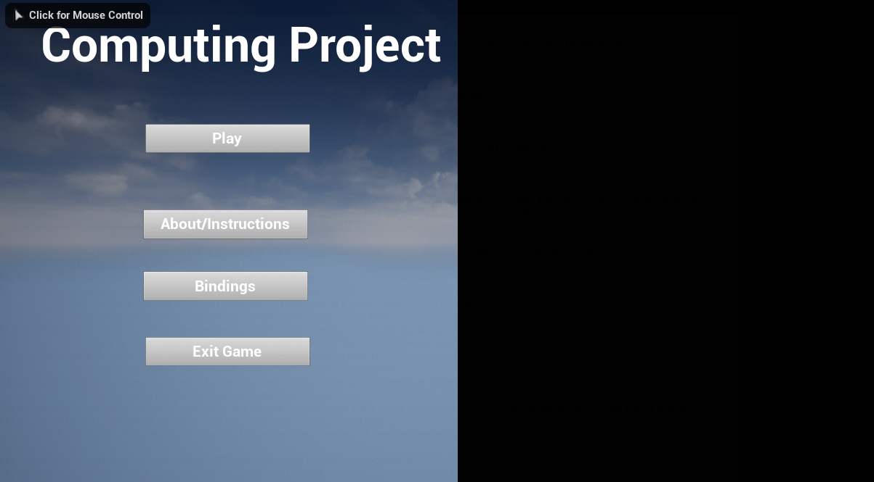

The white on black background allows for the user to have a nice contrast they don’t need to strain their eyes to see the instructions of the game on top of that no actual special colours are used so colour blind people can see the writing.

### Usability issues

A main problem that arises with usability is that well for one it isn’t cross platform, the solution requires you to use a pc or a laptop this isn’t as good when trying to cater to the immense global market this interestingly would work just fine on other platforms like console or on the phone, this is because it doesn’t require quick snap reactions like in most fps games where you need to aim at someone within seconds, it only takes intuitive jumping this would be very simple to implement on the phone or consoles as this is something which you only really need a joystick as it would do fine compared to the wasd controls of pc gamers.

One thing I wished I had time to implement would have had been a tutorial, you are only presented with a about page which I didn’t spend as much time as I should have writing it up, it provides the user with some understanding of the game however to people who are newer to gaming and not as well versed the game would alienate them as they don’t have prior understanding from other games.

### Limitations and their potential solution

The main limitations of the game would have to be the variance of the game, such as guns enemy ai and different kinds of platforms the problem with this is that if I simply just made more guns than you’d have the thought of what if there were more guns or what if there were attachments or what if there were a platform with a spinning blade or a platform with spinning blades and minefields, the main problems is that you can only add so much however the amount of thins that can be added are infinite, however the one good thing about my code is that it is highly replicable so if I wanted to make a new gun it would be a simple copy and paste with a change of the values for that weapon same goes for ai, the movement algorithms of the smaker the rocket and the shooter are exactly the same so actually adding in new things would only come to finding some new meshes and slapping on the exact same code, the solution to this is more development time and a actual reason to keep adding more.

One main limitation is also the graphics the meshes weren’t particularly triple A per say, they were mostly blocky shapes, I also had a player character instead of the unreal engine robot, however implantation of this would have looked odd without having other meshes to accompany it, e.g. a normal human who pretty much has a big concrete block for a jetpack would not look good in the slightest, this project has the main code down however what makes a game a game are the visuals so a solution to this would have been to obviously either make the models on blender of finding them online and without a doubt I can say that actually making the models myself would have probably taken longer than coding the whole program, a simple solution to this could have been going with a lower polly art style as making a cartoonish character which has about 30 edges on the whole would have been very achievable however I do not have the blender expertise to properly create a skeleton for the character which can be combined with the ue4 skeleton on top of that I am not particularly artistic myself so the main limitations to actually making this to a successful steam game for example would majorly be the visuals as there are many games which don’t actually have that many different things like different guns different enemies however the visuals can carry them a long way, at the end of the day the major limitation to this being fixed would be time and expertise, I would have to team up with a artist to actually make this into a worth while game.

A minor limitation due to time that was caused was the saving of the entire game for minor things like key bind setting’s this could be avoided by changing up the saving algorithm so that different amount of memory is saved for every single piece of code however the current piece of code is perfect for auto-saving and normal saving just a bit overkill for saving anything minor.

### Future development

|  |  |
| --- | --- |
| Menu | The menu is not particularly aesthetic therefore I would add more fancy buttons such as special textures on them or pop up particle effects just to enhance the attention to detail applied to the game, I would have also added more key bindings which could be changed as this could enhance the game significantly |
| Weapons | One single gun is clearly not enough it would make the game significantly more enjoyable if more and different weapon types were added as one single gun won’t do the job for a full game, this is easy to change as any automatic rifle would use the same code ,a shotgun would just add more bullets with larger spread, explosives would also be pretty fun like rocket launchers |
| Graphics | If the game is to go further the actual graphics would need to be enhanced dearly this would be by adding a standard art style such as low polly or high polly for example(leaning towards low) this would make the game actually look good which is the most important thing in a game as sadly people are not too interested about knowing how the saving algorithm works or how the ai move towards the player. |
| Ai | A bigger variance would have been fun only 3 seems bland especially how two of them just ram into you, however again this could only be possible with a standardised graphics style so this would essentially be end production copy and pasting of ai code |
| Platforms | It would be a great addition to actually make the platforms have more variance e.g. spinning blades etc, at the current time they simply spawn differently, have ammo drops and health packs, this is not a great amount of variance however it can be later added into the game. |
| Hitboxes | The hitboxes don’t greatly go along the player rather they just have a block/ cylinder around the character this can cause parts which are meant to be a hit not to be one and parts which are empty air to actually be counted as hits which is not too good if you are trying to do a great game. |
| Crosshair | It would have been good to have added a crosshair where the player can aim however the auto aim didn’t make this a great priority |
| Rework of controls | The controls of the game are very familiar to me as I use unreal engine regularly however to a non regular user they appear to be very foreign as they aren’t entirely similar to other games, people don’t like having to control their own camera and movement from a relativistic point they like their view to be the forward direction rather than their camera be more of a narrator view which is something that needs to be considered for future development. |
| Optimisation | The current game uses more memory space than it should as there are asset files which are not necessarily needed for this development option therefore this would be the highest on the priority list, I added too many animations etc which need to be removed to save user memory. |

### Future development problems

The only main problems that may arise from the current solutions is that the implementation of making the game actually multiplayer would not be possible this is simply because the weapon targeting system of the characters is made so that it shoots the closest enemy this isn’t particularly good for actually having a multiplayer game as there is only one enemy so fighting between players would be rather dull and boring, yes I could change the player weapon so that all the aim is player based rather than based on a automatic ai this would make the game compatible with multiplayer however it would make single player rather dull as it’s near to impossible for a human to defeat the waves of ai so therefore there would be less ai which means less projectiles on the screen which ruins the whole aesthetic of the game, this game should remain as a single player only game which does limit expansion however it’s at the cost of keeping the game the same.

### Maintenance

The problems with maintaining this is that there needs to be a big investigation into how the code runs on other computers, the computer I used has a RTX 2060 GPU and a very powerful i7 CPU, the average user does not have these kind of high end components at their availability, it is undoubtably important that the program is used on other computers so that it is thoroughly checked and that the program sets limits to the amount of ai that can spawn in, all controlled experiments have had about 50 ai at max with a lot of bullets flying about, it ran perfectly fine however this may not be the case on worse computers.

Another thing that would help to maintain the code is that I develop a program which determines the skill of the player and different levels of difficulty are offered currently there is only one singular difficulty, the reason I didn’t prioritize this in the time I was allocated for coding the solution was because this would mostly take a lot of hard coding not many data structures involved rather it would be trial and error with multiple stake holders and determining what would make the game be the best it could be.

### The obey of design defined standards

I would say that certain standards were violated the main standard which wasn’t fully obeyed would have to be the camel case syntax writing variables were written as I pleased at the time, I do admit that the readability of the code would be greatly reduced to this not being implemented, on top of that the code is on multiple files which wasn’t a pre set standard however it might be hard to follow and read the code when it is spread over multiple files, however this was the most optimised option due to the engine I was using.

### Effects of analysis on final solution

At the beginning of this solution I didn’t have too much clue of how it was going to turn out however I believe that ahead of time research and my own biases did affect the final solution, after playing Roblox for so long I was very inclined to include the exact same movement system within the actual game so I believe that having this prior knowledge that this movement system is easy to learn and highly popular made me inclined to include it within the actual solution of the game which did actually happen, I also was very happy to include the huge and grandiose idea of ai hordes, they swarmed the player shooting him with a large arsenal of weapons, this was very good at putting a lot of pressure and tension on the player at the end of the day I didn’t fully follow one single game however I did take inspiration from multiple of them.

### Conclusion

I personally believe that the game was pretty successful however at the end of the day as I kept repeating it is very barebones however I personally(maybe a bit biased) like actually playing the game, making something challenging is like spice you don’t want to make it impossible and you don’t want to make it too easy that it is a walk in the park, I’d say that I made the game just right it definitively is capturing after playing it for a while, just trying to get the high score higher is what makes the player very enticed to win and do better each time rather than delete it from their computer, I personally feel that the movement system was the greatest success without it the game would not be as fast paced, the jetpack and dash function makes the player move very quickly around the map which is enhanced by the absolute onslaught of enemy ai I am in fact happier about the finish product than what I thought it would be even though graphics were not truly implemented I am genuinely happy of what has become the game.